MirrorMate



Group 9
Jake Hochstadt
Matt Simons
Jerome Yearwood
Ryan Moreland
December 6th 2012
Table of Contents
Table of Contents i
1.0 Executive Summary 1
2.0 Project Description 2
2.1 Project Motivation and Goals 2
2.2 Objectives 5
2.2.1 Emergency Vehicle Detection 5
2.2.2 Infrared Beacon Uses 5
2.2.3 Infrared Beacon Applications 5
2.2.4 MirrorMate Display 6
2.2.5 MirrorMate Mobile Application 6
2.3 Project Requirements and Specifications 7
2.3.1 Hardware Requirements and Specifications 7
2.3.2 Software Requirements and Specifications 9
3.0 Research Related to Project Definition 12
3.1 Existing Similar Projects and Products 12
3.1.1 Gentex and OnStar Mirrors 12
3.2 Display Technologies and Mirror Integration 14
3.3 PAN Technologies 15
3.4 Considered Technologies 16
3.4.1 Heads-Up Display 16
3.4.2 Video Recording 16
3.4.3 Speedometer 17
3.4.4 OBDII Integration 18
3.4.5 Blind Spot Sensors 18
3.4.6 IR Beacon Weatherproofing and Remote Configuration 20
3.5 Mobile Development 21
3.5.1 Software Architecture Possibilities 21
3.5.2 Mobile Device Platforms 22
3.6 Infrared Communication 24
3.6.1 The Opticom System 24
3.6.2 Infrared Beacons 26
3.6.3 Signal Encoding, IR Range and Transmitter/Receiver Design 27
3.6.4 Safety Operations for the High Output SFH4547 28
3.7 Hardware Interface Development 30
3.7.1 Hardware Interface Possibilities 30
4.0 Hardware and Software Design Details 36
4.1 Packaging and Physical Design Considerations 36
4.2 MirrorMate System Overview 38
4.3 Microprocessor 39
4.4 Power Supply 40
4.5 Display Technologies and Interfacing 42
4.5.1 Display Function Goals 42
4.5.2 Memory 42
4.5.3 LCD Technology 43
4.6 Infrared Receiver 46
4.6.1 Opticom 46
4.6.2 Reduced Speed Zone Detection 48
4.6.3 IR Receiver Specifics 50
4.7 Infrared Beacon 50
4.7.1 IR Beacon Physical Characteristics 51
4.7.2 IR Beacon Optical Characteristics 52
4.7.3 Powering the IR Beacon 52
4.7.4 IR Beacon Electrical and Firmware Design 53
4.8 Bluetooth Communication 56
4.9 Mobile Device Development 62
4.9.1 Initial Setup 62
4.9.2 Interfacing with GPS and Location 62
4.10 GUI Development 77
4.10.1 Initial Design Considerations – Mirror and Application 77
4.10.2 Final Design Implementation – Mirror 79
4.10.3 Final Design Implementation – Application 83
4.11 PCB Design 88
4.11.1 MirrorMate PCB 88
4.11.2 IR Beacon PCB 89
5.0 Design Summary of Hardware and Software 90
5.1 Drawing Package 90
5.1.1 MirrorMate Schematics 90
5.1.2 Reduced Speed Zone Beacon Schematics 94
5.1.3 UML Diagrams 99
5.1.4 Flow Charts 102
5.1.5 Build Of Materials 104
6.0 Project Prototype Testing 106
6.1 Initial Prototype Testing 106
6.1.1 Initial Hardware Testing 106
6.1.2 Initial Software Testing 106
6.2 Hardware Specific Testing 107
6.2.1 Test Environment 107
6.2.2 Hardware Testing 108
6.3 Software Specific Testing 111
6.3.1 Test Environment 111
6.3.2 User Acceptance Testing 112
6.3.3 Unit Testing 125
6.3.4 Performance Testing 125
7.0 Administrative Content 127
7.1 Milestone Discussion 127
7.2 Budget 128
7.3 Finance – Sponsorships 129
7.3.1 Gentex 129
7.3.2 Department of Transportation 129
7.3.4 Bob’s Barricades 129
7.3.5 GTT 130
7.3.6 Personal Contributions 131
Appendix A List of Tables and Figures A-1

1.0 Executive Summary

MirrorMate is an interactive rear view mirror designed to assist drivers and provide helpful information in a convenient location. Among the key features are Bluetooth connectivity to an Android app, the ability to send turn by turn navigation to the mirror, and the notification of nearby emergency vehicles as well as alerts for upcoming construction and school zones.
The Android app will communicate with the MirrorMate via a built in bluetooth module. Once plugged in, the MirrorMate will start in pairing mode to allow the user to connect with their Android phone. Once connected, the user can navigate through Google Maps and find their desired final destination. From there, the turn by turn directions will be sent via Bluetooth to the rear view mirror to display to the LCD.
The application will be able to create a custom route from the current location to a user-specified driving destination and transmit the directions to the mirror. The mirror will be able to notify the driver of the next turn via a helpful graphic on the LCD display. This LCD display will update the next direction as the vehicle moves through the designated route. One of the key objectives was to the keep both the application and the LCD display relatively clean and free of unnecessary clutter to distract the driver from the road, as the MirrorMate system is intended to be a driving aid and not a hindrance.
The final key feature of the MirrorMate is the ability to interface with emergency vehicles and an Opticom beacon. If an emergency vehicle comes within the range of the module, the mirror will notify the user. Also, a programmable reduced speed zone beacon will communicate and send the posted speed limit to the mirror. A 38 kHz IR signal will broadcast the posted speed limit in the area. If the vehicle comes within the range of the beacon, the mirror will pick up the signal and post the speed limit to the driver.
Rearview mirrors are capable of providing much more than just the one feature they’re limited to. MirrorMate is intended to be an alternative to expand on those features giving quality in driver assistance. With easy-to-use compatibility, it can be made available to use for drivers of any vehicle. Overall, the MirrorMate module with all the included features will give customers a great experience that no other product can provide.

2.0 Project Description

2.1 Project Motivation and Goals

The starting point for the MirrorMate was the already developed Opticom System, a system utilized for traffic signal preemption by emergency vehicles. In the simplest terms, the Opticom System allows ambulances, fire trucks, and police cars to alert an upcoming intersection of their presence and modify the traffic patterns so they will not have to wait at stop lights or dart through oncoming traffic. This system is well established in the United States currently but the goal of this project is to use a similar technology and expand the applications for this system.

While the Opticom system is very helpful for moving through intersections, improvements could be made so that it would be more helpful in alerting other drivers to the nearby emergency vehicles. It is helpful for the emergency vehicles that an intersection would always change to allow them quick passage, but to a driver who is accelerating through a light that just turned green just to watch it turn red again it can be rather confusing. If the driver were instead alerted that there was an emergency vehicle approaching then the problem would be averted.

The Opticom system being simulated is based on a line of sight transmission system. Each individual transmitter emits an infrared frequency that can be recognized by the receiver at the intersection. The receiver can then change the light patterns such that the emergency vehicle will not have to stop or slow. This infrared signal is transmitted at 14 Hz to a range of about 2,500 feet. [1] This low frequency allows for a signal that can travel a sufficient distance with minimal interference such that the emergency vehicle will only have to slow down before they reach the intersection.

Along with the emergency vehicle notification the system can be used to alert drivers of other road factors that require their attention as well. While the emergency vehicle uses a beacon to alert the intersection, with minor alterations it was decided to create a beacon that would alert divers of construction zones as well. A transmitter placed at the start of the construction zone would allow a car ample time to slow down to the reduced speed limit to alleviate the safety concerns of speeding through an area where workers are present. Additionally these beacons can be used in school zones to notify drivers that the zone is active and a lower speed is required.

In order for the system to be useful for civilian drivers they would need to be alerted while driving that an emergency vehicle is approaching their vehicle. An additional notification on the dashboard was considered but for the purposes of this project it was deemed too difficult and expensive as the instrument cluster varies from car model to model and would require complicated installations.

Information panels on rear-view mirrors are becoming more commonplace in the United States. These mirrors provide an excellent line of sight to the driver without adding an additional distraction. Rear-view mirror installations are much simpler than updating the instrument cluster in the dashboard, and can be completed without the help of a mechanic in most situations. Additionally, as mirror systems become more advanced the driver would be able to upgrade as new technologies become available. The mirror's location on the windshield surrounded by glass and away from the dashboard allows for easier transmission of multiple frequencies as well as an ideal line of sight for the driver.

The standard rear view mirrors installed in new cars for the past decade were usually equipped with at minimum a compass and a thermostat displaying the outside temperature. MirrorMate was initially designed around these features and the Opticom system. A small LED allows for quick and simple notification of an incoming emergency vehicle or traffic situation. In order to display the compass and thermometer a small LCD screen was added to the design to make this information available with minimal distraction as well as still allowing the drive full use of the mirror.

With the addition of an LCD to the mirror the possibilities were almost endless as to the information that could be shown. After much debate the MirrorMate prototype was not equipped with OBD-II integration capabilities. The on-board diagnostic sensors allow access to trouble codes and engine monitoring information for an automotive technician. All cars manufactured after 1996 are required to have an OBD-II port within arm’s reach from the steering wheel for easy access. There are many retailers that provide the hardware necessary to connect to the OBD-II port and some are even able to stream this information wirelessly to nearby computers and mobile devices so the diagnostics can be available in real-time. The MirrorMate does not have this additional functionality for two major reasons. The first was the goal of making the system self-contained, wireless, and easy to install. An additional connection to the OBD-II port would require another piece of hardware and it was agreed that this would be stretching the systems capabilities at the risk of spreading time and resources too thin. Even if diagnostic capabilities were added, the small LCD would not allow for much additional information to be displayed without interfering with the other stated goal of keeping the MirrorMate from becoming an additional distraction, rather than a helpful feature.

Keeping in mind that the mirror should be a safety device, interaction between a drivers mobile device was still considered a helpful feature. Using Bluetooth transmissions from the mobile device almost anything that could be viewed on a phone could be projected to the mirror. A Class 2 Bluetooth chip allows for communication between two paired devices up to 10 meters, so a mobile device anywhere in the vehicle would be effective. Effort was made to avoid unnecessary complications like displaying incoming texts or web pages on the LCD. Instead, priority was given to features that would allow the driver to avoid looking back and forth between the road and his or her phone. One such feature is GPS navigation and turn by turn directions. Most smart phones can be used as a navigation tool as they already are embedded with GPS tracking hardware and have access to map software. Using the already available capabilities of the mobile device, the MirrorMate needs only to receive the directions from the phone and display them in a safe and simple manner. To avoid unnecessary computations and wasting screen space the MirrorMate only displays the next action needed by the driver to remain on course as well as a short text message to indicate when and where this action will take place. Some GPS screens show an entire map along with estimated time of arrival, current speed and more, but MirrorMate opts for a simple arrow indicating the next turn needed, with the expectation that if further information is required the user can view the mobile device itself.

With these features in mind, the MirrorMate system was also designed with the intention to learn more about the underlying technologies required to operate them. The group had a basic understanding of what the Opticom system was, but had never dealt with transmitting infrared frequencies over long distances or decoding the signals in a useful manner. A large burden on the hardware development was the creation of a demodulator to allow the MirrorMate to receive the signal and decode the information contained within. This embedded information could transmit the type of signal incoming, emergency, or zone change, as well as a speed limit to abide by. The infrared spectrum would be an almost entirely new area to learn and develop by the group. Another hardware difficulty would be the integration of an LCD screen into the mirror and the software required to display useful information with it. The group had not dealt with making functional displays more advanced than an assortment of LED lights in the past and saw this as another opportunity for growth.

Much of the LED display would be based on the communications from the mobile device transmitting via Bluetooth. Bluetooth technologies are becoming more and more prevalent in society but none of the group had any experience designing systems utilizing them. Creating and using the master-slave partnership between the MirrorMate and a mobile device would provide another avenue of knowledge expansion. In order to pair the devices and transmit accurate and helpful data to the mirror software would be needed for the mobile device as well and code written to decipher the signals received by the Bluetooth chip embedded in the mirror. It was decided that this software for the mobile device would take the form of an application written for the Android Operating System. Members of the group had some experience with mobile development but the creation of an entirely new app to pair with the MirrorMate hardware was another large learning goal.

2.2 Objectives

The objectives that follow are a broad description of the goals of the MirrorMate system based on the original research and design phase of the development cycle. These goals are further expanded upon and described in
Section 2.3 Project Requirements and Specifications.

2.2.1 Emergency Vehicle Detection

The following are the objectives that directly pertain to the Emergency Vehicle Detection of the MirrorMate system.

- The MirrorMate should be able to detect an incoming Opticom transmission from an emergency vehicle in a manner similar to how an intersection's receiver would function.
- The MirrorMate should be able to alert the driver in a highly visible manner that an emergency vehicle is approaching.
- The MirrorMate should be able to notify the driver of the direction that the emergency vehicle is approaching from.
- The MirrorMate should cease alerting the driver when the emergency vehicle moves out of range.

2.2.2 Infrared Beacon Uses

The following are the objectives that directly pertain to the uses of the IR beacon designed for use with the MirrorMate system.

- The IR beacon should be a small device able to be easily installed on or near construction equipment.
- The IR beacon should have sufficient range so the driver will be alerted at a similar range as with emergency vehicles.
- The IR beacon should be able to transmit speed limit information embedded in the signal for use with a construction zone or a school zone.
- The IR beacon should have a simple interface to allow the user to alter the speed limit being transmitted.
- The IR beacon should be able to be easily turned off when a school zone is not active.

2.2.3 Infrared Beacon Applications

The following are the objectives that directly pertain to the applications of the IR beacon and the MirrorMate system. These deal with the MirrorMate systems response to the signal output by the IR beacon.

- The MirrorMate should alert the driver when a construction zone is entered with a unique color scheme.
- The MirrorMate should have a directional indicator to let the driver know whether a construction zone being approached, currently in the middle of, or being exited.
- The MirrorMate should alert the driver when a school zone is entered with a unique color scheme.
- The MirrorMate will be able to visually display the temporary speed limit for both a school zone and a construction zone.
- The MirrorMate should cease alerting the driver when the temporary reduced speed zone is exited.
- The MirrorMate should be able to detect multiple and overlapping signals without reducing functionality.

2.2.4 MirrorMate Display

The following are objectives that pertain to the MirrorMate Mirror and the information that will be displayed to the driver during the use of the system.

- The MirrorMate display should be sufficiently large so as to allow text to be read without strain on the driver's eyes or attentions.
- The MirrorMate display should be small enough to still allow for a standard rear view mirror in the same frame.
- The MirrorMate display should use an intuitive color scheme to notify drivers of various traffic situations (I.E. Red- Emergency Vehicle, Yellow- School Zone, Orange – Construction Zone)
- The MirrorMate display should be able to indicate driving directions.
- The MirrorMate display should be able to display Cardinal directions and outside temperature.

2.2.5 MirrorMate Mobile Application

The following are objectives that pertain to the MirrorMate Mobile Application and the information that will be displayed to the driver by the mobile device as well the constraints and features of the Application.

- The MirrorMate App should be able to communicate without any cable attachment to the MirrorMate mirror. (Wireless)
- The App should run on the mobile device without using an extensive amount of the CPU such that other apps can be run concurrently.
- The App should have a simple and functional display for user interaction.
- The App should allow the user to create a custom driving route.
- The App should be able to transmit simple driving directions to be displayed on the mirror.
- The App should be able to display a local map of the surrounding area.
- The App should be able to alter driving directions based on the vehicle's current position, including reverse course messages if necessary.

2.3 Project Requirements and Specifications

2.3.1 Hardware Requirements and Specifications

The table below explains the MirrorMate hardware requirements and specifications.
Hardware Requirements  Specification | Description
HRS-001 | The MirrorMate device shall be a self contained automotive mirror which can be installed in any typical automobile.
HRS-002 | The MirrorMate system shall be reliably powered by a typical automotive 12V charging system and will not require more than 24W from the charging system.
HRS-003 | MirrorMate will contain a color graphics LCD which will display several standard automotive conditions on the screen.
HRS-004 | MirrorMate will display outside temperature conditions color graphics LCD.
HRS-005 | MirrorMate will display accurate cardinal direction of the vehicle from color graphics LCD.
HRS-006 | MirrorMate will display turn-by-turn directions on the color graphics LCD.
HRS-007 | MirrorMate will display Bluetooth identification code when pairing with phone on color graphics LCD.
HRS-008 | MirrorMate will receive optical signals in the infrared spectrum at a wavelength of 950nm.
HRS-009 | MirrorMate shall detect emergency vehicles utilizing the Opticom system within a range of 1500 ft.
HRS-010 | The MirrorMate device shall determine and display the direction emergency vehicle is approaching from.
Table 2-1 MirrorMate Hardware Requirements Specifications
Hardware Requirements  Specification | Description
HRS-011 | The MirrorMate device shall detect reduced speed zones reliably within a range of 1500 ft.
HRS-012 | The MirrorMate device shall determine from which direction the reduced speed zone is located relative to the vehicle.
HRS-013 | MirrorMate will reliable receive encoded data from reduced speed zone beacons and display decoded information.
HRS-014 | MirrorMate shall detect and display the recommended vehicle speed and will keep that speed displayed until the vehicle is no longer inside the reduced speed zone.
HRS-015 | MirrorMate shall display color coded notifications if the vehicle is within range of reduced speed zone or emergency vehicle.
HRS-016 | MirrorMate will not produce any signal that will interfere with operations of existing IrDA (Infrared Data Association) or Bluetooth devices.
HRS-017 | MirrorMate will be constructed of components resilient to the harsh conditions inside a vehicle and will operate reliably in this environment.
Table 2-2 MirrorMate Hardware Requirements Specifications

The table below explains the MirrorMate reduced speed zone beacon hardware requirements and specifications

Hardware Requirements  Specification | Description
HRS-018 | The reduced speed zone beacon shall be a portable self contained beacon which can be easily mounted to a post or barricade.
HRS-019 | The reduced speed zone beacon shall be powered by a variety of sources including 12VDC, 24VDC, and 120VAC 'mains' power.
HRS-020 | The reduced speed zone beacon shall produce a signal at a frequency of 38 kHz
HRS-021 | The reduced speed zone beacon shall transmit information in the infrared spectrum at a peak wavelength of 950nm.
HRS-022 | The beacon shall transmit information no farther than 3000ft.
HRS-023 | The reduced speed zone beacon will encode speed and zone type information in a proprietary protocol similar to RC-5.
HRS-024 | The beacon shall not produce any signal that will interfere with operations of existing IrDA devices.
HRS-025 | The LEDs will not run at a current higher than 500mA. 50% brightness level.
HRS-026 | The beacon shall be configurable utilizing buttons and a seven segment displays.
Table 2-3 IR Beacon Hardware Requirements Specifications

2.3.2 Software Requirements and Specifications

The table that follows explains the MirrorMate software requirements and specifications.

Software Requirements  Specification | Description
SRS-001 | The MirrorMate Application should be able to be installed on a mobile device using the Android operating system.
SRS-002 | The App should be able to pair with the MirrorMate Mirror using a Bluetooth signal.
SRS-003 | The MirrorMate system should allow for multiple attempts to pair with a Bluetooth device if conflicts are encountered.
SRS-004 | The App should be able to indicate the device’s current location.
SRS-005 | The App should be able to display a local map of the surrounding area on the mobile device.
SRS-006 | The App should be able to display a local map of the surrounding area on the mirror display
SRS-007 | The MirrorMate system should be able to update and redraw the local map at the user’s request.
SRS-008 | The App should be able to calculate directions from the current location to a user-specified endpoint
SRS-009 | The App should be able to display a list of directions from the current location to a user-specified endpoint.
SRS-010 | The App shall contain both local map and driving direction functionality without requiring a connection to the Mirror.
SRS-011 | The Mirror should be able to indicate the next turn on the list of driving directions on the display.
SRS-012 | The System should be able to display alternate directions if the original destination is entered incorrectly.
SRS-013 | The System should be able to recalculate directions as the vehicle moves along the travel path.
SRS-014 | The System should be able to display the recalculated list of directions on both the Application and the Mirror.
SRS-015 | The App should be able to be closed and the process ended on the mobile device by a command inside the application.
SRS-016 | The Mirror should return to the original state if the App is closed.
SRS-017 | The App should be able to terminate the Bluetooth pairing when the program is closed.

Table 2-4 Software Requirements Specification
3.0 Research Related to Project Definition

3.1 Existing Similar Projects and Products

3.1.1 Gentex and OnStar Mirrors

Gentex is a leading producer of automotive rear view mirrors containing electronic content. This content is designed to keep the driver informed and offer useful information for enhanced vehicle safety. Gentex has developed many mirrors that have advanced functionality and many elements that are similar to the features of MirrorMate. Gentex was one of the first manufacturers to develop a rear view mirror with auto-dimming capability. Digital compass, ambient temperature display and automatic garage door openers (HomeLink) were added as features and were commonly seen in luxury cars and trucks. These electronic mirrors are now the norm and it is typical to see a highly functional mirror in any car. Recently, Gentex developed a rear view mirror with an LCD display integrated into the mirror. Currently, this LCD mirror is advertised to be used with a back up camera as the primary feature. Additionally, Gentex produces an LCD mirror where the LCD is also utilized to display compass and temperature information. Since these LCD mirrors contain a display, they are 'blank slates' for advanced functionality.

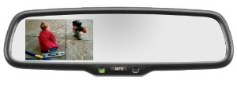

Figure 3-1 Gentex Auto-dimming LCD mirror
Figure reprinted courtesy of MITO Corp.

Recently, GM developed a new rear view mirror that could be added to any car. This mirror, called the OnStar FMV (meaning For My Vehicle), adds OnStar to a vehicle that currently does not have this functionality. OnStar advertises many safety features and driver information services that could also be provided by MirrorMate without paying a monthly service fee. The OnStar mirror does not contain an LCD but provides turn-by-turn navigation through a cellular service and auditory directions to the driver. Because the OnStar mirror is able to communicate wirelessly to the OnStar monitoring center, emergency services are immediately accessible. This mirror also features sensors that detect an accident and will alert the monitoring center if certain conditions occur which facilitates fast emergency response. OnStar also features a concierge service available through the monitoring center.
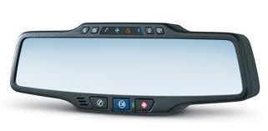

Figure 3-2 OnStar FMV mirror
Figure reprinted courtesy of MITO Corp.
Directus (whom was recently purchased by the Intraphex Corporation) has developed three mirrors which feature advanced electronics. The flagship Directus mirror features a 4.3" touch screen display. This display is primarily used for turn-by-turn navigation. The navigation electronics are contained entirely in the mirror in contrast to the OnStar mirror where navigation information is accomplished via a call center. Directus' flagship mirror is designed to be installed in large SUV's, trucks, and RV's as the mirror is physically large.
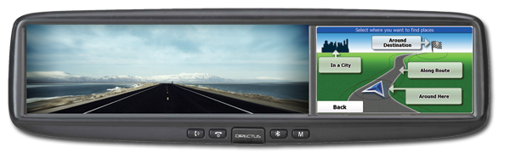

Figure 3-3 Directus TD43TOUCH mirror
Figure reprinted courtesy of Intraphex Corporation
The two other mirrors developed by Directus feature a smaller LCD incorporated into the mirror similar to the Gentex LCD mirrors. These two Directus mirrors are designed to be a direct replacement for the OEM mirror installed in an automobile. Like the Gentex LCD mirrors, the Directus mirrors are advertised as back-up camera mirrors. Directus offers additional connectivity in their TD43BT mirror. This device features Bluetooth communication and can be paired to a smart phone. This connectivity allows the mirror to display incoming call information on the LCD.
3.2 Display Technologies and Mirror Integration

In the past few years the amount of technology in automobiles has risen to an all-time high and is still rising. Year after year the MirrorMate Team noticed manufacturers constantly try to cram more devices, electronics, buttons, and whatever else car-bound gadgetry they can think of. Cars have been implemented with groundbreaking modern technology. This technology makes the interaction safer and easy to use not only between the driver and the vehicle, but the vehicle and the surrounding environment as well. The MirrorMate Team hopes to accomplish these goals with the electronic content the MirrorMate Team plans to incorporate within the rearview mirror.

Designing the rearview mirror as an electronic module for cars is not uncommon or unfamiliar to manufacturers. Companies like Gentex, Azentek, Directus, and Mito Corporation all specialize in devices which they call SmartMirror technology. However, SmartMirror technology is not used as much due to the fact that the same technology is more often integrated into a dashboard inbuilt system in most vehicles.

Experts would agree that the location in the dashboard would make more sense for several reasons. The most obvious practical advantage of an inbuilt system would be the large amount space the designer would have to work with to implement a display. There is less chance of theft to occur due to tedious task of disassembly. Car interiors look aesthetically pleasing without any additional devices protruding out of the dashboard or fixed to the windscreen. The system is also an integral part of a car’s infotainment system, with its hands-free voice command and feedback clear vocal instructions that give you GPS driving directions through the vehicles sound system.

While these features are impressive, a built in dash system is not without its cons. A few technical issues are maintenance, repair, or replacement. If something breaks, the arduous labor involved to fix or upgrade the in dash system could be expensive. Additionally, the system is not portable at all so it’s difficult to replace. Software will become quickly out of date, so it can be almost impossible to make updates. Since the screens are built in behind the dash, it cannot be moved around as easily to adjust it to the driver’s convenience.

Gentex believes that the mirror is a more ideal location for this technology. They say it is by far a much more cost-effective solution. It takes out the costly time consuming labor needed to redesign and improve upon a head ups display, control panel, or center console whenever a new feature is added to the vehicle. Reducing parts to components that can work with other advanced features can save cost, space and overall vehicle complexity. Being located higher has a greater vantage point for display in the driver’s line of sight. It is also an optimal location for antennas and receivers to send and receive signals. For safety reasons, looking at the rearview mirror requires minimal eye movement. A study was conducted by a Japanese Insurance Association comparing how frequently drivers view the rearview mirror as opposed to the center console. The results showed that drivers view rearview mirrors at least every 15 seconds, or 4 times per minute compared to the center console which was only view 3 times per minute. [2] If SmartMirrors were used more by electronic consumers, demand would be quite high. They would be quick to market and installation would be almost effortless which allows manufacturers to implement new features efficiently across any vehicle platform. The SmartMirrors can be accessed easily for maintenance and serviceability, making diagnostic performance less expensive. Also, with minimal installation and easy access, SmartMirrors are much easier to change out, replace, or update. This means that cars new and old alike can keep pace with today’s technology without having to buy a brand new car.

3.3 PAN Technologies

The MirrorMate device will feature RF communication. This will enable the mirror to communicate within the vehicle to other devices such as proximity sensors, OBDII readers, smart phones and tablets. It has been determined that Bluetooth is the best communications solution for MirrorMate, however many other PAN technologies were considered.

The IEEE 802.15.4 standard for personal area networks would be a viable communication standard for MirrorMate. This standard is also known by a few other names such as MiWi, Xbee, Zigbee. For clarity, 802.15.4 will be referred to as MiWi. This technology is emerging as an extremely popular wireless solution for electronic design. MiWi has many advantages and disadvantages when applied to MirrorMate. Currently, MiWi is somewhat proprietary as it is only able to communicate with other MiWi enabled devices. Smart phones do not currently contain the necessary hardware to communicate with MiWi devices. If MiWi was utilized for MirrorMate an external MiWi device would need to be connected to the smart phone. A MiWi smart phone accessory would be inconvenient for the end user as the accessory would make the phone bulky and the accessory could be easily lost or broken. Despite this major disadvantage, MiWi is extremely easy to implement in an embedded environment. There are many MiWi development kits and modules available which allows for quick and seamless integration into hardware. From a software point of view, MiWi is also much easier to implement than Bluetooth as the protocol is easier to interface. MiWi is also capable of communicating over longer distances and consuming less power than a similar Bluetooth module. However, MirrorMate would not benefit from conserving power as the mirror will be connected to vehicle power. Also, extended range is not necessary, and is discouraged as the device would only need to communicate in and around the vehicle. If MirrorMate had extended wireless range beyond the vehicle it could present a security risk. Though MiWi is a viable technology it is not the best solution for MirrorMate.

Infrared communication is also considered a PAN technology and has been implemented in many PAN enabled devices. MirrorMate will inherently contain infrared communication abilities for emergency vehicle detection and reduced speed zone correction. Utilizing this method of communication with other devices would save on the complexity and component count comprising MirrorMate’s main board. Infrared communication protocols are relatively simple compared to MiWi and Bluetooth so this would save on design time and software/firmware complexity. However, similar to MiWi an external infrared device connected to the smart phone would be required for communication to MirrorMate. Also, if proximity sensors are employed, they would have to be placed within 'line of sight' of MirrorMate's infrared sensors. It is apparent that infrared is not the ideal PAN technology for MirrorMate given the two major drawbacks.

3.4 Considered Technologies

3.4.1 Heads-Up Display

Depending on the direction the project was going; if during the research and testing, the MirrorMate Team realized that a heads-up display is feasible. The project would have moved forward to design a heads up display across the windscreen of the car. It would have included all the features that were hoped for in the MirrorMate rearview mirror display. The first consideration was to use a projector and place it either between the two front seats or facing forward on the dashboard and use a transparent film with a reflective surface. With more research it was found that buying this film or trying to fabricate it can be very costly. Instead of projectors, heads up displays are integrated with infrared cameras. However, infrared cameras are incredibly expensive and to build one would be a painstaking task of its own. General Motors has been working on heads-up displays since 1988, nearly 24 years. For the group to complete such a project within a year does not seem feasible.

3.4.2 Video Recording

The components and technology that will be featured in MirrorMate would be well suited to video recording applications. Internet media has frequently demonstrated the benefits of on-board cameras and recording devices in a vehicle. Many scams and dishonest activities have been thwarted on the roadways by proactive drivers with on-board cameras. Hit and run accidents can also be documented if an on-board camera is present. There are innumerable scenarios where a driver could protect themselves if their vehicle had a video recording device. Law enforcement agencies realize the importance of continuous video recording, and modern patrol cars feature a rearview mirror with video recording capabilities. The average driver could utilize the same benefits. MirrorMate would be an ideal device to feature video recording due to many applicable characteristics of a multi-media rearview mirror. MirrorMate has an advantageous viewpoint of the entire vehicle and the roadway as it is mounted high on the windshield. MirrorMate contains a microprocessor and data storage components which are necessary for video recording. Since MirrorMate will be powered by the vehicle's charging system, a large amount of power is available to MirrorMate so that it can record continuously even if the vehicle remains parked for extended periods of time. The microprocessor and related components consume minimal power relative to other components within a typical vehicle. Furthermore, the microprocessor firmware could be written to detect a low battery condition and cease recording to avoid a dead battery. Since MirrorMate will feature Bluetooth, additional cameras could be easily mounted in the vehicle at remote locations if additional camera views were desired. The video data could be streamed to MirrorMate via Bluetooth.

MirrorMate may be well suited to contain video recording features, however it would increase the cost, component count, development time, and require a more potent microprocessor. Video recording is a desirable feature, however due to the limited development time available and budget constraints, video recording is not feasible at this time. The microprocessor that will power MirrorMate does not contain the processing power necessary to encode a live video stream. Also, this encoding would greatly complicate the firmware resulting in a need for larger program memory in the microprocessor. In addition, external storage of the encoded video would require an SD card or some other form of storage. This increases component count, development time, and cost as this SD card has to be integrated and then interfaced to the microprocessor. Additionally, camera(s) must be added to MirrorMate increasing cost and the physical complexity of the system. Video recording will be considered as MirrorMate development continues. If budget and time constraints allow, this feature will be included in the MirrorMate system.

3.4.3 Speedometer

The MirrorMate Team came up with a great possible feature to be integrated into the rear view mirror. The idea was to display the vehicles’ speed on the rear view mirror.

The MirrorMate Team thought of two ways to integrate this. Since MirrorMate has an embedded LCD, displaying the vehicle speed would not be an issue. The first way is to connect to the onboard computer of the vehicle and grab the speed from there. The only plausible way of doing this would be through OBDII integration. One possible specific way would be to send the OBDII data over Bluetooth for the onboard microcontroller to decipher and display the speed. Unfortunately, connecting to a mobile device and an OBDII Bluetooth device would make this device more sophisticated than the Team wanted. The other approach would be to estimate the speed of the vehicle by taking samples of the current location of the vehicle. For example, if the mirror sampled the location every hour and the distance between the two samples was 25 miles, than the speed limit would be approximately 25 mph. Unfortunately, this would be an approximation and relative distance according to two points does not reflect actual distance traveled. Furthermore, the MirrorMate Team felt that it was not very practical. The driver can view the speed on the dashboard. It’s not critical for the driver to view the current speed in two different places. After considering the feature, the MirrorMate Team decided not to add the speedometer to the rear view mirror.

3.4.4 OBDII Integration

OBDII integration into MirrorMate was one considered technology. The OBDII onboard computer on a vehicle can keep track of many things including but not limited to, fuel consumption, throttle position, RPM, GPS location and any engine malfunctions that may be occurring. The original idea was to display basic statistics on the mirror while the vehicle was on. If any engine malfunctions occurred, such as a check engine light triggered, the MirrorMate would display this warning to alert the driver. A database would be stored on the MirrorMate that would cross reference the code to common possible reasons as to why the vehicle had a malfunction. While the MirrorMate Team was researching this possible feature, the Team found a company called Rev by DevToaster that designs similar technologies. Rev designed a product called the KwiwWifi adapter. This adapter plugs into your OBDII connector usually below your steering wheel and transmits the data over Wi-Fi. A mobile device, with the installed app, then can read and compute the data to display to the user. After careful consideration of time, resources and priorities, the MirrorMate Team decided not to integrate this functionality at this moment.
3.4.5 Blind Spot Sensors

The MirrorMate Team gave much consideration to incorporating a receiver signal into the rearview mirror. This would display a notification that a vehicle has been detected on the left or right side of the car using an automotive ultrasonic range sensor. Most automobiles use a Bosch automotive ultrasonic sensor. (See Figure 3-5 below)

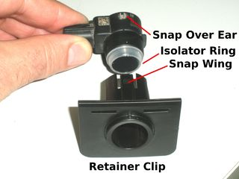
Figure 3-4 Bosch Automotive Ultrasonic Sensor

This is a very common sensor that can be found in any junkyard in GM or Chrysler vehicles manufactured since 2006. Or for an easier solution the MirrorMate Team considered getting the same type of sensor made Maxbotix that can be found on sparkfun.com for a fairly low price. (See Figure 3-6 below) The MirrorMate Team felt that the sensor would be viable application to the rearview mirror.
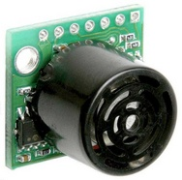
Figure 3-5 Maxbotix Ultrasonic Range Finder Sensor
Image courtesy of Sparkfun

There are many advantages to using an ultrasonic range sensor. The list that follows describes some of them.
- Easily detect objects within a two meter range.
- Detect multiple objects within the sensor's field of view. This particular sensor returns all echoes after a ping event.
- No analog signals are used between the control module and sensors. The sensors are all digital. The first generation automotive sensors were analog and had many problems.
- Water proof. Both the sensor and the connector are completely water proof, being inside a vehicle fascia.
- Short circuit proof. The IO pins can be shorted to battery, or ground, or in any combination without harm to the sensor. This includes reverse battery and double (24 Volts) battery connections.
- EMI (electromagnetic interference) resistant. The sensor is capable of both being resistant to EMI interference and resistant to generating EMI noise. The EMI tests take weeks.
- Hardened. The face of the sensor is electro primed and painted solid aluminum. The rest of the sensor is plastic with the electronics rubber potted.
- Shock Proof. Each of the sensor pin is tested during EMC (electromagnetic compatibility) testing to verify it can survive a high voltage discharge 15kV
- Temperature proof. Tested from -40 degrees C to +85 C
- Expandable. Multiple sensors can easily be used to cover any portion of 360 degrees. As an example, it would be easy to use eight sensors on a robot where the sensors were placed at 45 degree increments around a circle. The robot could then have a complete 360 degree view with no moving parts!
- Fast. One ping out two meters and back takes just under 50ms (milliseconds).
- Smart. A sensor can be commanded to generate a ping or, instead, to simply listen. Using a pinging sensor and one, or more, listening sensors tricks can be done to detect additional very close objects.
- Low Power. A sensor only draws about 20 to 25mA. About the same amount of energy used to light a standard LED.
The MirrorMate Team has not completely ruled out the option of implementing the blind spot sensor into the rearview mirror, however the MirrorMate Team would care to see main objectives for hardware and software specifications implemented first before attempting to work on any additional tasks to improve the project.

3.4.6 IR Beacon Weatherproofing and Remote Configuration

The reduced speed zone beacon, as a final production device will be deployed into harsh environments. The device could be mounted to a construction barricade outdoors in the elements or onto a sign post in a permanent location such as a school zone. This would require the beacon to be weatherproof and resistant to elemental forces such as UV light from the sun.

If the beacon is to be used in a construction environment it was considered that a special 'construction edition' beacon be created that is much more resilient to vibrations, harsh impacts, and generally of a more robust design than most electronic components. This beacon requires a connector for power connections. This interconnect would require a MIL spec connector for waterproofing and durability. Military spec connectors are resilient to many connection/disconnection cycles which would be encountered in the construction environment. The circuit board and all components would be encased in potting compound for reliability. The IR emitters would also be recessed in the face of the unit to reduce the chance of damaging the components. The construction edition version of the beacon would not feature any buttons or switches as these would be a fragile point of failure for something in the construction environment. Instead, the device would be configured remotely as discussed in the next paragraph. The power supply in the construction edition beacon would also feature over voltage protection.

Since the IR beacon will feature IR communication components it would be expected that the device could be remotely configured via an IR remote control. This feature would allow permanently mounted devices to be configured easily and remotely from the comfort of a car or office. If the beacon is permanently mounted in a high location this would be the only efficient way to configure the beacon. Also, if multiple beacons are necessary for a construction zone, multiple beacons could be configured at once via the IR remote. The beacons could also be configured to communicate amongst themselves to share settings. For instance in a construction zone one beacon could be configured manually, and all other beacons in range would 'see' this and adopt the first beacon's configuration.

While the reduced speed zone beacon lends itself to weatherproofing and remote configuration abilities, this would increase development time and component costs. The beacon is also not the primary feature of this project. These attributes will be considered as the project progresses and if time and funds are available.

3.5 Mobile Development

3.5.1 Software Architecture Possibilities

The MirrorMate Team sifted through many possible software languages. The Team needed a powerful language that supported the mobile environment. Some languages that were considered included Flash ActionScript, C++, C#, Java and even a web app builder called Ruby on Rails. The MirrorMate Team’s final decision was to use Java as the development language.

3.5.1.1 ActionScript and Flex

The first software language considered was ActionScript. ActionScript is a powerful object oriented scripting language similar to JavaScript. ActionScript 3 works with the Adobe Flash Player but will work with the Adobe AIR runtime. Flex is an open source framework built for deploying consistent applications across multiple platforms. Flex works great for deploying mobile applications that need to work on all platforms including but not limited to Blackberry, iPhone, Windows and Android platforms. One of the MirrorMate Team members had brief exposure to ActionScript at an internship. It was explained that ActionScript was used to build mobile applications for IOS. Currently, there’s an application called RocketScience101 available for the iPad that was built using ActionScript and the Flex library. With this knowledge, the MirrorMate Team knew it was possible to build the MirrorMate Android app. Since a member had knowledge of ActionScript, this was one of the main reasons this language was considered. Another benefit of ActionScript was the ability to make animations using the Deco tool. This tool gives you the ability to animate any object. The MirrorMate app would be able to easily incorporate beautiful elegant animations. This is another main benefit to using ActionScript. Unfortunately, the detriments outweighed the benefits. The major detriment to using ActionScript is the fact that the MirrorMate Team would need to use the Adobe IDE to develop. The Adobe Suite 6 currently retails for $2,599 [3]. This suite is the only suite that includes the Flash Builder software needed to develop ActionScript Flash code. Furthermore, the MirrorMate Team currently doesn’t have a lot of knowledge in software development. ActionScript support on the internet and in print is not as abundant as other programming languages. In the end, MirrorMate decided not to go with ActionScript.

3.5.1.2 C++ and C#

Another software language considered was C++. C++ is a version of the C programming language with the addition of classes and other object oriented properties. This language was briefly considered for developing the MirrorMate Android application but the Team found very little support. Java and Flex had a lot of community help on Stack Overflow compared to C++. Another variety of the c programming language is C#. C# is another object oriented variation of C. The key features the MirrorMate Team liked were interoperability, scalability and simplicity. Unfortunately, just like C++, there was not as much support compared to other programming languages. While looking into C mobile applications though, the Team found a software company called Xamarin. Xamarin assists in cross platform development in C#. Xamarin claims that the code is compiled in the native binary. This enables for high performance cross platform apps. This would be a great feature if the MirrorMate Team decides to develop the software for multiple platforms. Unfortunately, this software is not free.

3.5.1.3 Java

The final programming language considered for MirrorMate was Java. Java offered the same benefits when it came to being object oriented, but offered immense community help for developing on the mobile side. Furthermore, the IDE, eclipse, was free to use. The MirrorMate Team didn’t need to spend any extra money to begin developing.

3.5.2 Mobile Device Platforms

The MirrorMate system is designed to be used with an accompanied mobile application in order to utilize all of the features of the MirrorMate mirror. The navigation and map systems require a smart phone, tablet, or mobile device to access that can communicate with the mirror through Bluetooth.

Three mobile operating systems were researched for use in the MirrorMate app based on the devices member’s of the MirrorMate Team use in their day to day lives. The top three that were considered were the Windows Phone, Apple’s iOS and the open-source Android Operating System for a number of reasons, most of which are detailed below. After a thorough investigation it was decided to use the Android OS in order to maximize the number of potential users that the MirrorMate system could reach. Research in Motion (RIM) is the OS that Blackberry devices are used with. RIM is a major player in the mobile device market, but no members of the MirrorMate Team use a Blackberry currently, meaning another device would have needed to be bought or borrowed to test the system.

The graph below represent market share of mobile devices based on operating systems in Quarter 3 of 2012.

Figure 3-6 Mobile Devices Market Share

3.5.2.1 Windows Phone

The Windows Phone Store requires a developer to be registered with Microsoft and pay an annual $99 subscription fee to submit applications to the store. The MirrorMate app was intended to be free software included with the MirrorMate system but the Windows Phone development process still requires a developer to both subscribe and send the app to Microsoft for verification before inclusion in the Windows Phone store. This entry fee along with the extremely small market space that the Windows Phone currently possesses made developing for this OS an unlikely feature.

3.5.2.2 Apple iOS
Similar to the Windows development method, Apple also requires a developer to pay a $99 registration fee to be eligible to distribute the app to any mobile device including their own test device. Apple’s SDK for mobile development, Xcode, is available for a free download to users of the Apple OS; however no members of the MirrorMate Team use an Apple as their main computer, which would also add to the difficulty of development as Xcode is not designed to run in a Windows environment. All iOS apps must be acquired from the iTunes App Store which must first verify each developer’s submission. This process can be time extensive as Apple reviews each App thoroughly to ensure that duplicate and low quality apps are not available in their store. While the MirrorMate Team has previous experience developing for the iOS, these monetary barriers to entry and possible timeline delays made the iOS a less appealing option.

3.5.2.3 Android OS

The Android operating system is an open-source Linux code base. Applications written for the Android OS can be distributed free of charge by any third-party developer using either Google Play or any third party download site. The Android SDK uses Java as the main programming language, and can be downloaded free of charge on any computer. Multiple members of the MirrorMate Team have developed using Java in the past and the adjustments to make use of the additional features of a mobile device were not considered a hassle. Additionally developing for Android, which is owned by Google and fully open-sourced allows for the easy integration of the Google Maps code base which was intended to be utilized for the navigational features.

The ease of access to developer’s tools for Android as well as the large market share advantage they possess made Android the obvious first choice for development of the MirrorMate application.

3.6 Infrared Communication

3.6.1 The Opticom System

Many emergency vehicles such as patrol cars, fire trucks, and ambulances feature an optical infrared communication system called Opticom. This system is designed to trigger traffic lights and enable emergency vehicles to maneuver through traffic quickly. This expedites travel time to the source of the emergency. This system provides an additional safety feature ensuring that the emergency vehicle is able to navigate intersections with no other vehicles present in the intersection. The infrared emitter installed on the emergency vehicle consists of an array of infrared LED's and a control module. This emitter is typically included in the light bar mounted on the roof of the emergency vehicle, or mounted behind the windshield.
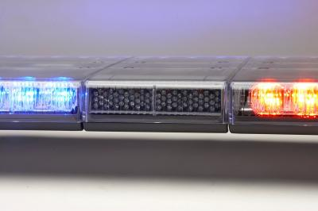
2 ft.

Figure 3-7 Whelen light bar featuring a GTT 795H emitter in the center
Image courtesy of Whelen

The Opticom detector module is mounted on the traffic light and features infrared receiver electronics and directional optics. Typically, multiple receivers are mounted on the traffic signal to determine which direction the emergency vehicle is approaching from. A control module is also necessary to determine direction and authenticate the emergency vehicle with the traffic light.
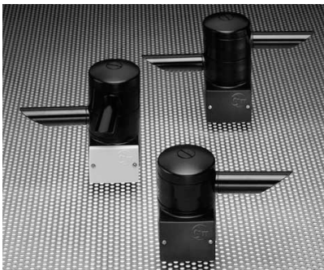

4 inches

Figure 3-8 GTT 700 Series Detectors
Image courtesy of GTT

According to documentation from GTT regarding their 700 series emitters and detectors, the Opticom system has a range of 2,500 feet. The flash rate of the LED's is 14Hz for high priority vehicles (emergency vehicles) and 10Hz for low priority vehicles (buses). The Opticom system also features encoded data for vehicle identification and authentication purposes (10,000 different codes are available). This is to avoid false traffic light preemption due to nefarious devices.

Utilizing the Opticom system for enhanced driver awareness and safety is an obvious path in which to pursue new features in vehicle electronics. The infrastructure required to implement emergency vehicle detection currently exists as the necessary infrared emitters are installed on most emergency vehicle. Other than the actual MirrorMate device no additional devices or infrastructure will have to be installed or implemented for emergency vehicle detection. MirrorMate will be designed to detect the 14Hz flash rate of high priority vehicles only. MirrorMate will not decode the vehicle identification codes from this band of infrared as the codes are not provided by the city to prevent the use of nefarious devices. Also decoding this information is not necessary for MirrorMate to properly detect the 14Hz carrier signal. Since infrared is directional MirrorMate will be able to determine from which direction the emergency vehicle is approaching, and alert the driver.

3.6.2 Infrared Beacons

MirrorMate will feature reduced speed zone detection such as school zones and construction zones. Similar to the Opticom system, this detection will be accomplished via infrared communication. This will require that one or more beacons be placed at the reduced speed zones. It has been determined in order to properly populate a reduced speed zone a beacon will be necessary at each end of the zone. If the zone extends for more than 1600 feet, an additional beacon must be placed every 800 feet which is the anticipated maximum reliable communication distance of the beacon. Research indicates that Infrared communication is the ideal medium for reduced speed zone detection as infrared communication protocols are well understood, simple to interface, and the beacons could be produced cheaply which will allow schools and construction zones to implement the beacons easily. Infrared communication is directional which is a benefit as MirrorMate will be able to determine which direction the reduced speed zone is located relative to vehicle travel. Light produced in the infrared spectrum is pervasive and easily detected at long distances. Radio communication initially appears to be the best choice for reduced speed zone beacons, however RF presents many disadvantages such as high power consumption of the radio to transmit the distances required by the beacon, and RF is not directional so it would be difficult for MirrorMate to inform the driver of which direction the reduced speed zone is located.

Information was obtained regarding long distance infrared communication devices. There are examples of devices other than Opticom that communicate via infrared over long distances. Both MyChron and XT Racing lap timers utilize moderate to high powered infrared emitters to achieve accurate lap timing for motorcycle racing, go-karts, and snowmobiles. The lap timer beacons are capable of triggering the timers at distances of several hundred feet and at a wide vertical angle relative to the beacon. The lap timer beacons contain several IR emitters (usually less than ten). Typically, different types of emitters are used which allow the beacon to create multiple beam patterns such as a very intense 15° beam from some of the emitters, or a less intense wide range 45° beam pattern. None of these beacons contain any optics to focus the infrared signal.
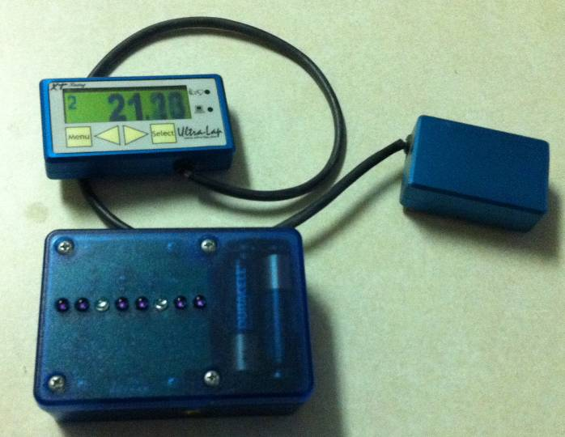

Figure 3-9 XT Racing Ultra Lap and beacon

These lap timer beacons communicate over the 38kHz IR band. The wavelength of light produced by the emitters is 950nm which was determined experimentally. This frequency and wavelength is commonly used for TV remotes and other devices which utilize infrared to communicate.

3.6.3 Signal Encoding, IR Range and Transmitter/Receiver Design

Similar to the lap timer beacons, 38kHz 950nm IR communication was determined to be the best option. IR decoders are readily available for devices utilizing this spectrum of communication which will save on development time and component count as a discrete decoder will not need to be designed.

The reduced speed zone beacons will encode some information onto the 38kHz carrier signal so that MirrorMate can determine what type of reduced speed zone the vehicle is approaching, and the posted speed limit of the zone. MirrorMate can then alert the driver of upcoming reduced speed zones and if they are speeding. This information will be encoded utilizing the RC-5 remote control protocol or similar communications standard. The RC-5 protocol was chosen as an ideal communications standard as the protocol is well documented and firmware code libraries are readily available. This is to save development time. The data transmitted will not follow any known electronics manufacturer's remote codes so that MirrorMate cannot be triggered by any TV or consumer electronics remote. The beacon will feature a user friendly method to set the zone speed and zone type. The beacon will confirm the set speed via seven segment displays located on the back of the unit. This beacon design maximizes usability and cost tradeoffs.

The reduced speed zone beacon must communicate with MirrorMate at long enough distances to provide the driver ample time to react. Distances of 1500 ft are expected to be achieved. Beacon design will include an array of high-power IR emitters. Osram's SFH 4547 LED emitters have been identified as a possible choice for the beacon. These emitters feature a maximum forward current of 1 amp at 100 µs pulses. These emitters are also relatively inexpensive compared to some of the other high power emitters available. Current research indicates multiple emitters must be configured in an array so that long communication distances can be achieved. It is anticipated between 10 and 20 emitters will be necessary for long range communication. Complex optics are to be avoided due to the resulting increase in development time. Complex optics will also increase the size of the infrared detecting system inside MirrorMate where minimal component size is required. Therefore a high power emitter array is the ideal solution for the reduced speed zone beacon.

It is anticipated the reduced speed zone beacon will be physically similar in size to the lap timer beacon shown in figure 3-9. This size will be easy to implement and provide enough space to accommodate the infrared emitter array and controlling components. This size will allow for easy utilization at the reduced speed zone. Research has shown that provisions to mount the beacon on a construction zone barricade or traffic sign post would be beneficial as the beacon may be permanently mounted at some locations.

The electrical design of the beacon will feature a low power microcontroller and some simple electronics to control the seven segment displays and IR emitters. Considerations for wireless configuration of speed and zone type are being considered (meaning if the beacon is permanently mounted, officials can configure the beacon remotely). The beacon will require 9V to 28V input power due to utilizing a LM7805 voltage regulator. The beacon will draw significant amounts of current due to the quantity of high power LED emitters. Due to the power consumption of the emitters, the beacon will require a large battery, construction vehicle power, or mains power. This is not anticipated as a problem because these sources of power are common throughout construction and other reduced speed zones.

3.6.4 Safety Operations for the High Output SFH4547

MirrorMate will be using high output infrared emitters to transmit the IR signal to the beacon. Depending on the configuration, these infrared emitters have the possibility of producing unsafe products that do not follow the IEC 60825-1 and IEC 62471 standards. The MirrorMate Team will limit the emitters to a low current to prevent any un-safe conditions. Each safety standard needs to be followed. The two standards are outlined below.

IEC 60825-1
The IEC 60825-1 Standard was created to provide safe laser products to consumers. The MirrorMate Team needs to take into consideration safety before anything else. With that, the IEC 60825-1 Standard has four classes, with each possibly having subclasses. The bullets below outline the different classes and subclasses according to the IEC 60825-1 standard:

- Class 1: These lasers are safe under any normal and reasonable condition. This also includes the use of optical instruments.
- Class 1M: Lasers with this class are safe under reasonable conditions, but may pose a risk if optics are used within the beam.
- Class 2: Lasers with this class are still considered safe because of the blink reflex. This also includes the use of optical instruments.
- Class 2M: Lasers with this class are still considered safe due to the blink reflex, but risks due apply if optical instruments are used.
- Class 3R: Risk is lower than Class 3B lasers, but the emissions must be within five times the acceptable emissions limit of Class 2 within the wavelength range of 400 nm to 700 nm. If they don’t fall in this range, the emissions must fall within five times the acceptable emissions limit of Class 1.
- Class 3B: Lasers with Class 3B are normally dangerous and hazardous when viewed directly.
- Class 4: Lasers with a Class 4 are the most dangerous. These lasers are capable of hazardous reflections. They may also cause skin damage, or even fire. The use of these lasers requires extreme caution.

The MirrorMate Team will have a primary goal not to produce any lasers, in the visible and non-visible spectrum more than a Class 2 standard.

IEC 62471
The IEC 62471 Standard is guidance for evaluating the safety of light emitting lamps and diodes, but specifically excluding lasers. The primary goal of this standard is to identify any products that pose a photobiological hazard. The requirements are met by this standard by meeting the following requirements. [4]

- an actinic ultraviolet hazard (Es) within 8-hours exposure (30000 s), nor
- a near-UV hazard (EUVA) within 1000 s, (about 16 min) nor a retinal blue-light hazard (LB) within 10000 s (about 2,8 h), nor
- a retinal thermal hazard (LR) within 10 s, nor
- an infrared radiation hazard for the eye (EIR) within 1000 s.

In order to measure the intensity of the MirrorMate IR LED’s further equipment is required. The Team will attempt to work with the University of Central Florida and any other possible sponsors to make sure MirrorMate does not produce any damaging products to the user and creator. Some of the required measuring equipment is shown in the below bulleted points

- Luminance Meter
- Monochromator
- Spectroradiometer
- Retina Radiance Meter

3.7 Hardware Interface Development

3.7.1 Hardware Interface Possibilities

The MirrorMate Team looked through many data sheets and parts lists just to find the right components such as microcontrollers, sensors, LCD displays, controller chips, and Bluetooth modules, but these components wouldn’t be as useful unless it has the proper interface to tie them all together so that all the functions can be displayed on LCD display. There were several possibilities for interfacing a microcontroller to an LCD display. A particular configuration met the MirrorMate Team’s specifications, functioned more efficiently and was more cost effective toward implementation in the MirrorMate. The following discusses possible factors considered to make a good interfacing for the microcontroller to the LCD, including operational amplifiers, and on-chip peripherals that can be used for display application.

3.7.1.1 Microcontroller Interfacing

A key feature when selecting a microcontroller for TFT interfacing is the DMA (Direct Memory Access) and the PMP (Parallel Master Port). The DMA is multi-channel and flexible especially when it comes to moving data between pages, character generating and rendering tables, animations and video. A preprogrammed and autonomous DMA functionality will allow the MirrorMate’s display to refresh while the core microcontroller goes to sleep. This power-reducing feature that can be very useful in certain power saving applications. The PMP is a module specifically designed to communicate with the LCD display as well as other communication peripherals.

The MirrorMate Team took into consideration which LCD displays to feature. Whether to go with a smart serial interface LCD or a non-serial interface LCD. If a serial interface is unavailable or infeasible, an LCD display may require interfacing to the microcontroller. This may be accomplished directly with the microcontroller or with an external graphics controller device. A serial LCD would not be required to interface this way since the LCD establishes communication when it is connected to microcontroller’s serial UART (Universal Asynchronous Receiver/Transmitter) port and by using ASCII commands. The commands send RS232 serial data to the LCD in order to interpret and display what is necessary.

Since the MirrorMate device was fairly small and being built from scratch, designing a PCB layout is critical since the primary interface lies in drivers for the thin film transistors. The stable common voltage reference to which all pixels are referenced is key. This is called V_{COM} and several discrete and integrated solutions for generating a V_{COM} signal are available. An effective solution would be to use an operational amplifier. The MirrorMate Team considered using a National Semiconductor LMH6640MF/NOPB made by Texas Instruments (as shown in Figure 3-10) which is a rail-to-rail voltage feedback that can operate up to 16 volts, has a high output of up to 100 mA. This amplifier is optimized for TFT transistor driving. The fast 170 V/µS slew rate yields a 28 MHz full power bandwidth at 5 volts and its small SOT-23 package can be fit into tight spaces in the back of the rearview mirror. Figure 3-11 conveys how the circuit would have to be wired for the operational amplifier to operate at up to 16 volts.
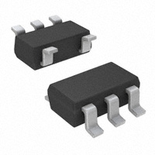
Figure 3-10 LMH6640MF/NOPB Operational Amplifier
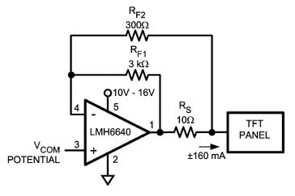
Figure 3-11 VCOM levels

A stable VCOM level is necessary for a clear display. Note the ground reference which is usually VCC/2.
The larger the panel, the more current will be required to operate the transistors. For larger panels, another Op-Amp contender is the MAX9550EZK+T made by Maxim Integrated, which can drive up to 800 ma peaks up to 20 volts. It settles to within 0.1 percent in less than 2 µSec and features a soft start circuit to limit inrush current during startup. Note that the V_{COM} level is usually set between the upper voltage level and ground instead of being set to ground. This allows full scale alternating polarity to be driven to the pixels without the need for a negative power supply.

Also, the V_{COM} function and all its subtleties are often times integrated into more encompassing TFT driver chips like Texas Instruments’ LM8207MT/NOPB which combines an 18 channel gamma corrected driver with V_{COM} referencing buffer as you can see Figure 3-13. Note that the built-in V_{COM} buffer will allow a buffer tree to be created from a single reference for larger displays.
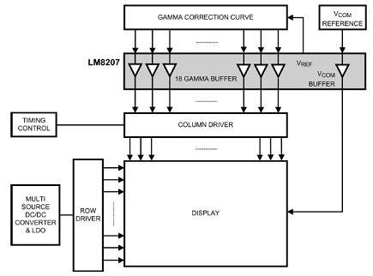
Figure 3-12 VCOM Buffers

It is possible to use space saving integrated parts that combine V_{COM} buffers, references, column drivers, and gamma correctors.
3.7.1.2 TFT Controller Chip Interface (On-Chip Peripheral)
One approach that the MirrorMate Team considered to drive a TFT display without using a high end processor was to use a discrete TFT controller chip. The TFT controller chip can be interfaced to a processor with less horsepower. Taking that into consideration, the MirrorMate Team has considered implementing an Intersil TW8811-LD2-GR TFT controller chip which displayed below in Figure 3-13 along with a schematic drawing of the chip in Figure 3-14. Figure 3-15 conveys the embedded design of the TW8811-LD2-GR TFT controller chip.
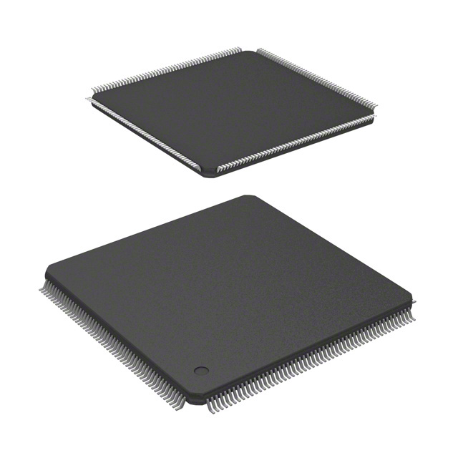
Figure 3-13 TW8811-LD2-GR TFT controller chip
Image reprinted courtesy of Digikey

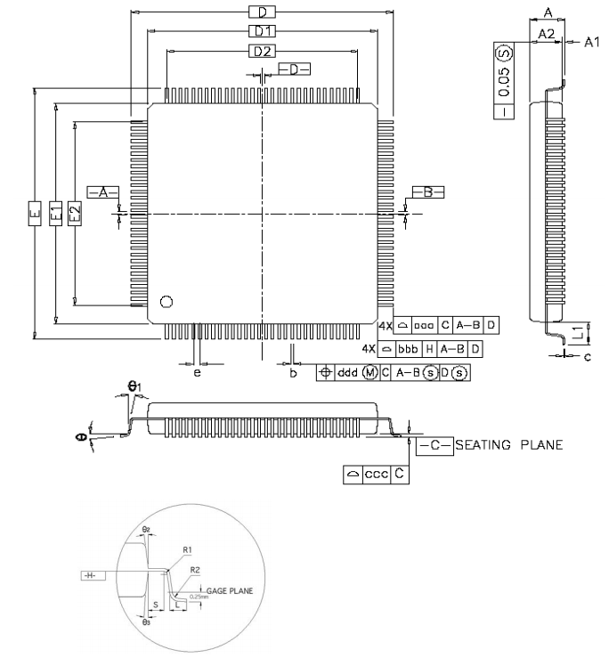
Figure 3-15 TW8811-LD2-GR TFT controller chip schematic
Image reprinted courtesy of Digikey
This is a highly integrated TFT controller chip from Intersil that combines analog and digital video in and out and also has TFT control.

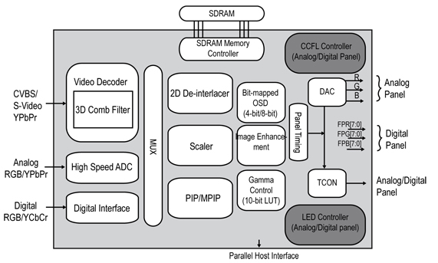
Figure 3-16 TFT Controller Chip
Image reprinted courtesy of Digikey
The TW8811 is perfect for automotive applications, combining control and even video standard (analog, RGB, S-Video, NTSC, PAL, and Secam) integration into a single chip controller. Supporting several different video sources it ties together all these applications to allow the same display to be used for navigation systems, engine displays, environmental control, vehicle entertainment systems, and even backup cameras. The on-chip SDRAM interface provides the depth and cost-effective performance needed for displays up to WXGA (Wide Extended Graphics Array) resolution which is an aspect ratio of 1280 x 800. MirrorMate’s resolution only needs to be up to 400x240. The size of the controller chip itself is no more than just over an inch², and the –40 to +85 degree temperature range makes this usable for a variety of harsh environment applications.
If a single microcontroller can perform the task at hand while also controlling the embedded system for interfacing with the display, this would probably be the most cost-effective solution. Most people will use a TFT module which already houses the V_{COM}, gamma correction, and TFT transistor drivers. As a result, the interface to the module is TTL, CMOS, or Low Voltage Differential Signaling (LVDS).
This is a fall back decision made by the MirrorMate Team to see if the TFT design tasks are capable of being done in a reasonable amount of time, looking at chips strictly with display design solutions. These would be more of the higher-end, 32-bit, RISC-type processor architectures with streamlined peripherals and resources that handle both display-oriented and non-display-oriented functions such as communications, sensor interfacing.
Not every processor needs to have a dedicated TFT interface to make it a viable candidate. The TI TMS470R1B1MPGEA for one is a RISC-based 60 MHz ARM7 processor that can easily interface to a majority of TFT modules that are driven via a digital interface. While some modules need constant refreshing, others can be loaded with display data and generate all the timing and display data movement internally unburdening the host CPU. The CPU must be fast enough to keep up with any animations or video if this is the case.

4.0 Hardware and Software Design Details

4.1 Packaging and Physical Design Considerations

The MirrorMate prototype will be built into an existing automotive rearview mirror with typical dimensions. Any electronic components present in the mirror will be removed and replaced by MirrorMate components. The mirror enclosure will not be significantly modified externally to ensure an attractive finish, as well as proper fitment in the vehicle. MirrorMate will feature standard automotive rearview mirror mounting locations and hardware to ensure compatibility with any vehicle. MirrorMate is a self-contained device to simplify the installation process and ensure ease of use. All components must fit within the existing mirror's enclosure. This places many design constraints on the electronic components. A printed circuit board will be designed which fits entirely inside the mirror behind the glass, and utilizes as many of the original mounting locations inside the mirror as possible. Due to high temperatures and environmental extremes inside a vehicle, components will be selected that are rated for automotive use, or are designed for high temperatures and harsh environments.

MirrorMate will feature a color graphics LCD to convey information to the driver and this must be integrated behind the mirror glass. The LCD will be a 2.6" display as this was determined to be the largest display to fit properly behind the mirror glass. A 2.6" display is also a common size and readily available. The display will be located as far to the driver's side of the mirror as possible. This is to ensure the information is easily conveyed to the driver while still allowing full use of the rearview mirror. The display will be mounted behind the mirror glass using custom brackets.

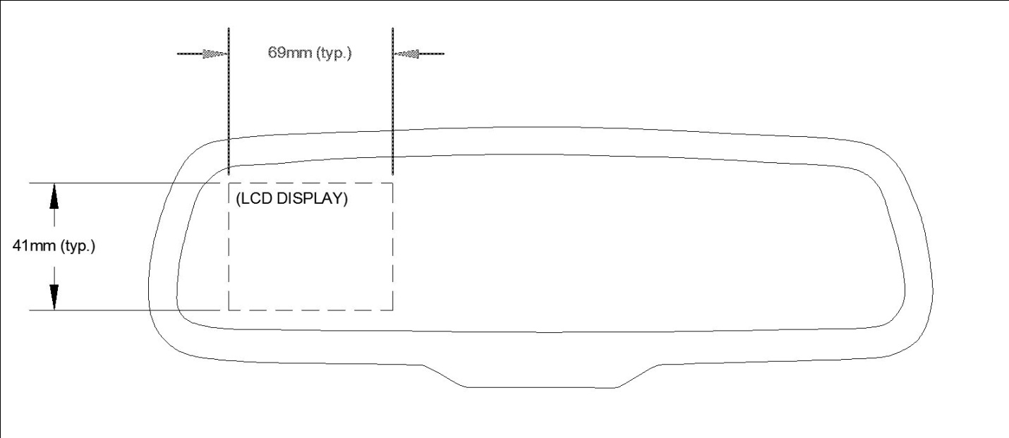

Figure 4-1 LCD Location
MirrorMate's infrared receivers will be located in a low profile housing mounted to the bottom of the mirror. This housing will be unobtrusive and transparent to the driver. This is similar to many existing BMW mirrors. Within the infrared housing, 4 directional 'blinders' will be utilized so that MirrorMate can determine from which direction the signal is detected. The infrared detectors will connect to the PCB via wires.

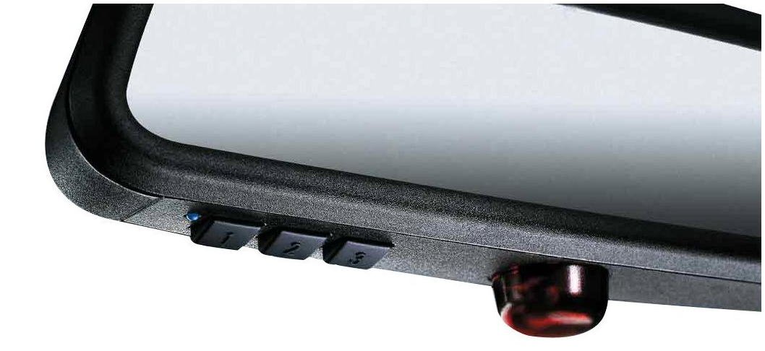

Figure 4-2 BMW rearview mirror with IR
Image reprinted courtesy of BMW

MirrorMate features PAN communication (Bluetooth) so that the number of physical wires required to connect MirrorMate to the vehicle will be minimal. Only two wires are necessary to connect MirrorMate to the vehicle's 12 VDC charging system. This is to ensure simplicity in installation for the end user. These wires will exit the back of the mirror and can be neatly routed inside the vehicle's head liner. Connectivity to MirrorMate's peripherals (smart phones, proximity sensing, OBDII readers) within the vehicle is accomplished via Bluetooth to ensure ease of installation and future expandability. The Bluetooth antenna is built into the module so that no external antennas are necessary.

4.2 MirrorMate System Overview

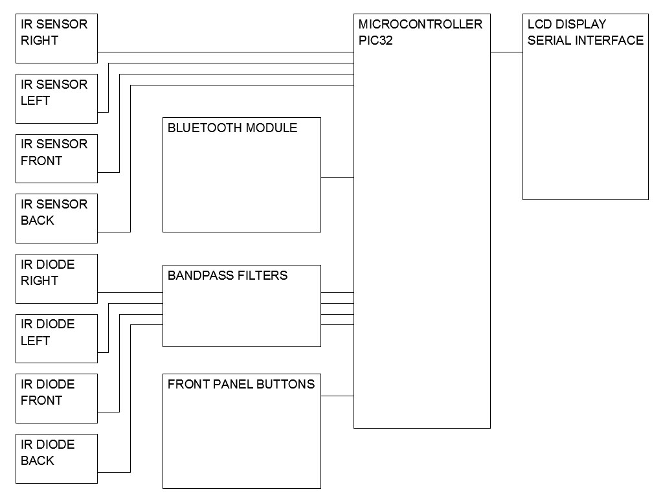

Figure 4-3 MirrorMate System Overview

The image below is a representation of some information that MirrorMate will convey to the driver.
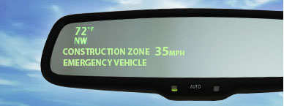

Figure 4-4 MirrorMate Representation
4.3 Microprocessor

The microprocessor featured in MirrorMate will be a PIC microcontroller from Microchip. The Pic32 architecture will be utilized as these devices feature high speed CPUs and many advanced peripherals necessary for MirrorMate. More specifically the PIC32MX340F512H device will be at the heart of MirrorMate. This microprocessor features two UARTs. Two UARTs are necessary as one will be utilized to communicate with the Bluetooth module and the other will be used to send video data to the smart LCD module. Onboard IrDA encoding/decoding is featured on this chip and will be utilized to detect the 14Hz signal from the Opticom beacon. The PIC32MX340 device also features a 4 channel DMA and a parallel (PMP) port. If a 'smart' serial interface LCD is unavailable or infeasible, an LCD display may require interfacing to the microcontroller. This may be accomplished directly with the microcontroller or with an external graphics controller device. Both of these methods require the use of DMA channels and PMP ports. The TQFP package will be implemented as soldering of the TQFP is significantly easier than QFN devices.

The figure below details some of the most important feature of the PIC32 microcontroller.

PIC32MX340F512H Key Features
Feature | Value
Max CPU speed | 80 MHz
Internal Oscillator | 8 MHz
Program Memory | 512 KB
Ram | 32 KB
Operating Voltage | 2.3V - 3.6V
DMA Channels | 4
Parallel Port | PMP
UART (featuring IrDA, RS232, SPI, I₂C) | 2
High current sink/source from all I/O pins | 18mA
Real-Time Clock and Calendar | Yes
Packages available | TQFP, QFN

Figure 4-5 PIC32MX340F512H Key Features

4.4 Power Supply

MirrorMate contains many sensitive electronic components which have very specific power requirements. Clean, regulated 3.3VDC is specifically required by the LCD display, microcontroller, and Bluetooth module. The infrared receivers have a wide voltage range and will operate at 3.3V. The remaining passive components and status LED's will also be powered by the 3.3V supply. Therefore only 3.3V will be needed internally by MirrorMate. Since every component in MirrorMate will be utilizing the 3.3V rail, significant current is required from the power supply. An estimate of current requirements is detailed below:

Component | Estimated Current Requirement
Microcontroller | 10mA at 80mHz
IR receivers (4) | 4 X 3mA = 12mA
IR diodes and filters | 10mA
LCD | 90mA
Bluetooth Module | 100mA (transmit)
TOTAL: | 222mA

Table 4-6 MirrorMate Current Requirements

The estimated current required of the 3.3V power supply is 222mA. However, a margin of safety will be included into the power supply design to ensure ample power is available if additional features are added in the development phase. A LM1085 low drop out regulator from Texas Instruments will be at the heart of the power supply. This device is capable of supplying 3A of current at 3.3V with the appropriate heat sink attached. This device was chosen because it is simple to implement and provides extremely stable power. The LM1085 does not require many external components in contrast to small switching power supplies which require external inductors or transformers and create a noisy environment that must be filtered out. This linear regulator contains many safety features that are useful to MirrorMate's design. The LM1085 device features internal current limiting, power dissipation, and thermal overload protection. This will ensure a failure of the power supply is an extremely rare event. The LM1085 has a large voltage input range (4.8V to 27V). This allows for flexibility and stability when installed in the vehicle as the vehicles charging system is able to fluctuate without damaging MirrorMate. Lastly, the specification sheet for the LM1085 advertises that the device is applicable to microprocessor supply, which is how the device will be applied in MirrorMate's case.

Design of the power supply is shown in Figure 4-7. A reverse polarity protection diode will be included in the design as the LM1085 does not provide any protection for reverse polarity. A 100µF 25V automotive rated capacitor is utilized to dampen any significant changes in voltage from the vehicles charging system. The LM1085 requires two 10µF capacitors which will be placed in close proximity to the regulator on the PCB.

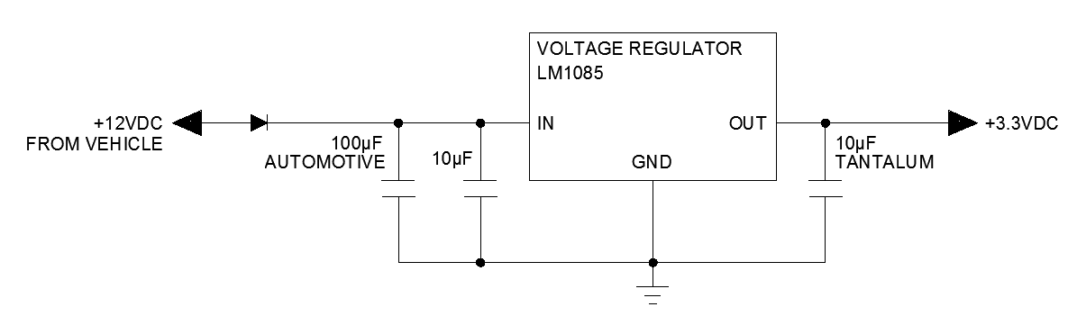

Figure 4-7 MirrorMate Power Supply

4.5 Display Technologies and Interfacing

The following section is a discussion of the factors necessary to create a proper interface between the microcontroller and the visual display system in the MirrorMate. This section will be covering display function goals, required display technology and comparisons.

4.5.1 Display Function Goals

The most crucial task on the MirrorMate Team’s agenda is being able to provide a visual display that will convey several different functionalities of the MirrorMate. In order to accomplish this, the MirrorMate Team needs to choose the right configuration for interfacing an LCD module that will work easily with the microcontroller.

The MirrorMate Team needs to display 5 different standard automotive conditions in the rearview mirror. The first function is a notification that will display a certain color depending on the corresponding reduced speed zone. Situations like an emergency vehicle approaching, entering a construction or school zone or a night bicyclist nearby would classify as moments where the MirrorMate would display a notification. The second function is a notification to display the reduced speed in the reduced speed zone. The third notification is to display the interface between the GPS and turn by turn system from the mobile device to LCD via Bluetooth. The last two functions need to display Cardinal direction based on which way the front of the vehicle is pointed towards, and the current temperature outside of the vehicle.

4.5.2 LCD Technology

With display technology becoming more advanced, microcontrollers with dedicated controller chips, embedded modules, and faster more streamlined processor architectures are needed. 8-bit microcontrollers are low cost and can easily handle 7 or 14 segment LED or LCD displays, but the display the MirrorMate Team decided to go with a serial thin film transistor liquid crystal display (serial TFT-LCD) as shown in Figure 4-8. The MirrorMate Team has chosen this type of LCD for the very the reason that its capabilities meet the standards that allow it to function in a way that’s more efficient and fairly cost effective. Also when comes to user interfaces in this modern day, nowadays they are expected to be in full color, optimal visibility, brightly backlit, touch sensitive, and highly reliable compared to LCDs that only display characters and visually hard to see without backlight especially during the day.

The MirrorMate Team’s TFT LCD is an ezLCD-301 will be 2.6” as shown on schematic in Figure 4-9 16 bit color touchscreen with a resolution of 400 x 240. It contains an LED backlight with 180 nit brightness. The module is extremely low power drawing less 100mA and operates at a voltage of 3.3V. It is a smart serial LCD module meaning that it contains its very own microprocessor and controller chip built into it already. So there is less difficulty in attempting to interface the microcontroller with the LCD. The LCD establishes communication when it is connected to microcontroller’s serial UART (Universal Asynchronous Receiver/Transmitter) port and by using programming commands in ASCII sends RS232 serial data to LCD in order to interpret and display what is necessary.
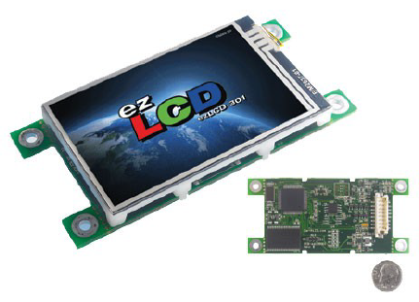
Figure 4-8 TFT Color LCD
Image reprinted courtesy of EarthLCD
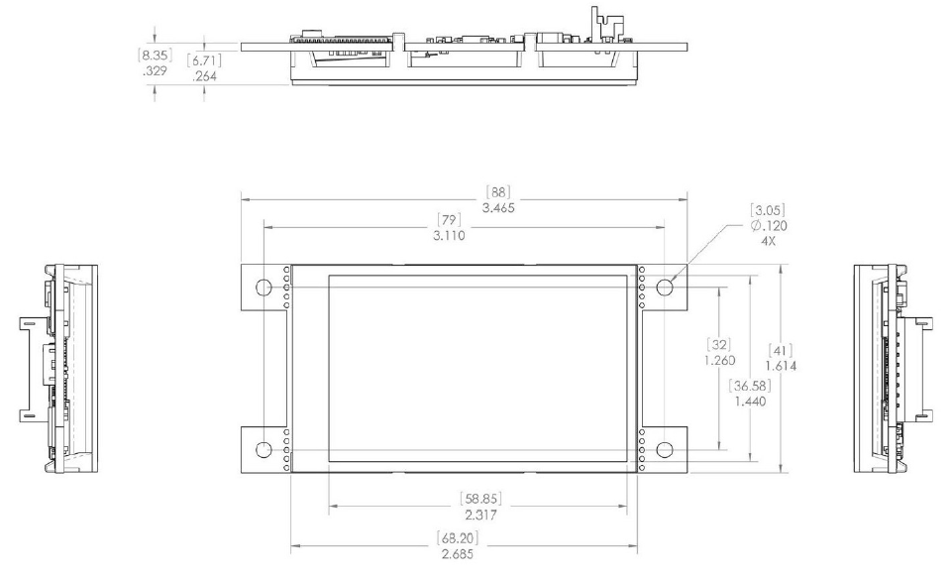
Figure 4-9 TFT Color LCD schematic
Image reprinted courtesy of EarthLCD

Figure 4-10 shows how this type of display uses transistors for every single pixel. Electrical current is controlled to make every pixel addressable by an electronic two-dimensional control matrix. The advantage of a TFT screen is that the display is fast enough for video display; it provides a brighter illumination and shows a smoother color palette. Most low-cost displays use an amorphous silicon crystal layer put onto glass through a plasma-enhanced chemical vapor deposition. Figure 4-11 shows a breakdown of a TFT screen where polarized light is passing through the liquid crystal display cells. TFT screens use better diffusers, polarizers, and better light source, like LED-based backlighting to make the display more vivid, instead of CCFL (Cold Cathode Florescent Lighting) bulbs which like LED’s can evenly distribute light, but require a higher voltage inverter to power it.
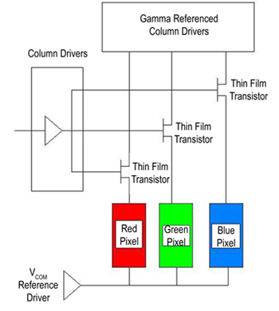
Figure 4-10 Pixel Description
Image reprinted courtesy of Digikey
Gamma corrected drive voltage passing through each transistor. Each pixel has a red, green, and blue picture element. The intensity of each color determines the resulting bit resolution of each color. 18-bit interfaces consist of 6 bits of each color, while 24 bit interfaces use 8 bits per color.
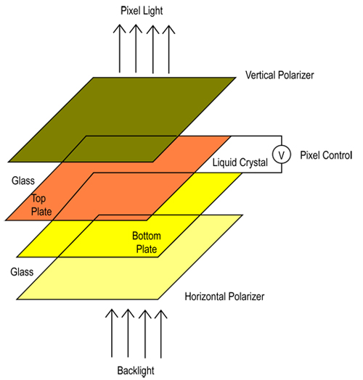
Figure 4-11 Polarized Light
Image reprinted courtesy of Digikey
The figure above explains polarized light passing through liquid crystal cell for a more vivid display.

4.6 Infrared Receiver

MirrorMate will feature an advanced infrared receiver module designed to distinguish long distance IR signals. The IR module will receive and interpret two different types of signals, Opticom and reduced speed zone signals. Both of these signals are broadcast at the 950nm wavelength of the IR spectrum. Due to the vast differences between the Opticom signal and the reduced speed zone signal, MirrorMate’s IR receiver module will contain two distinct portions to detect the differing signals. This system is designed as follows;

4.6.1 Opticom

The signal generated by the Opticom beacon will be a 14Hz pulse width modulated signal. In practice the Opticom system encodes a vehicle identification number onto the traffic light preemption signal. This is to prevent unauthorized preemption by nefarious devices. MirrorMate will not decode this signal for two reasons. The first reason is that the authentication codes are not published by the city as this would negate the benefits of authentication. Even if the codes were published it would decrease ease of use as MirrorMate would have to be updated on a case-by-case basis to authenticate emergency vehicles. The second reason is that decoding the authentication codes would increase the complexity of hardware and firmware design. The receiver module will look for any IR signal at 14Hz, with appropriate hysteresis and noise rejection established in microcontroller firmware and band pass filters. If the 14Hz signal is detected the microcontroller will trigger the emergency vehicle notification to the driver.

To detect this signal, a system of photodiodes optimized for the 950nm portion of the IR spectrum is utilized. Distinguishing this signal will be primarily accomplished via firmware, though input to the microcontroller will be optimized somewhat via bandpass filters. This is to eliminate as much undesired characteristics of the signal as possible without utilizing the processor. The band pass filter will be of typical RC filter design and combine a low pass and a high pass filter to create the desired band pass characteristics. The filter was designed to utilize commonly available resistor and capacitor values. These parts will also be low tolerance to ensure the best possible operation of the filters. The topology and characteristics of the filter are shown in Figure 4-12.

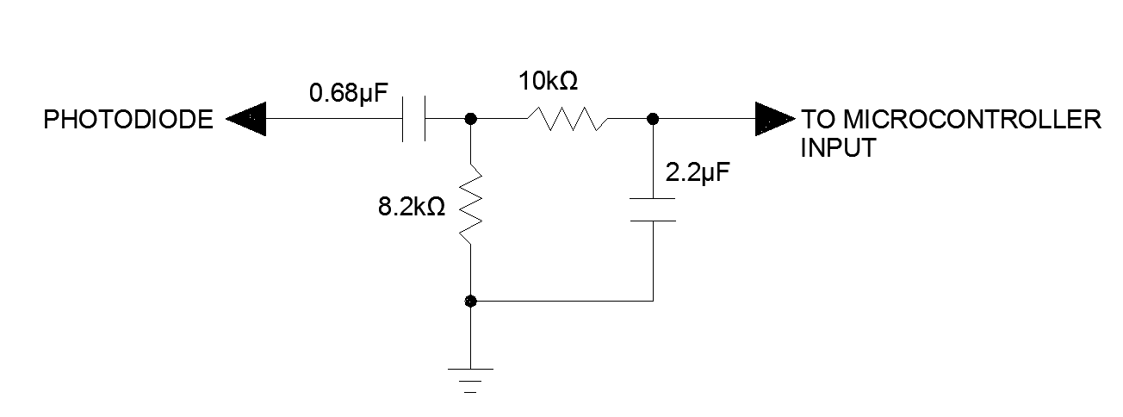

Figure 4-12 Band Pass Filter

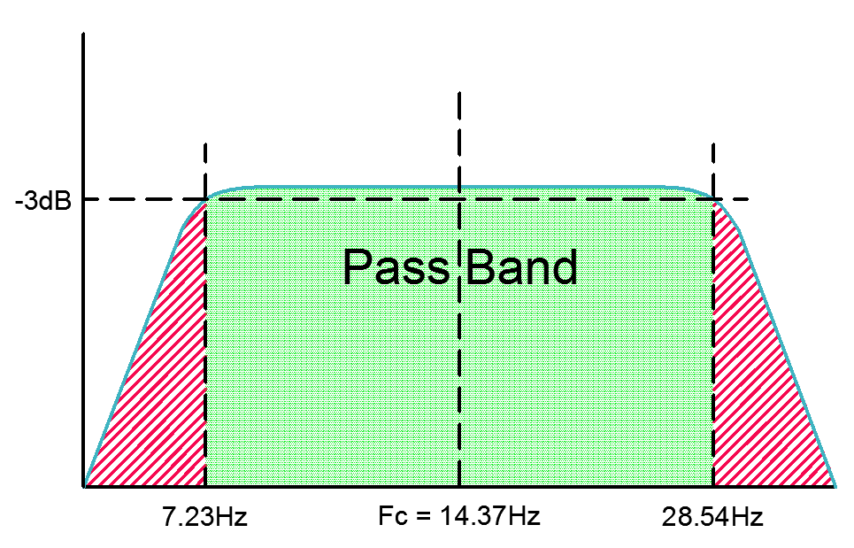

Figure 4-13 Band Pass Filter Characteristics

The output of the band pass filters will be connected to I/O pins of the microcontroller. The processor will be configured to interrupt when the filters pass a ‘high’. The microcontroller will then programmatically determine if the signal is nonsense or the correct Opticom signal. This presents a disadvantage as the processor may be continually interrupted, however the clock speed of the PIC32MX340F512H is 80MHz so the interrupt should be a non-issue for usability and processor utilization.

4.6.2 Reduced Speed Zone Detection

Alternatively, the reduced speed zone beacons broadcast via commercially accepted IrDA methods. More specifically the reduced speed zone signal will be broadcast at 38 kHz. A speed and zone type signal will be encoded onto the 38 kHz carrier. The signal will be encoded following best practices for the RC-5 remote control protocol. It should be noted that MirrorMate will not use any known remote codes to avoid any false triggers by inadvertent remote signals or nefarious devices. The receiver module will utilize 4 TSOP32338 IR receiver devices from Vishay. These devices automatically decode the speed and zone information from the 38 kHz carrier. This method of communication was chosen to simply MirrorMate’s design. If photodiodes were utilized for this portion of signal detection, either a discrete signal decoder would be required, or processor intensive firmware would be needed. Also, the TSOP32338 devices have a proven track record for reliability and noise rejection.

The information sent to MirrorMate will be in one byte segments of information. The first four bits will be used to determine zone type and the second four bits will be used to determine appropriate speed through the zone. The correlation between the byte of data and driver alerts is detailed as follows in the figure below.

First Encoded Character | Zone Type | Driver Alert |  | Second Encoded Character | Zone Speed  (MPH)
0 | School Zone | Flashing yellow “School Zone” with speed limit and directional arrow |  | 0 | 1
1 | Construction Zone | Flashing Orange “Construction Zone” with speed limit and directional arrow |  | 1 | 2
2 | Accident Scene | Solid yellow “Hazard, drive with caution” with speed limit and directional arrow |  | 2 | 3
3 | Special Events | Solid Blue “Caution” with speed limit and directional arrow |  | 3 | 4
4 | Not utilized |  |  | 4 | 5
5 | Not utilized |  |  | 5 | 10
6 | Not utilized |  |  | 6 | 15
7 | Not utilized |  |  | 7 | 20
8 | Not utilized |  |  | 8 | 25
9 | Not utilized |  |  | 9 | 30
A | Not utilized |  |  | A | 35
B | Not utilized |  |  | B | 40
C | Not utilized |  |  | C | 45
D | Not utilized |  |  | D | 50
E | Not utilized |  |  | E | 55
F | Not utilized |  |  | F | 60

Figure 4-14 Reduced Speed Zone Data Byte

4.6.3 IR Receiver Specifics

As discussed in the ‘physical design considerations’ section, the IR receivers will be located in a module at the bottom of the mirror. This module will be made of optical plastic designed to filter out most light that is not in the infrared spectrum. Opaque plastic blinders will be installed in the module so that 4 different directions (front, back, left, right) can be discriminated by the microcontroller. Each of the 4 sections in this module will contain a photodiode for Opticom detection and a TSOP32338 device for speed zone detection. The microcontroller will be connected to each sensor and determine where the signal emanates from with respect to the vehicle.

4.7 Infrared Beacon

The MirrorMate system requires a beacon to be installed at any reduced speed zones such as school zones or construction zones. The beacon will be configurable for different situation and will encode this information into a signal. MirrorMate will decode this information and inform the driver. The diagram below serves as an overview to the beacon.
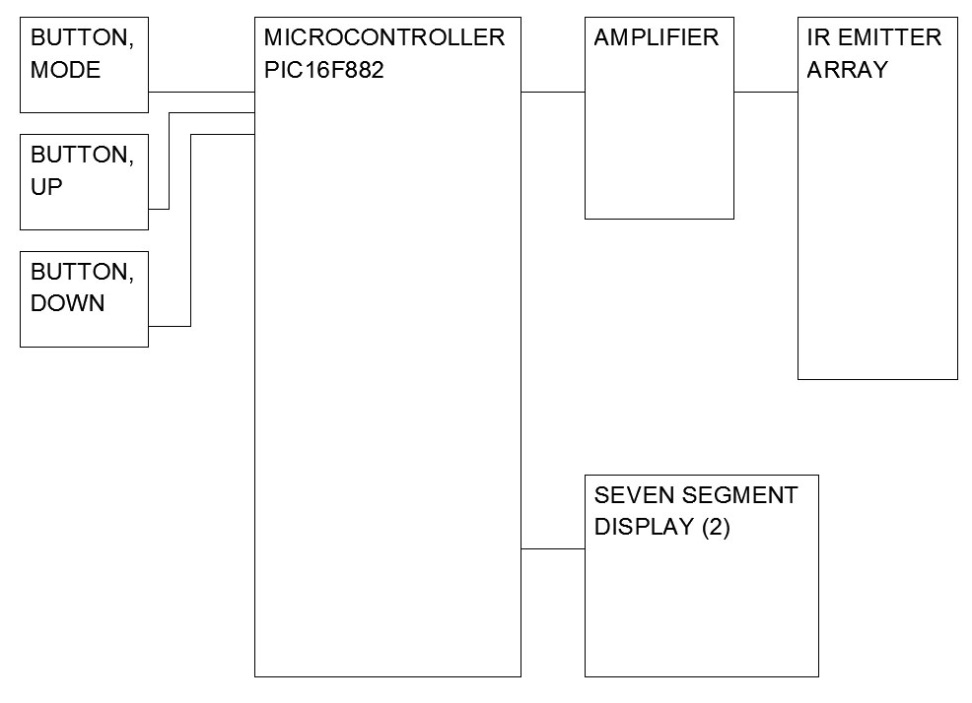

Figure 4-15 IR Beacon Overview

4.7.1 IR Beacon Physical Characteristics

Physically, the device will be a small rectangular plastic enclosure with 10 or more IR emitters. The device will have mounting points on the bottom of the unit for a tripod or construction barricade. Additional mounting points will be designed into the back of the beacon so that the device can be permanently mounted on a post at the reduced speed location. Figure 4-16 illustrates the unit mounted on a post.

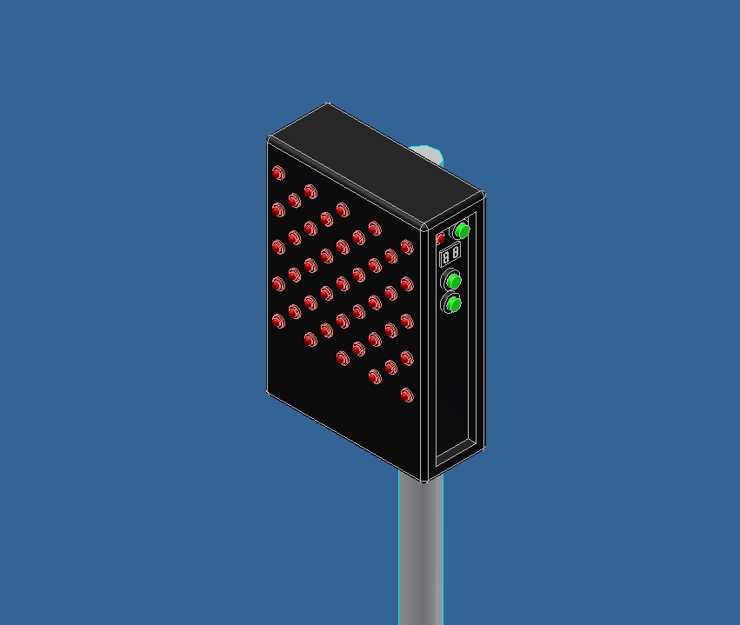

Figure 4-16 IR Beacon 3D Model

The side of the unit will feature the required configuration switches and two seven segment displays to display the current configuration. Seven segment displays were chosen as they are easy to interface, inexpensive, and simple to create firmware for. This design will allow the end user to easily re-configure the unit.

4.7.2 IR Beacon Optical Characteristics

The reduced speed zone beacon will include an array of 41LED emitters. Each one of these emitters produces a 30° light pattern. The emitter array's primary purpose is to provide a reliable broadcast pattern for MirrorMate. The 30° light pattern provides excellent transmission distance while still providing a broad enough pattern to ensure communicate with vehicles close in proximity to the beacon. The Osram Corporation manufactures many IR emitters that are designed specifically for long range communication. Osram's SFH4547 high output emitter has been chosen as the LED of choice as it is specifically advertized as applicable to traffic preemption systems. This device also features exceptional output power. Another advantage of using a large array of high power emitters is that this design ensures reliable operation of the system without using lenses or optics which increase design complexity and cost. The array of emitters will establish long range communication while keeping costs down. Low costs are an attractive feature when organizations begin to implement new devices.

4.7.3 Powering the IR Beacon

The reduced speed zone beacon will require significantly more power than typical electronics as the device will feature an array of high power IR emitters which have high current requirements. The beacon will have an internal 9V battery for emergency use and for configuration mode. Operation time of the beacon in transmit mode when utilizing the internal 9V battery will be very short. External power is necessary for long run times of the beacon.

The power supply inside the beacon will feature a high current 5V regulator, specifically the LM1084 LDO regulator from TI. This regulator is capable of supplying up to 5A of current with the appropriate heat sink. The regulator will power all of the electronic components inside the beacon including the IR emitters. Multiple regulators will be utilized to power the emitter array as the current requirement exceeds 5A. Each regulator will supply a specific bank of emitters to avoid linking the output from the regulators together.

This regulator specifies the minimum input voltage must be 1.5V more than the output voltage and the maximum input voltage must be less than 25V. Therefore the input voltage of the beacon will be 7.5V (considering reverse protection diode) to 25V. This method of power conversion was chosen because the regulator is relatively inexpensive, these regulators have a proven track record for clean power and reliability, the power supply will take up minimum board space, and it is easy to implement.

The beacon will feature an external interconnect so that a power source can be connected. Due to the beacons wide input voltage range it can be powered by both 12VDC and 24VDC systems. This versatility allows the beacon to be powered by a myriad of sources. These two voltages are present in any construction equipment or vehicles. Therefore if it is feasible the beacon can be powered by any stationary equipment already present at the construction zone. It will be possible to power the beacon off of a typical 12V lead acid battery in the form of a car battery or lantern battery. These types of batteries are also rechargeable. If the beacon is mounted to a construction zone barricade, solar power is also an option. The solar cell could charge a lead acid battery which the beacon would be powered. It would also be possible to power the beacon using 'main' 120VAC utilizing a typical (though high current) step down transformer in the form of a 'wall wart'. This could be connected directly the power connector on the beacon.

4.7.4 IR Beacon Electrical and Firmware Design

The reduced speed zone beacon will contain a PIC16F882 microcontroller from Microchip at the heart of the design. The microcontroller will be responsible for generating the encoded IR broadcast signal. This signal will be generated programmatically based on some parameters. The signal will be changed based on configuration discussed previously. The buttons will be connected to I/O pins on the microcontroller and will trigger interrupts to modify the settings stored in the chip. Settings will be stored in the on-chip EEPROM non-volatile memory so that configuration remains even if power is removed from the beacon.

The microcontroller will generate a 38kHz carrier signal with information encoded. This will be established using the PIC16F882's on board PWM module. The module will be configured programmatically for 38kHz carrier signal. The PWM module will be enabled/disabled at the appropriate times to encode the signal. The signal will be encoded using a slightly modified RC-5 protocol which incorporates some aspects of the NEC remote protocol. Also, the RC-5 protocol requires a 36kHz carrier, and MirrorMate will utilize a 38kHz carrier.The reason for deviating from the protocol slightly is to eliminate false triggers with the MirrorMate system. No commercial remote control will be able to generate a signal that can trigger MirrorMate. Alternatively, the reduced speed zone beacon will be unable to trigger commercial devices that utilize IR remote controls.

The RC-5 protocol transmits two start bits followed by an 8 bit address, then a 6 bit command.

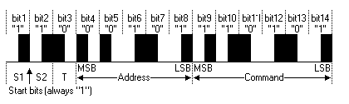

Figure 4-17 RC-5 Protocol

The bits are modulated using a form of Manchester coding and are determined by the location of an 889µs modulated pulse. Each bit requires 1778µs to transmit and if the first 889µs consists of a pulse then the bit is a zero. If the second 889µs of the bit consists of a pulse then the bit is a one. This method of modulation is illustrated in the image below.

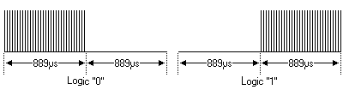

Figure 4-18 Manchester Coding

The reduced speed zone beacon will transmit the bits in the same way as RC-5 (manchester coding) however there will be no address byte. MirrorMate only requires one byte of information to be transmitted where as RC-5 transmits two bytes. To further differentiate the transmitted signal from the RC-5 protocol, the beacon will transmit an 8ms leading modulated pulse instead of the two start bits. This leading pulse is similar to the NEC protocol, however the pulse is a different length. The total time required to transmit a command using this method is 30.2ms. This signal will be repeated indefinitely by the beacon with no pulses transmitted for 8ms between commands. The end result of this encoding method is 'security through obscurity' as no device currently transmits information in this manner. A full transmitted command is illustrated in Figure 4-23.

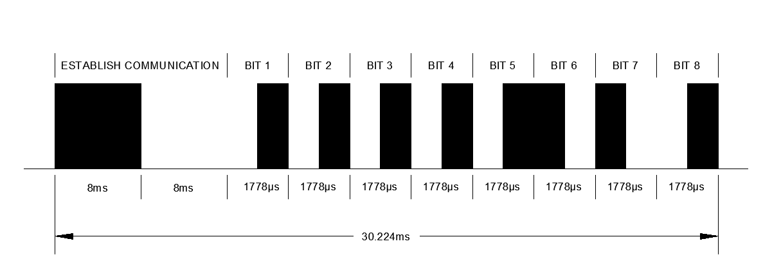

Figure 4-19 MirrorMate IR Command

As discussed previously, the IR beacon will emit infrared at the 950nm wavelength. The unit will contain an array of high power emitters (up to 1A of forward current per emitter). It is estimated that the beacon will contain up to 75 emitters. To drive these emitters, a signal amplifier will be used. The amplifier will consist of a MOSFET driver chip (Microchip's MCP1407) and a power MOSFET capable of switching at the required speed.

The power MOSFET will be an IRFZ44V series part from international rectifier. This part features a continuous drain current of 55A and pulsed drain current of 220A. The power dissipation rating of this part is 115W with the appropriate heat sink. The TO-220 package will be utilized as many heat sink options are available. Power dissipation calculations result in 41W of power dissipation at 50A of forward current and 92W at 75A of forward current (assuming Vgs = 12V). This is well within the parts rated conditions. When switching frequency is taken into consideration, the part will be required to switch cleanly at 38kHz. The period of a 38kHz wave is 26µs therefore the MOSFET's turn-on and turn-off delay times should fall well below 26µs. The IRFZ44V's turn-on and turn-off times are 13ns and 40ns respectively. This parts switches quickly enough to establish a clean 38kHz wave form. These specs illustrate that the IRFZ44V is an ideal part for this application.

The MOSFET driver creates a necessarily high current signal from a low level signal generated by the microcontroller. The high current signal is used to overcome the capacitive load of the MOSFET gate. This is to ensure that the gate of the part is switched on and off extremely quickly to avoid operating the MOSFET within its linear region. If the MOSFET is operated in the linear region for extended periods the part could overheat and fail due to high levels of power dissipation. Capacitors are utilized by the MOSFET driver to generate the high instantaneous currents to switch the MOSFET. These capacitors are specified in the datasheet and are located close to the driver on the PCB. The MCP1407 device is capable of switching much faster than the IRZF44V so the rise and fall time of the driver can be neglected. An additional advantage of using a MOSFET driver is that the driver's output is 'push-pull' which means that no pull down resistors or special considerations are necessary. The design of this amplifier is illustrated in Figure 4-20. For clarity, only 20 emitters are shown.

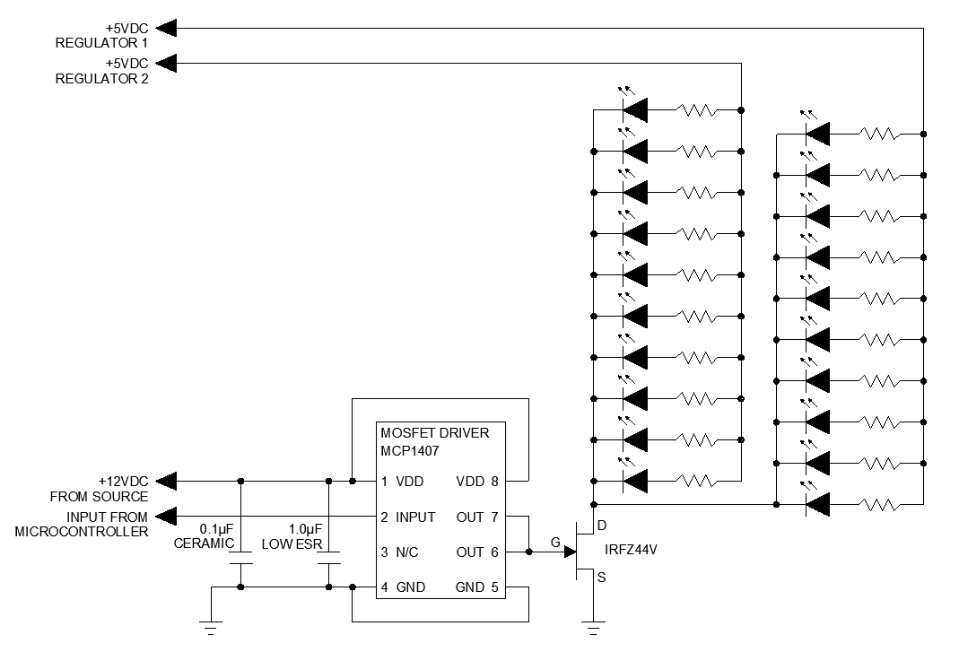

Figure 4-20 LED Emitter Amplifier Design

As seen in Figure 4-20 the LED current will be controlled by resistors. Each LED will have its own resistor as different emitter types will be employed in the beacon. Each type of emitter has specific current requirements. Also, due to slight variations of LED forward voltage from the manufacturing process it is best to control LED current individually. If LED current was not controlled individually the manufacturing variations could cause a set of LED's that share the same resistor to fail. The LED's will be load balanced, receiving power from different regulators. This will ensure that no regulator is overloaded.

4.8 Bluetooth Communication

Core Specifications
Bluetooth has 3 core specifications. They are as follows:

- Bluetooth v4.0 with Hallmark Feature
- Bluetooth v3.0 + HS
- Bluetooth v2.1 + EDR

V4.0
Bluetooth v4.0 is the newest and most recent core specification available. It was announced in July 2010. The main features include Ultra-low peak, average and idle mode power consumption, the ability to run on button cell batteries, cost savings, improved range and Multi-vender interoperability. These are all great features but unfortunately, many mobile phones do not come with v4.0. If the MirrorMate device was designed around the v4.0 standard, the hardware would not only be more expensive compared to older versions, but also the mobile phone hardware would be as well. Only newer and pricier mobile phones come with v4.0. Currently, the MirrorMate Team doesn’t have an Android v4.0 Bluetooth capable phone.

V3.0 + HS
Bluetooth v3.0 was announced in April 2009 with the core new features including power optimization, improved security, enhanced power control and lower latency rates. Currently, no MirrorMate Team member owns a Bluetooth v3.0 capable mobile phone. It’s in the best interest of the MirrorMate Team not to spend extra on a phone for the purpose of using v3.0.

V2.1 + EDR
Although Bluetooth V2.1 is two generations old, it’s still widely used. One of the MirrorMate Team members owns a Motorola phone, which supports Bluetooth V2.1. The Bluetooth V2.1 cores enhancements include lower power consumption, improved security and near field communication support. Based on the core specifications and the availability both on the Team member side and throughout the population, V2.1+ EDR will be used on MirrorMate.

Architecture
It’s important for the MirrorMate Team to have a competent understanding of the Bluetooth architecture to develop a working product. The figure below outlines the core architecture.
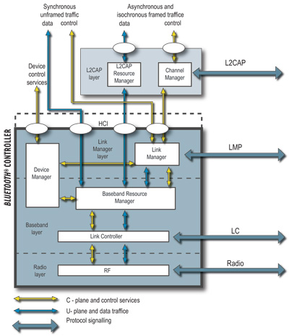
Figure 4-21 Core Architecture
Image reprinted courtesy of Bluetooth.org

The lower three layers consists of the Link Manager Layer, Baseband Layer and Radio Layer. These are grouped together and sometimes referred to as the Bluetooth Controller. Error detection occurs in the L2CAP layer. This feature will be enabled in MirrorMate to compensate for any lost undetected errors in the transmitted data.

Profiles and Protocols
Bluetooth Technology offers a wide range of profiles and protocols. A complete list can be referenced here [5].
For communication between the rear view mirror and the mobile device, the MirrorMate Team is planning to use the serial port profile and the generic object profile.

Serial Port Profile
The serial port profile sets up a virtual serial connection between two devices. There are two rolse defined in a SPP profile. They’re as follows

- Device A – Forms the connection to another device
- Device B – Waits for a connection from another device.

The interactive rear view mirror will act as Device B and the mobile phone will act as Device A. The profile stack is shown below.

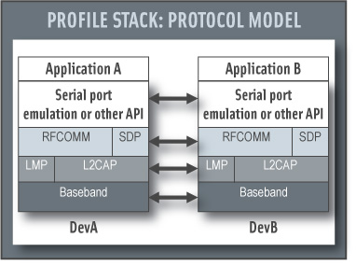
Figure 4-22 Profile Stack
Image reprinted courtesy of Bluetooth.org

Layer 1 and layer 2 of the OSI Bluetooth protocol are the Baseband, LMP and the L2CAP. RFCOMM will be the Bluetooth adaptation according to GSM TS 07.10. This protocol provides transport for the serial port emulation. SDP is the service discover protocol. The serial port emulation will communication with the Android API to control what is sent and received to the MirrorMate and connected Android device.

Generic Object Exchange Profile
GOEP will be used to transfer objects between the MirrorMate and mobile device. The two roles in this profile are Server and Client

- Server – This will be the device that provides the object to exchange.
- Client – This is the device that will push and pull data from the server.

The server role will be filled by the Android device and the client role will be the
interactive rear view mirror. Objects can be pushed and pulled between the two connected devices. This is the primary reason this profile will be considered when building the interface between the MirrorMate and mobile device.

RFCOMM Protocol
The RFCOMM protocol emulates the RS-232 connection. This is used to provide the serial data transfer. In essence, the wireless Bluetooth will be the path between the two devices, but the connection will be a serial connection. This is beneficial because the MirrorMate Team has more experience with connecting two devices over serial than Bluetooth.

Streaming Video over Bluetooth

One of the original ideas for MirrorMate was to stream and sync the embedded LCD on the mirror with the screen on the mobile device. For example, whatever the user ended up doing on the mobile device would be mirrored on the MirrorMate LCD. This would have significantly lowered the amount of individual programming of the turn by turn directions. The MirrorMate Team wouldn’t have to worry about programming each direction to send over Bluetooth. Unfortunately, there are some limitations with Bluetooth.

One of the main limiting factors was the low throughput of Bluetooth. Bluetooth currently has a protocol called Audio / Video Distribution Transport Protocol but it’s not enough to provide a consistent user experience. There’s a high variability in the strength of the radio signal. A smooth frame rate wouldn’t be possible.

Power Classes

Bluetooth has three power classes. They’re outlined in the figure below:

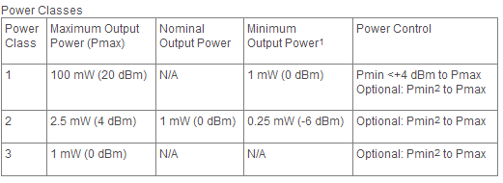
Figure 4-23 Bluetooth Power Classes

Since the MirrorMate device will constantly be plugged into the vehicle, power constraints are not going to be considered when choosing the correct power class. What is very important that the MIrrorMate Team will need to consider is the operating range for each power class. The below figure outlines the range of each power class.
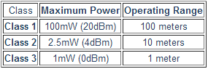
Figure 4-24 Power Class Ranges
Image reprinted courtesy of Bluetooth.org

If a class 3 Bluetooth module is chosen, extreme range limitations may affect the user experience. Although class 3 Bluetooth modules are the least expensive, the MirrorMate Team felt they didn’t want to take away from the user experience and restrain the user within 1 meter of the MirrorMate. Class 1 Bluetooth modules are a range of up to 100 meters, but costs are dramatically higher. The best module for MirrorMate will be a class 2 Bluetooth module. A 10 meter range is more than sufficient while providing an ideal price point.

RN24 Bluetooth Module
The RN24 Bluetooth module is a class 1 module with a RS232 serial interface. It includes status LEDs, an optional SMA jack for extended range and an onboard antenna. The key features are as follows:

- Fully qualified Class 1 Bluetooth 2.1 + EDR module
- Bluetooth SIG qualified
- UART (SPP or HCI) data connection hardware interfaces
- Onboard embedded Bluetooth stack (no host processor required)
- Supports HID profile for making accessories such as keyboards, mouse, pointing devices
- Programmable low power modes
- Secure communications, 128 bit encryption
- Error correction for guaranteed packet delivery
- UART local and over-the-air RF configuration

The primary reason the MirrorMate Team chose this Bluetooth module was due to the strong possibility of financial help by Microchip. The MirrorMate Team and Microchip have been in constant communication to finalize a parts list that may be provided on Microchips expenses. The below block diagram is an overview of the RN24 Bluetooth Module.

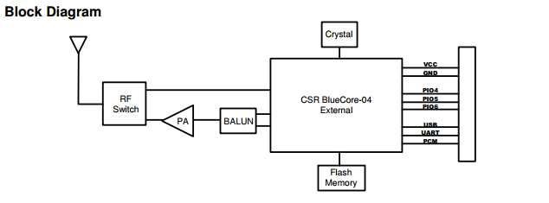
Figure 4-25 RN24 Bluetooth Module
Image reprinted courtesy Microchip

The MirrorMate Team will not use the optional SMA jack to plug in an extended range antenna. Without the antenna, the range will not be of class 1 operating range but this won’t affect the user experience. The user will not be 100 meters from the rear view mirror.

4.9 Mobile Device Development

Discussion about the overall process of Mobile Device Development including setup, requirements and overall goal of the application MirrorMate is building.
4.9.1 Initial Setup
In order for the MirrorMate Team to begin developing the Android app, the initial environment needs to be setup. This included installing the Android SDK, the Java SE and eclipse. Installing the Android SDK involved going to developer.android.com/sdk/ and downloading the correct file based on the OS. The MirrorMate Team used Windows machines, so they installed the zip file. Before completely install the SDK, Java SE needs to be installed, which can be found in the following site.[6] After both the Java SE and SDK were installed correctly, the SDK manager pops up and allows you to select the desired Android version. Based on initial research, the MirrorMate Team decided to develop based on the latest version of Android, Jelly Bean. Eclipse can be installed through online. After installing Eclipse, an additional plugin needs to be installed to interface with the Android SDK. The plugin is called the Android Development Tools ADT.

4.9.2 Interfacing with GPS and Location

There are three ways to find your location through a mobile device. The first way is through Google’s WPS technology. This technology allows you to pinpoint your location through a WiFi connection without a GPS signal. This may not be the most suitable situation for the MirrorMate Team because it’s going to be attached to a vehicle. The WiFi signal may be in and out of range frequently. The second way the MirrorMate Team can use location based services is through AGPS. A-GPS triangulates your location using a mobile networks tower. [7] The advantage using this system is that it can find your location quicker. Unfortunately, this relies on an internet connection and may not be as accurate. The MirrorMate Team needs a more accurate way for location. The third way to use location services is through GPS. This is the most accurate measure and does not require internet based services. This is the main reason why the MirrorMate Team decided to use GPS. Furthermore, today’s smartphones come with GPS module. Essentially, Interfacing with the GPS and sending the directions via Bluetooth to the Mirror is going to be one of the main obstacles for mobile development.
4.3.2.1 The Google Distance Matrix API
The Google Distance Matrix API is a Google provided service that gives users travel distance and time. This includes a database of destinations and origins. To interface with the Distance Matrix, the java app needs to send a URL to google with the parameters of the location, this in turn will return the directions.
Certain parameters are required, while others are optional. Each parameter needs to be separated by an ampersand. The required parameters are origins, destinations, and sensor. The origin parameter accepts both latitude/latitude numbers and a string for instructions. If a string address is sent, it will be converted to a latitude and longitude before providing the directions. Furthermore, the directions need to be separated by a pipe character. An example is below.
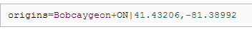
The second required parameter is the destination. The destination parameter also accepts both multiple string addresses and latitude/longitude values. Each values, if passing more than one destination, needs to be separated by the pipe key. Furthermore, coordinates cannot have spaces included. An example is below
The sensor parameter indicates if a GPS sensor is being used in your application. A Boolean value is used.
There are four optional parameters that can be used with the Google Distance Matrix API. They are Mode, Language, Avoid, and Units. Mode is used to specify the mode of transportation. This parameter accepts “Driving”, “Walking”, and “bicycling”. The language parameter is used to choose the language the directions are returned. The full list of supported languages can be found a the following location. [8] Avoid parameter is can be used if a user wants to avoid a specific location in the route. The two accepted parameters are “Tolls” and “Highways” The last parameter units can be used to specify the units returned.
The output from the Google Distance Matrix is either JSON or XML. Google strongly recommends using JSON as the output. As a result, the MirrorMate Team is going to use that. An example output can be seen below.
http://maps.googleapis.com/maps/api/distancematrix/json?origins=Vancouver+BC|Seattle&destinations=San+Francisco|Victoria+BC&mode=bicycling&language=fr-FR&sensor=false

Status codes are also returned which will be helpful for the MirrorMate Team debug any issues they have during testing. The status code returns 5 results which are below
- OK indicates the response contains a valid result.
- INVALID_REQUEST indicates that the provided request was invalid.
- MAX_ELEMENTS_EXCEEDED indicates that the product of origins and destinations exceeds the per-query limit.
- OVER_QUERY_LIMIT indicates the service has received too many requests from your application within the allowed time period.
- REQUEST_DENIED indicates that the service denied use of the Distance Matrix service by your application.
- UNKNOWN_ERROR indicates a Distance Matrix request could not be processed due to a server error. The request may succeed if you try again.

Google Maps allows you to interface with their services through a wide variety of APIs. The MirrorMate Team plans to incorporate the maps technology to provide the turn by turn navigation. The MirrorMate Java application needs to take the turn by turn directions and transmit them via Bluetooth to the rear view mirror.

4.3.2.2 The Google Maps JavaScript API

To Interface with Google Maps, the JavaScript API needs to be used. Before the MirrorMate Team can start using this, an API key needs to be obtained. Google requires all mobile applications to obtain an API key to monitor usage and contact the user if need be. According to usage limits defined in the documentation [9] the MirrorMate Team cannot exceed 25 000 page loads. Since the MirrorMate Team will be using a java mobile app, the java code must call the JavaScript using a Script Engine [10]. The ScriptEngine allows a java application to embed JavaScript code.

4.3.2.3 Google Maps Android API - External Library

To use the Maps External Library, the following needs to be incorporated in the MirrorMate application:

- Setup a new Android project
- Setup an Android Virtual Device
- Add a uses-library element
- Use the Maps classes
- Integrate the Maps API Key
- Sign the MirrorMate application

Setup a new Android project
The MirrorMate Team will be using Eclipse with the ADT plugin for developing. To setup a Map project in Eclipse, right click the project and choose properties and select a build target. “Google APIs” but be chosen here as the build target

Setup an Android Virtual Device
Setting up the AVD is explained in the Initial Setup section outlined in 4.3.1

Add a uses-library element
The Maps library must be referenced first in the code. One way to reference maps is by using XML. An example is below

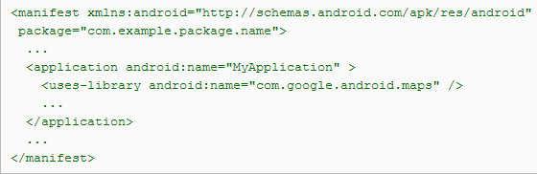

When the “uses-library” is referenced in MirrorMate, the build tools will link against the Maps external library. Also, it checks that the library is available on the Android device before installing

Use the Maps classes
The primary class used to incorporate Maps is the MapView class, which is a subclass of ViewGroup. The MapView class is responsible for displaying the data from the Google Maps service. It also helps with the interaction between the services. In essence, the MirrorMate Android app will have a layout that extends the MapActivity class that includes the MapView.

Integrate the Maps API Key
To receive the Maps API Key, the MirrorMate Team will need to register for it. Setup has two main parts. The first part is registering the MD5 fingerprint of the certificate that’s used to sign the MirrorMate application. Once registered, the Maps API will be provided. The second part is to reference the Maps API key in MirrorMate’s MapsView. This can be done either through XML or instantiated.

Sign the MirrorMate application
Both the certificate used to sign the application and the Maps API key must match. One possible solution is to only sign the application using the debug certificate. If the MirrorMate Team decides to sign the application for public release on the Android Play Store, then the process takes a lot more time.

4.3.2.4 Sending the directions via Bluetooth
The MirrorMate Team can generate the full directions via the Distance Matrix API, but sending the turn by turn directions when the user is at that point, may be a little bit harder. The app will need to compile the directions received by Google first. Based on the location the user is, and then send the next direction. The application will check the location of the mirror based on GPS coordinates. Once on route and reach a specific turn for example, the mirror will then send the next direction to reach the destination.
4.3.2.5 Android Bluetooth API and Connectivity

The MirrorMate Team plans to incorporate Bluetooth technology to send data to the MirrorMate device. Fortunately, Android supports the Bluetooth stack. With the available Bluetooth APIs, the MirrorMate mobile app can accomplish the following:
- Scan for other Bluetooth devices
- Query the local Bluetooth adapter for paired Bluetooth devices
- Establish RFCOMM channels
- Connect to other devices through service discovery
- Transfer data to and from other devices
- Manage multiple connections

From the mobile application connectivity standpoint, the first step is to check that Bluetooth is supported on the current android device the application is running on. This can be done through the “getDefaultAdapter()” method. If the device supports Bluetooth, Bluetooth can then be enabled by the “ACTION_REQUEST_ENABLE” action Intent. The MirrorMate application will incorporate enabling Bluetooth if disabled. A dialog box will pop up on the Android phone informing the user the application is requesting to enable Bluetooth.
The MirrorMate application will need to search for the MirrorMate device. Bluetooth devices have three states; usually referred to discovering, inquiring or scanning. The MirrorMate device will be set to discovering mode before being paired. Once in discovering mode, the Bluetooth capable mobile device with the MirrorMate application installed will find the MirrorMate. The MirrorMate device will send the phone the MAC address and device name which can be used to pair the device.
When the MirrorMate connects with the mobile device for the first time, a paring request will need to be setup with the user. To pair the two devices, the two devices need to authenticate through a shared link key. This allows an encrypted connection between the two devices. After the encrypted connection is setup, the two devices will be allowed to send data to each other. A popup will prompt the user before pairing. The user will need to accept in order to pair with the rear view mirror.
When the MirrorMate and Bluetooth capable mobile phone are paired, one of the two devices needs to act as the server. This needs to happen because the server socket needs to listen for incoming connection requests. If there’s a connection request, the server client provides a connected “BluetoothSocket”. The basic steps needed to setup a server socket are outlined below (http://developer.android.com/guide/topics/connectivity/bluetooth.html):
- Get a BluetoothServerSocket by calling the listenUsingRfcommWithServiceRecord(String, UUID).

The string is an identifiable name of your service, which the system will automatically write to a new Service Discovery Protocol (SDP) database entry on the device (the name is arbitrary and can simply be your application name). The UUID is also included in the SDP entry and will be the basis for the connection agreement with the client device. That is, when the client attempts to connect with this device, it will carry a UUID that uniquely identifies the service with which it wants to connect. These UUIDs must match in order for the connection to be accepted (in the next step).

- Start listening for connection requests by calling accept().

This is a blocking call. It will return when either a connection has been accepted or an exception has occurred. A connection is accepted only when a remote device has sent a connection request with a UUID matching the one registered with this listening server socket. When successful, accept() will return a connected BluetoothSocket.

- Unless you want to accept additional connections, call close().

This releases the server socket and all its resources, but does not close the connected BluetoothSocket that's been returned by accept(). Unlike TCP/IP, RFCOMM only allows one connected client per channel at a time, so in most cases it makes sense to call close() on the BluetoothServerSocket immediately after accepting a connected socket.
Wi-Fi Direct
Wi-Fi Direct is very similar to Bluetooth as to where you don’t need any additional hardware. As of Android 4.0, Wi-Fi Direct is supported. Unfortunately, from a mobile phone hardware perspective, Most of today’s devices do not support Wi-Fi Direct. Because of this, the MirrorMate Team decided not to use this wireless technology. Bluetooth capable mobile phones are far more abundant and less expensive as well.
Animation and Graphics
The MirrorMate Team has limited graphic experience. The Team will work in Photoshop if necessary to create attractive graphics. Furthermore, fellow colleagues will be asked for help for more complex animations or graphics.
4.3.2.6 MirrorMate App Resources

In order for the MirrorMate app to run smoothly, good coding practices need to be incorporated when writing the app. The initial goal for this application will not be integration for all mobile devices such as tablets and mobile phones. The initial goal will be to optimize the application to work on one mobile device available to the MirrorMate Team. If time permits, the MirrorMate Team will move toward compatibility with many different devices with different screen sizes and pixel densities. App Resources can be broken down into 5 different sections outlined below:
- Providing Resources
- Accessing Resources
- Handling Runtime Changes
- Localization
- Resource types
Each of these subsections are very important to understand when the MirrorMate Team begins developing. Not fully understanding these subsections can lead to resource errors, inefficient code, or a slow to respond app for the end user.
Providing Resources
Resources used in the MirrorMate app should be set aside from the main code. For example, image links and strings should be referenced in the code but stored in an external resource. This allows for easier maintainability in the future, especially when debugging. The below table outlines the directories supported inside the [res/] directory. The MirrorMate app will incorporate the below directories to maximize scalability. [11]
.
Directory | Resource Type
animator/ | XML files that define property animations.
anim/ | XML files that define tween animations. (Property animations can also be saved in this directory, but the animator/ directory is preferred for property animations to distinguish between the two types.)
color/ | XML files that define a state list of colors. See Color State List Resource
drawable/ | Bitmap files (.png, .9.png, .jpg, .gif) or XML files that are compiled into the following drawable resource subtypes:  - Bitmap files  - Nine-Patches (re-sizable bitmaps)  - State lists  - Shapes  - Animation drawables  - Other drawables  See Drawable Resources.
layout/ | XML files that define a user interface layout. See Layout Resource.
menu/ | XML files that define application menus, such as an Options Menu, Context Menu, or Sub Menu. See Menu Resource.
raw/ | Arbitrary files to save in their raw form. To open these resources with a raw InputStream, call Resources.openRawResource() with the resource ID, which is R.raw.filename.  However, if you need access to original file names and file hierarchy, you might consider saving some resources in the assets/ directory (instead of res/raw/). Files in assets/ are not given a resource ID, so you can read them only using AssetManager.
values/ | XML files that contain simple values, such as strings, integers, and colors.  Whereas XML resource files in other res/ subdirectories define a single resource based on the XML filename, files in the values/ directory describe multiple resources. For a file in this directory, each child of the <resources> element defines a single resource. For example, a <string> element creates an R.string resource and a <color> element creates an R.color resource.  Because each resource is defined with its own XML element, you can name the file whatever you want and place different resource types in one file. However, for clarity, you might want to place unique resource types in different files. For example, here are some filename conventions for resources you can create in this directory:  - arrays.xml for resource arrays (typed arrays).  - colors.xml for color values  - dimens.xml for dimension values.  - strings.xml for string values.  - styles.xml for styles.  See String Resources, Style Resource, and More Resource Types.
xml/ | Arbitrary XML files that can be read at runtime by calling Resources.getXML(). Various XML configuration files must be saved here, such as a searchable configuration.
Table 4-26 Application Hierarchy
Alternate resources are useful to support separate devices. Since the MirrorMate Team will not be incorporating compatibility with different Android devices, this is not as important to cover.
Accessing Resources
When the resource has been provided to the MirrorMate app, the resources can be referenced by using the ResourceID. These IDs will be defined in the MirrorMate “R” class. There are two ways resources can be accessed. The first way is embedded through code. An example is shown below where “string” is the resource type and “hello” would be the resource name.
The other way resources can be accessed is through XML. An example is show below where “@string” is the resource type and “hello” is the resource name.
For readability and personal preference, the MirrorMate Team will use embedded code to address resources.
Handling Runtime Changes
The MirrorMate app will need to incorporate runtime changes such as screen orientation, keyboard display and language. Another state restart that the MirrorMate app needs to incorporate is phone call interruption. If a phone call is received during use of the MirrorMate app, the application cannot lose its users data. It must return back to the same state the user was before the phone call.To handle these changes, Android restarts through the resource called “Activity” [12]. The MirrorMate app does not need to incorporate languages because the Team is only making the app in English. It’s not ideal to restart the MirrorMate app each time so there are two alternatives to restarting the app. The two alternatives are listed below:
- Retain an object during an object reconfiguration
- Handle the configuration yourself.
Retain an object during an object reconfiguration
If there’s a configuration change, a stateful object carries over to the new instance of the current activity. An object can be retained by first overriding the onRetainNonConfigurationInstance() method, then when the activity is started, call the getLastNonConfigurationInstance() method, which will recover the previous object that was saved.
Handle the configuration yourself.
Having the developer handle the configuration is recommended only if configuration files don’t need to be changed and there’s a specific performance limitation. Also, Android only recommends using this method as a last resort. Since the MirrorMate won’t have any of those challenges, the Team decided to retain the object during an object reconfiguration.
More on object reconfiguration
The main reason object reconfiguration was chosen instead of restarting the entire app is because the MirrorMate app will be gathering large amounts of data from Google Maps and if a restart were to occur, this would require a lot of time to retrieve the data again. Saving the data in an object will speed up the application dramatically.
Localization
Localization is an issue most developers face when deploying an app across many different regions and platforms. Initially, the MirrorMate Team will develop the application to work in one region, the United States. If time and resources permits during development, the Team will make the necessary adjustments to accommodate different localizations.
The app will consist of default localizations only. The MirrorMate app will store default text in the following required directory:
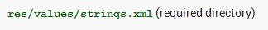
Alternative Resources and prioritizing resources will not be incorporated into MirrorMate initially because of only one localized region
The MirrorMate app is being developed in Java so referring resources will use the following syntax:
Testing for Default Resources
Default resources will be the only specified resources in MirrorMate so it’s important to test for it. There are three steps involved in testing the default resources are setup correctly. The first step is to set the language to Spanish, which isn’t supported by MirrorMate. Once the language is set, start the MirrorMate application. Finally, if the application shows an error message, make sure the string is defined in the following directory:
Text and Input
The MirrorMate Team is planning to add some convenient text services to the Android application. These services include copy and paste, voice typing, and spellchecker. These features will make it easier for end-users to enter addresses.
Copy and Paste
The Android clipboard will support both complex and simple data types. Users will be able to copy an address for example, from one application such as a browser, and paste them into the MirrorMate app. The clip object supports three different forms. The first one is text. A text string will be the most common type to be copied into the clipboard object. To paste the string into the MirrorMate app, the development Team will copy the clipboard object and place the string in the applications storage.
The second type available is URI. This type is primarily used for copying complex data types. The MirrorMate application will need to take into account this type just in case the end user decides to copy this data type into the application. Once the URI data type is copied into the clipboard object, the MirrorMate application will grab the URI object, resolve the data source and copy the data source into the MirrorMate’s application storage.
The final form available is an Intent. This is used to copy application shortcuts. At this time, the MirrorMate development Team is not planning to support this type of copy and paste. The below diagram explains the overall layout of the clipboard system within Android [12].

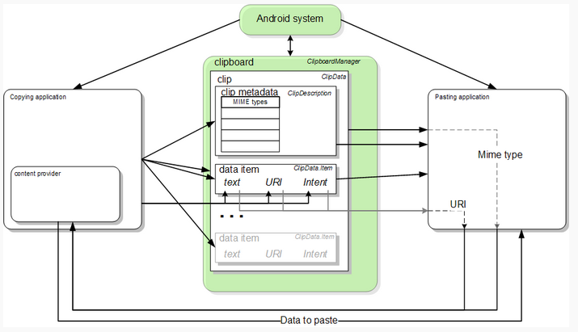
Figure 4-27 Android Clipboard System
Image reprinted courtesy of Android
Creating an Input Method Editor
An IME is the primary method to input text. Users will be able to type the address with the available Android keyboard to get to a destination. The below image is the lifecycle of the IME [13].
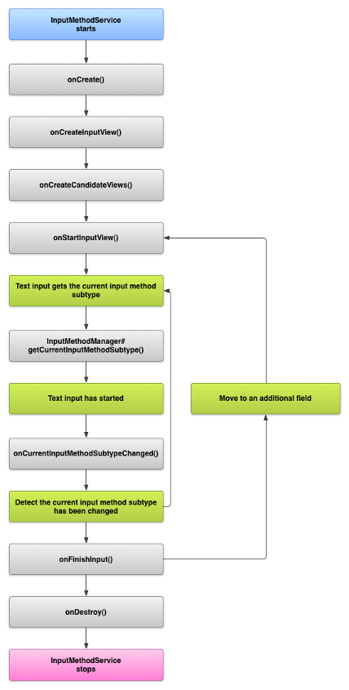
Figure 4-28 IME Lifecycle
Image reprinted courtesy of Android

The Input Method API

The primary function of the input method is to be a service component. The InputMethodService class will handle the following bulleted points:
- User Input
- Deliver Text to Fields on Screen
- Handling the User Interface of the IME
- visibility of the keyboard
- Communicating with Current Text Field
The two other classes that will frequently be called in the MirrorMate code are KeyboardView and BaseInputConnection.
KeyboardView
This class is an extension of the View class and will respond to input evens by the user. This will need to be defined by calling an instance of Keyboard and can also be specified in XML
BaseInputConnection
The BaseInputConnection class is used to define the communication channel between the application and the InputMethod. MirrorMate will use this class to commit text on a text field and send raw key events to MirrorMate. As the development gets underway, the MirrorMate development Team should extend the class, appose to implementing the base interface InputConnection
Spellchecker
Spellchecker is a text service API included with the Android platform. The below flow diagram shows the lifecycle of the service.
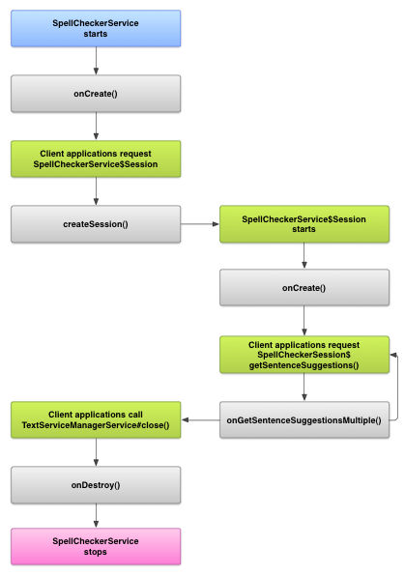
Figure 4-29 Spell Check Lifecycle
Image reprinted courtesy of Android

After careful consideration, the MirrorMate development Team decided not to implement spellchecker for a few reasons. The first being the level of complexity added to the app. With the limited time and resources, the development Team believed resources should be dedicated toward more demanding features. Also, most text being typed into the app will not need spellchecker.

Sending Text to the Application
Best Practices
According to the Android API, Google has set 5 good practices to follow when creating Android applications. They are as follows:

- Improving App Quality
- Say Goodbye to the Menu Button
- Tools for Managing Screen Sizes
- Identifying App Installations
- Making Android Games that Play Nice

Improving App Quality
The overall MirrorMate app quality is the most important “Best Practice” the development Team needs to do well. Quality means minimizing the amount of bugs. To do this, extensive testing needs to be done on both the hardware and software side. More on software testing can be found in Section 7.3.

Say Goodbye to the Menu Button
Tools for managing screen sizes and making Android games are not a top priority for the development Team. The primary goal of the MirrorMate app is to have it work with the one Android device the Team is using and to deliver the content to the rear view mirror.
Identifying App Installations
Identifying the number of times the MirrorMate application was installed on an Android device is not a top priority. Initially, there’s no apparent reason to track this information. If the MirrorMate development Team finds out that it’s needed in the application, one of the best ways to track the number of devices is to use the devices serial number. This is accessible through android.os.Build.SERIAL.
Making Android Games that Play Nice
Finally, since the MirrorMate application will not be an Android game, the best practices here won’t be utilized. The only best practice here to take mention is utilizing multicores if the device supports it, and resources are limited. At initial design, the MirrorMate Team felt utilizing multicores is not necessary.

4.10 GUI Development

This section details the development process and methodology behind the construction of the Graphical User Interface for both the Mirror and the Mobile Application.

4.10.1 Initial Design Considerations – Mirror and Application

The MirrorMate Mirror is intended to be a driver aid and safety device while simultaneously maintaining all standard functionality of a standard vehicle’s rear view mirror. To that end it was necessary to design the Mirror with only minimal distraction possibilities and at the same time the capabilities of passing on the relevant information. The Mirror’s display is located in only a portion of the left side of the surface as shown in the figure below.

Figure 4-30 LCD location

Due to the limited area of the display the large amount of information that could have been transmitted needed to be prioritized and limited accordingly.

Originally the MirrorMate Team had intended to directly copy the display of the mobile device onto the Mirror; however this was deemed to be inefficient for a number of reasons. The first was that the mirror was not intended to be an interactive device, instead it would be a display only. The display will be a simple LCD, rather than a touch-screen capable system. It would be possible to design the mirror with buttons that could replicate the functionality of the mobile device’s screen, but this was decided to be unproductive and unnecessarily complicated. Additionally the risk of allowing users to replicate their mobile device screens to the display would allow them the option of using the MirrorMate as an entertainment device rather than a safety system. The MirrorMate Team did not want to allow the system to be seen as a possible safety hazard and wanted to take steps to prevent that from happening.
The Mirror will instead display only very limited information, such as a cardinal direction, outside temperature, future directions and indicator lights for possible altered speed zones. The bulk of the display will feature a very large and easily readable directional indicator for the next turn the vehicle was required to make to get to their intended destination. Many GPS navigation systems can be attached to the windshield or dashboard and give what was deemed to be extraneous information such as estimated time of arrival or current speed. The MirrorMate system is not designed to replicate information that can be viewed elsewhere, as this would likely be just another distraction to keep the driver’s eyes off the road. This was another point of information used in the deliberation of the integration of the OBD-II sensor into the MirrorMate System.
The final step in making sure the MirrorMate Mirror would not be another distraction was to implement the message of “Please Use Mobile Device” whenever Bluetooth communications were enabled but there was action required by the user. This is intended to keep the driver from being confused as to whether or not the system is malfunctioning when there was no helpful information present. The MirrorMate System is intended to be interacted with only when the vehicle is stationary and when the vehicle is in motion only as an additional informational aid. The user will be presented with this acknowledgement whenever the MirrorMate App is launched.

4.10.2 Final Design Implementation – Mirror

The MirrorMate Mirror will only have critical information displayed in the LCD and it was concluded that the Team would rather take a risk in underutilizing the capabilities of the LCD rather than creating a remarkable display that only serves to distract the driver from more important things. The LCD screen is divided into 5 major segments so that the user can always expect to see the same information in the same manner, and be immediately aware based on location what the corresponding message is referring to.
The MirrorMate Mirror display shows the navigation direction, the cardinal heading, the outside temperature, an indicator of the direction of the upcoming alert zone (if any) as well as a small section for additional information as shown in the figure below.

Figure 4-31 LCD Map

Navigation Directions
The following shapes and symbols are used to show the driver the next required navigation decision.
MirrorMate Display | Description
← | Indicates that a left turn is required at an upcoming junction
↖ | Indicates that the driver should keep left during an upcoming fork in the road
↑ | Indicates the driver should remain straight at an upcoming junction
↗ | Indicates that the driver should keep right during an upcoming fork in the road
→ | Indicates that a right turn is required at an upcoming junction
U | Indicates that the driver should perform a U-turn as soon as possible
Figure 4-32 Mirror Display Description

Cardinal Direction Heading

The display shows the compass direction that the vehicle pointing towards in the upper left hand corner of the screen, using standard notation:
N, NE, E, SE, S, W, NW
Outside Temperature
The outside temperature is displayed in the top right corner of the screen using standard numbers in degrees Fahrenheit.
Zone Direction Indicator
The speed zone alert system allows the MirrorMate System to detect the direction of the upcoming alert zone, or emergency vehicle. This segment of the screen shows an arrow indicating the direction the zone or vehicle is approaching from. This feature allows the driver to know the direction an emergency vehicle may be approaching an intersection from.
Notifications by Color
The Zone Direction segment of the display changes to the appropriate color as shown in the figure below based on the upcoming alert type.

MirrorMate Display Color | Description
RED | Emergency Vehicle is approaching
ORANGE | The vehicle is approaching a construction zone
YELLOW | The vehicle is approaching a school zone.
BLUE | The vehicle is approaching a special event zone that has an altered speed limit.
Figure 4-33 LCD Color Chart

This division by color allows the driver to see out of the corner of their eye the corresponding alert type that is being approached. For example, an arrow pointing left on a red background will show that an emergency vehicle is approaching the driver from the left, or a straight arrow on an orange background will show that a construction zone is being approached ahead.

Initial Design Considerations – Application

The MirrorMate Application required similar design constraints to the Mirror System, as it too is intended to be a system that serves as a safety device and aid rather than a distraction. To this end, the application is intended to be designed using simple, short and to the point text messages. Whenever possible the app is designed to convey the information on the screen in 10 words or less. In every screen displayed on the application developers attempted to make sure there would be only 2 buttons to choose from, ensuring a streamlined and simple movement flow from one screen to the next. While some exceptions must be made, especially in the case of the main menu screen, these guidelines allow for a sleek and clean display that is not bogged down by extraneous choices, and is also be able to load very quickly.
These arbitrary numbers were chosen in order to make sure each instruction can be read in a single glance. The use of the Android OS means that the MirrorMate system can be used on an unknown number and type of devices and the MirrorMate Developers would not know the exact specifications of the device to be used. This comes as a minor setback to the development process, for example all iPhone developers know (at least to the current generation) the exact specifications, screen size, computing power and all the other features of the device that their application will be run on. The MirrorMate Team had to attempt to design a system that would work on both large screens and small, with and without actual keyboards and any number of possible computing systems. As the only requirements for the mobile device are that it requires Bluetooth and the ability to run on Android, the device could be a phone or a tablet. These unknowns meant that the system simple design will allow for maximum functionality across the range of platforms that the Application can be run on.
4.10.3 Final Design Implementation – Application

The basic principles discussed were important to the design of the final MirrorMate App. The App will be concise and to the point in conveying the necessary information and will attempt to limit confusion by keeping the user’s choices per screen to 2 or 3 buttons each.

The screens of the application are described in the table below, which lists the number and title of each screen as well as a description of its purpose, the contents of the screen and the buttons that accompany it.

Screen number | Screen Title | Description | Text | Buttons
1 | MirrorMate Title | Loading Screen | MirrorMate App  Please do not use this application when the vehicle is in motion.  Loading… | (None)
2 | Bluetooth Connection | Allows for immediate pairing with the Mirror | Pair With Bluetooth | “Pair Now”  “Main Menu”
3 | Bluetooth Connectivity 1 | Displays when pairing is being attempted- Scanning | Searching | (None)
4 | Bluetooth Connectivity 2 | Shows detected device information | Pair With This Device?  (Device Code) | “Confirm”  “Pair With Another Device”  “Main Menu”
5 | Main Application | Allows the user to select function | MirrorMate | “Show Map”  “Get Directions”  “Pair w/ Bluetooth”  “Exit”
6 | Local Map | Shows a map of the immediate surroundings with a red dot showing the position of the vehicle | (None) | “Main Menu”  “Update”
Figure 4-34 Application Screen Breakdown

The table below is a continuation of the previous table and also shows the screens of the application, as well as listing the number and title of each screen and a description of its purpose, the contents of the screen and the buttons that accompany it.
Screen number | Screen Title | Description | Text | Buttons
7 | Directions Request | Allows the user to specify a final destination to create a route to | Get Directions From Current Location To: | (None)
8 | Direction Confirmation | Allows the user to confirm the final destination | Is This Correct?  Start Point:  End Point: | “Yes”  “No”
9 | Calculation | Displays when the App is attempting to create a route | Calculating | (None)
10 | Directions List | Shows a list of the turns in the driving route | Driving Directions  List of Turns:  1. 2. 3. (etc) | “Main Menu”  “Exit”
Figure 4-35 Application Screen Breakdown

The flowchart below shows the interactions between the screens in the MirrorMate Application. Each piece in the flowchart is identified by the screen title from the figures above.
Figure 4-36 Application Flowchart

4.11 PCB Design

4.11.1 MirrorMate PCB

MirrorMate will require a custom PCB for the mounting and operation of many internal components. This PCB will fit entirely within the Gentex mirror enclosure and utilize as many mounting locations provided by the mirror enclosure as possible. The original circuit board that controls the auto dimming functions in the Gentex mirror will be removed and the mounting locations will be replicated as close as possible onto the MirrorMate PCB. The MirrorMate PCB will fit into the right side of the mirror (facing the reflective portion). The PCB will be placed in this location to avoid interference with the LCD installation. Since a majority of the functions that MirrorMate performs occur within firmware on the microcontroller, the PCB itself will be relatively small as part counts are low. The perimeter of the PCB will be rounded to fit neatly inside the mirror. This will also allow for efficient board space use as most of the available space inside the mirror will be available. One drawback to a rounded board is this usually increases manufacturing costs.

Components will be mounted to the PCB so that the Gentex mirror enclosure can be re-assembled without any external modifications. This placed design constraints on component placement on the PCB. Physically, the largest component on the PCB will be the Bluetooth module. This will be placed near the center of the mirror as this location provides adequate clearance for the height of the module. Components that will be transmitting serial data will be placed closely to each other as to minimize cross talk. Components have been placed on the board to optimize trace routing and interference. Figure 4-37 details PCB location inside the mirror and layout of electrical components.

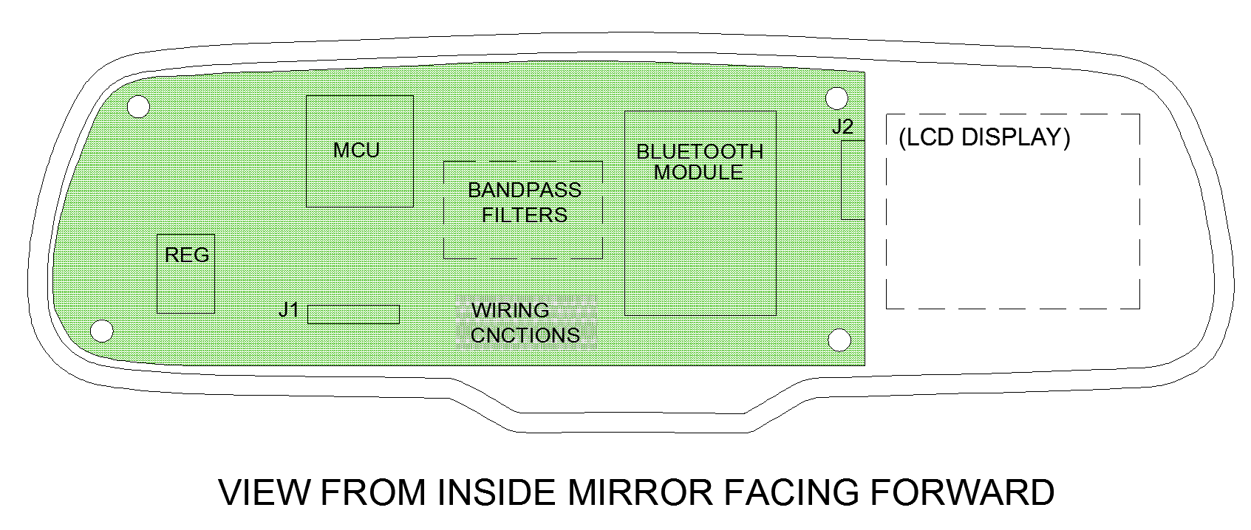

Figure 4-37 MirrorMate PCB Layout
4.11.2 IR Beacon PCB

The reduced speed zone beacon will also require a PCB for the operation and placement of electronic components. Compared to the MirrorMate PCB, much less physical constraints are placed on the design of the beacon PCB. The PCB will be designed with physical dimensions to fit into the ‘face’ of the enclosure. Also, the perimeter of the PCB will be a rectangle which will decrease manufacturing costs. The LED emitter array will be directly mounted to the PCB and will protrude externally through holes in the face of the enclosure. The LCDs will be soldered to the board on the opposite side than the rest of the components.

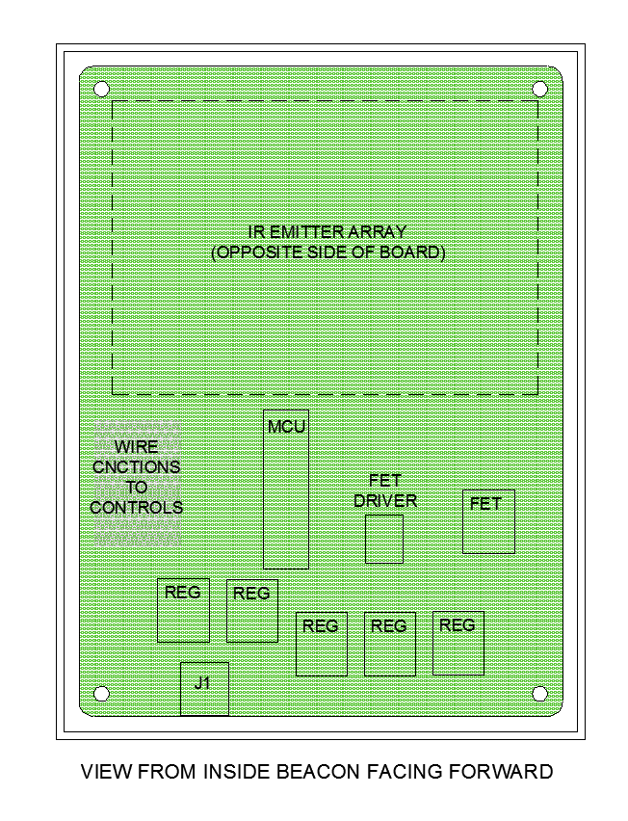
All components located on the control panel portion of the beacon will be hard mounted to the enclosure and connected to the PCB via wiring. This is because these components are located at a 90° to the PCB. The power connector is a barrel type connector and will be located on the PCB. Provisions will be made in the enclosure to ensure that the power connector is accessible externally. Components will be located efficiently on the PCB and all components utilizing signals will be physically located close to one another on the PCB. This is further illustrated in Figure 4-38.

Figure 4-38 IR Beacon PCB Layout

5.0 Design Summary of Hardware and Software

5.1 Drawing Package
5.1.1 MirrorMate Schematics
The schematic below represents sheet 1 of MirrorMate detailed electrical design.
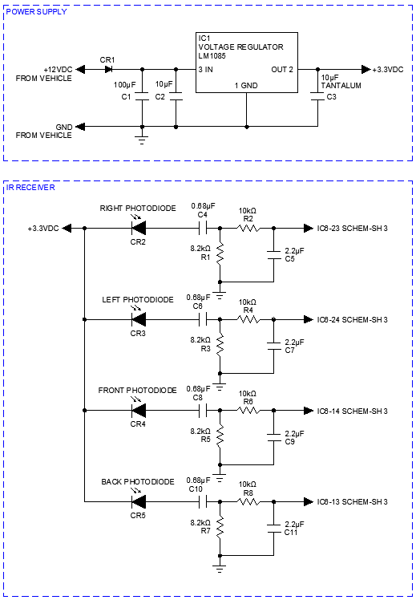

Figure 5-1 MirrorMate Schematics Sheet 1

The schematic below represents sheet 2 of MirrorMate detailed electrical design.
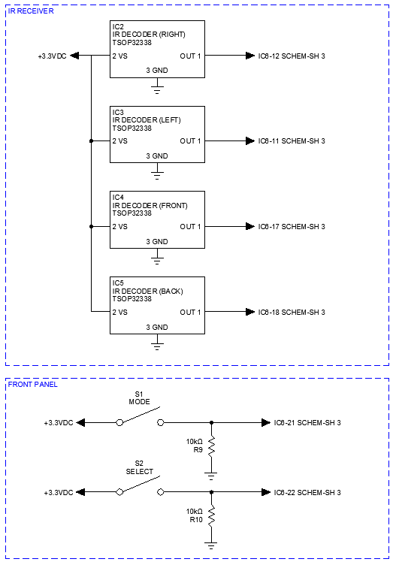

Figure 5-2 MirrorMate Schematics Sheet 2

The schematic below represents sheet 3 of MirrorMate detailed electrical design.

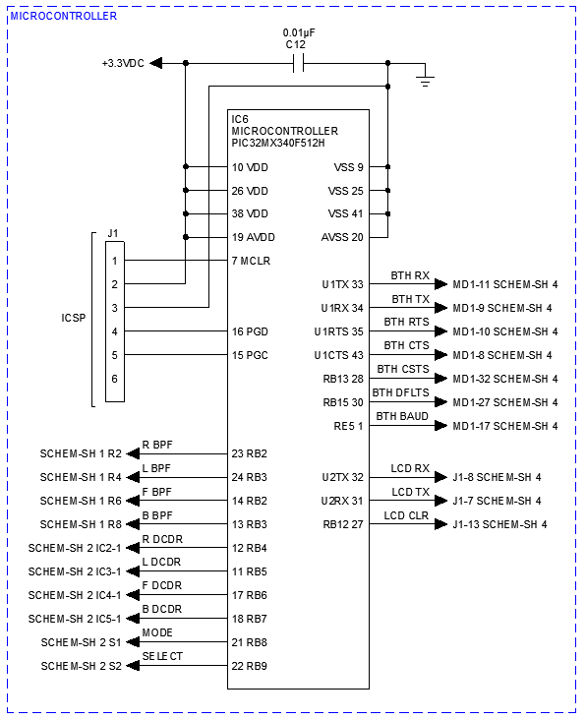

Figure 5-3 MirrorMate Schematics Sheet 3

The schematic below represents sheet 4 of MirrorMate detailed electrical design.
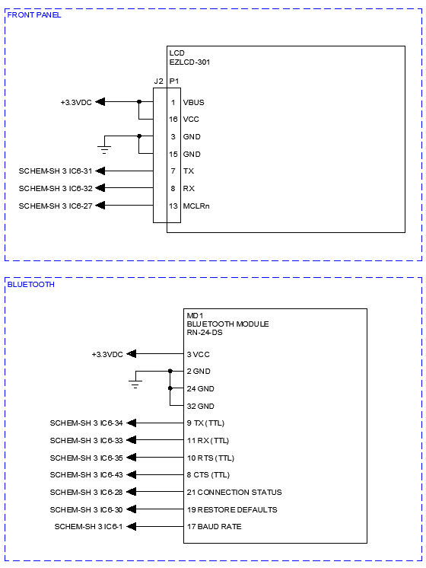

Figure 5-4 MirrorMate Schematics Sheet 4

5.1.2 Reduced Speed Zone Beacon Schematics

The schematic below represents sheet 1 of the IR beacon detailed electrical design.
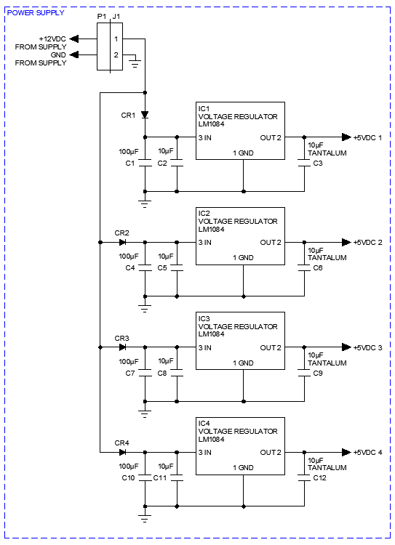

Figure 5-5 IR Beacon Schematics Sheet 1

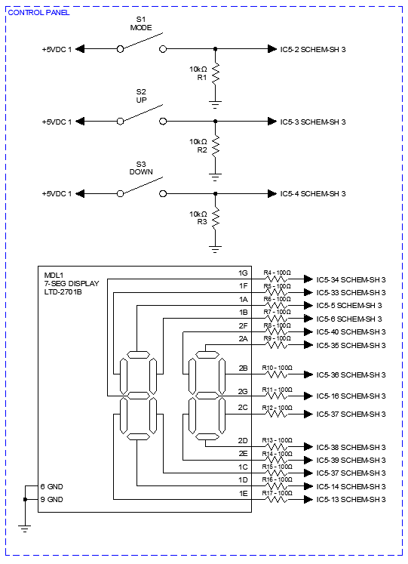
The schematic below represents sheet 2 of the IR beacon detailed electrical design.

Figure 5-6 IR Beacon Schematics Sheet 2

The schematic below represents sheet 3 of the IR beacon detailed electrical design.
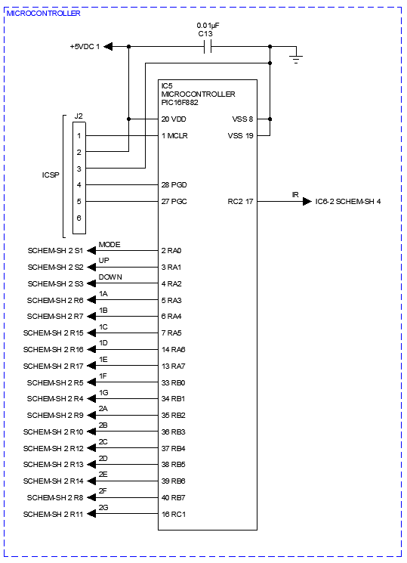

Figure 5-7 IR Beacon Schematics Sheet 3
The schematic below represents sheet 4 of the IR beacon detailed electrical design.
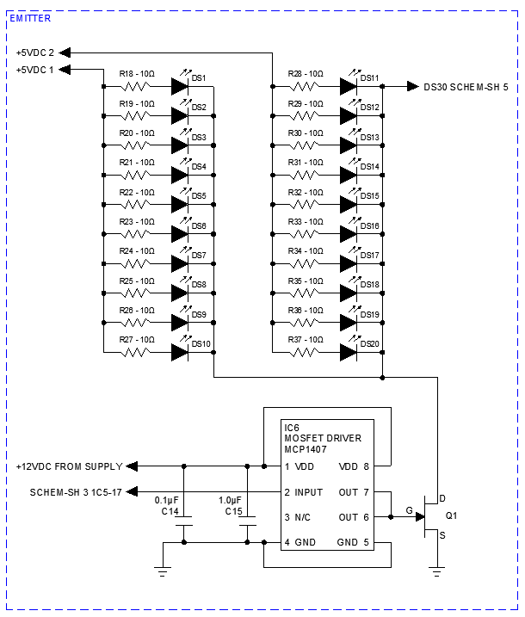

Figure 5-8 IR Beacon Schematics Sheet 4
The schematic below represents sheet 5 of the IR beacon detailed electrical design.
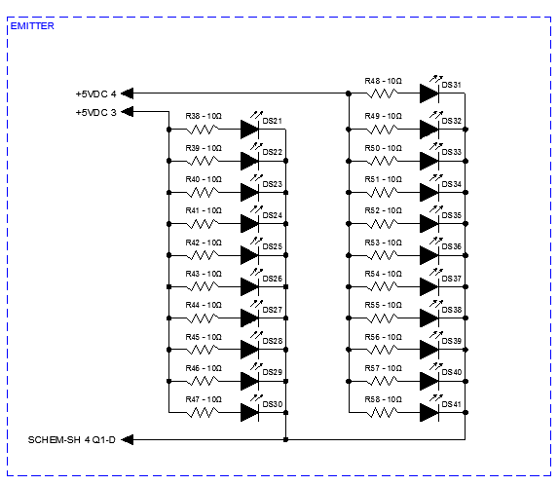

Figure 5-9 IR Beacon Schematics Sheet 5

5.1.3 UML Diagrams
Figure 5-10 Application Activity Diagram

Figure 5-11 Use Case Diagram

Figure 5-12 Architecture Design

5.1.4 Flow Charts
Figure 5-13 Application Flowchart

Figure 5-14 Navigation Flow Chart

5.1.5 Build Of Materials

The Table below shows the parts list for the Mirror components of the MirrorMate system.
PARTS LIST |  |  | MirrorMate
Find No. | Qty. | Part No. |  | Description |  | Ref
1 | 1 | 50-GENK2A |  | Mirror, Auto-dimming, Automotive
2 | 1 | 0100 |  | PCB, MirrorMate
3 | 1 | PIC32MX340F512H |  | Microcontroller, 32bit, TQFP |  | IC2
4 | 1 | RN-24-DS |  | Bluetooth module, RS232, through hole |  | MD1
5 | 1 | EZLCD-301 |  | LCD, color, 2.6", RS232
6 | 1 | LM1085 |  | Voltage regulator, 3.3V, 3A, TO-220 |  | IC1
7 | 1 | BY500-600-E3/54 |  | Diode, standard, 5A, through hole |  | CR1
8 | 4 | TSOP32338 |  | IR receiver, 38kHz, 950nm, noise immune |  | IC3-6
9 | 4 | TEFD4300F |  | Photodiode, 950nm, through hole |  | CR2-5
10 | 2 | PS1024ALBLK |  | Switch, panel mount, spst |  | S1, S2
11 | 1 | 68002-406HLF |  | Connector, header, 6pos, through hole |  | J1
12 | 1 | DF11-16DS-2C |  | Connector, female, 16pos, LCD |  | J2
13 | 1 | 25PK100MEFC5X11 |  | Capacitor, 100µF, 25V, electrolytic, automotive |  | C1
14 | 1 | FK26Y5V1C106Z |  | Capacitor, 10µF, 25V, ceramic, through hole |  | C2
15 | 1 | 173D106X9010VW3 |  | Capacitor, 10µF, 10V, tantalum, through hole |  | C3
16 | 4 | FK28X5R0J106M |  | Capacitor, 2.2µF, 6.3V, ceramic, through hole |  | C5,C7,C9, C11
17 | 4 | FK28X5R1E684K |  | Capacitor, 0.68µF, 25V, ceramic, through hole |  | C4,C6,C8, C10
18 | 1 | A103K15X7RF5TH5 |  | Capacitor, 0.01µF, 50V, ceramic, through hole |  | C12
19 | 6 | CRF-25JR-52-10K |  | Resistor, 10KΩ, 1/4W 5% |  | R2,R4,R6,R8,R9, R10
20 | 4 | CRF-25JR-52-8K2 |  | Resistor, 8.2KΩ, 1/4W 5% |  | R1,R3,R5,R7

Figure 5-15 MirrorMate Parts List

PARTS LIST |  |  | IR Beacon
Find No. | Qty. | Part No. |  | Description |  | Ref
1 | 1 | CU-3283 |  | Enclosure, plastic, 6.10” x 4.60” x 2.60”, black.
2 | 1 | 0200 |  | PCB, IR Beacon
3 | 1 | PIC16F882 |  | Microcontroller, 8bit, 28-pin PDIP |  | IC5
4 | 4 | LM1084 |  | Voltage regulator, 5V, 5A, TO-220 |  | IC1-4
5 | 4 | BY500-600-E3/54 |  | Diode, standard, 5A, through hole |  | CR1,CR2,CR3,CR4
6 | 1 | LTD-2701 |  | Display, seven segment |  | MDL1
7 | 1 | MCP1407 |  | Driver, MOSFET, non-inverting 8-pin PDIP |  | IC6
8 | 1 | IRFZ44V |  | MOSFET, 115W, 50A, TO-220 |  | Q1
9 | 41 | SFH 4547 |  | IR emitter, high power, 950nm, 30° |  | DS1-DS41
10 | 3 | PS1057ABLK |  | Switch, push button, SPST, pnl mnt |  | S1-S3
11 | 1 | PJ-032BH |  | Connector, barrel, through hole |  | J1
12 | 1 | 68002-406HLF |  | Connector, header, 6pos, through hole |  | J2
13 | 4 | 25PK100MEFC5X11 |  | Capacitor, 100µF, 25V, electrolytic, automotive |  | C1,C4,C7, C10
14 | 4 | FK26Y5V1C106Z |  | Capacitor, 10µF, 25V, ceramic, through hole |  | C2,C5,C8, C11
15 | 4 | 173D106X9010VW3 |  | Capacitor, 10µF, 10V, tantalum, through hole |  | C3,C6,C9, C12
16 | 1 | FK28X7RR1H105K |  | Capacitor, 1.0µF, 10V, ceramic, through hole |  | C15
17 | 1 | FK28X7RR1H104K |  | Capacitor, 0.1µF, 50V, ceramic, through hole |  | C14
18 | 1 | A103K15X7RF5TH5 |  | Capacitor, 0.01µF, 50V, ceramic, through hole |  | C13
19 | 3 | CRF-25JR-52-10K |  | Resistor, 10KΩ, 1/4W 5% |  | R1-R3
20 | 14 | CRF-25JR-52-100R |  | Resistor, 100Ω, 1/4W 5% |  | R4-R17
21 | 41 | CRF-25JR-52-10R |  | Resistor, 10Ω, 1/4W 5% |  | R18-R58
Figure 5-16 IR Beacon Parts List

6.0 Project Prototype Testing

6.1 Initial Prototype Testing

This section describes the testing that takes place during the creation of the prototype.

6.1.1 Initial Hardware Testing

The MirrorMate Team performed some testing in the senior design lab on infrared communication. This was an example of a small IR beacon that’s emits a frequency at 3 kHz and a receiver that has an LED indicator that lights when in range of the beacon. This was to confirm that the LED’s are functional and to ensure the beacon was successfully transmitting a signal to the receiver. After several tests, the MirrorMate Team came to the conclusion that the beacon is going to need a large array of LEDs in order to send a proper signal to the receiver.

6.1.2 Initial Software Testing

This section deals with the testing undertaken during the software phase of the MirrorMate System’s development cycle. The section entitled Software Specific Testing contains the majority of the test plans for the finished prototype but testing is also required during the coding phase. Software development was divided into three majors sections, Bluetooth Connectivity, Mirror Display Integration, and Application Development.

Bluetooth Connectivity was expected to be the most difficult segment because no members of the MirrorMate had previous experience dealing with Bluetooth chips or Bluetooth connections. In order to test the Bluetooth functionality a segment of code was written for the Android OS that would allow the device to search for nearby Bluetooth devices and attempt a pairing. This segment would not require authentication as the main purpose of this testing was to utilize the Bluetooth library searching algorithms. Once a connection was made the new test was created to attempt to send information back and forth between the Bluetooth pair. The information amount and type was not important to the testing as all Bluetooth communication would follow in the same manner. Testing for larger blocks of information would require the use of the MirrorMate Mirror and the accompanied display.

After Bluetooth communication could be achieved between the devices, it was necessary to test for ability to send signals that could be displayed on the screen. Hardware testing had already been completed such that it was proven the display was able to take commands from the microcontroller and display the corresponding messages. Next it was necessary to send signals from the application via Bluetooth and have the microcontroller decode them and display the correct message. Due to the rather simple nature of the messages to be displayed, this was expected to be less difficult than the original hardware testing for the display. Hardware testing had already verified that a signal could be decoded to display a message and Bluetooth connectivity testing had proved a message could be transferred between the paired devices so this test was the culmination of both of those smaller tests.

The MirrorMate App was able to be written in conjuction with the other tests as a series of screens in a code skeleton of sorts before actual functionality was added. The movement between screens was tested first, and then piece by piece different features could be implemented into the code. Bluetooth connection code could be reused from the first test and implemented into Bluetooth pairing screens. Then code was created to retrieve the display of a local map from Google Maps. Testing could then begin on the creation of a driving route from original destination to the final destination. Final functionality testing combined all of the previous test segments into using the App to connect to the Mirror through Bluetooth, create a driving route, and then send the appropriate signals to the Mirror and verify that it would display the appropriate messages on the display.
The Initial Software Testing (IST) was required to test major functions of the system during the development cycle. It is not expected that these tests will have formal documentation, instead opting that each programmer validates section functionality within their own coding environment. During final testing some minor features can be expected to be altered slightly but this segment of assessments is intended to ensure that major blocks of code can be written independently and minimize possible errors during the development process.

6.2 Hardware Specific Testing

The following involves testing procedures to verify that the MirrorMate system fulfills the Project Requirements and Specifications for the Hardware

6.2.1 Test Environment

The testing environment will first take place in the parking lot outside of the University of Central Florida Engineering Building. The MirrorMate will be first tested for installation when first entering the vehicle to replace the old mirror with a MirrorMate System, afterwards it will then be tested for activation to make sure the MirrorMate LCD display turns on properly.

Once MirrorMate is activated, the next testing environment is taken on the road driving along Gemini Blvd. where the Infrared Receiver Safety testing is initiated. On the road there are a couple of reduced speed zone beacons mounted to a post or barricade. One beacon is for construction zone areas, the next beacon is for school zone areas. The closest school zone is around over 2 miles away and construction zones come and go, so a predetermined route on-campus is prepared and the beacons are set up in certain area to make believe they are reduced speed zones. The IR Safety testing should demonstrate that the MirrorMate’s LCD display responds with notifications when within range of a beacon.

6.2.2 Hardware Testing

The following test procedures should adequately demonstrate the functions of MirrorMate’s responsive notifications and the IR Beacon’s signal transmission in order to fulfill all of the Hardware Requirement Specifications. The tables below should convey that as the test procedures followed along, the results should confirm what is supposed to happen at each step.

6.2.2.1 Activation and Initial LCD Display Test

The following table conveys what LCD in the MirrorMate is doing or displaying when it is first turned on.
Step | Procedure | Result
 | Turn the car on to start up the MirrorMate. | MirrorMate LCD display should turn on taking you the main menu.
 | Look to top left corner of LCD display. | Top left corner should display the current direction the vehicle is pointing towards. Depending on the direction the LCD will display N, S, E, W, NW, NE, SW, SE.
 | Look to top right corner of LCD display. | Top right corner should display the current temperature outside of the vehicle.
 | Look to bottom right corner of LCD display. | Bottom right corner always resets to blank when MirrorMate is off when car is turned off, but should display the speed of the current road the vehicle is on when in range of a speed zone.
 | Look to bottom left corner of LCD display. | Bottom Left Corner should display color coded notification based on specific alert when in range of an IR beacon/Opticom.
 | Press the Bluetooth button on the MirrorMate mirror. | The mirror should display the Bluetooth identification code on the mirror screen.  The App should display the identification code displayed on the mirror.
 | Look to center of LCD display. | Center of LCD should display turn-by-turn direction received from phone via Bluetooth.
Figure 6-1 LCD Activation Test

The activation and display test should verify the MirrorMate can be powered at 24W by a 12V charging system from the vehicle. Step 2-5 show that MirrorMate can display several standard automotive conditions on the screen and that if the MirrorMate successfully pairs with the phone via Bluetooth that no signal was produced to interfere with the operation of the Bluetooth device. This should accomplish HRS-001, HRS-002, HRS-003, HRS-004, HRS-005, HRS-006, HRS-007, and HRS-014. Further verification will be shown in the “Mirror Receiver Display Test” and the “Beacon/Opticom Transmitter Test”

6.2.2.2 Mirror Receiver Display Test

The following table conveys what happens when the Mirror receives an encoded signal for an IR Beacon or an Opticom Emergency Vehicle.

Step | Directions | Result
 | Drive down predetermined route to reach the first activated IR Beacon. Make-shift emergency vehicle approaches with opticom activated. | MirrorMate should receive encoded signal data from IR Beacon/Opticom within 1500 ft.
 | Encoded data sent from the receiver to the microcontroller. | MirrorMate decodes speed and zone type information.
 | Decoded data sent from microcontroller to the LCD display. | MirrorMate LCD should display colored coded notification based on alert.
 | Signal is produced from IR Beacon in construction zone. | MirrorMate LCD blinks and shows orange color in bottom left corner. And appropriate speed in the bottom right.
 | Signal is produced from IR Beacon in school zone. | MirrorMate LCD blinks and shows yellow color in bottom left corner. And appropriate speed in the bottom right.
 | Signal is produced from IR Beacon in special event zone. | MirrorMate LCD blinks and shows blue color in bottom left corner. And appropriate speed in the bottom right.
 | Signal is produced from Opticom Beacon from an emergency vehicle | MirrorMate LCD blinks and shows red color. Notifies driver to pullover.

Figure 6-2 Mirror Receiver Test

The Mirror Receiver Test should verify the MirrorMate can reliably receive encoded signal data from emergency vehicles and IR Beacons from within 1500 ft away at wavelength of 950nm. Step 3-7 show that MirrorMate can decode and display that signal data on the LCD display. This should accomplish HRS-008, HRS-009, HRS-010, HRS-011, HRS-012, and HRS-013.

6.2.2.3 Beacon/Opticom Transmitter Test

The following table conveys what the IR Beacon/Opticom is doing once it is activated.

Step | Procedure | Result
 | Mount IR Beacon onto a post or barricade. Mount Opticom beacon on make-shift emergency vehicle.
 | Push button to activate IR Beacon/Opticom. | Beacon is powered on and begins flashing LEDs at a current of 300mA. Seven segment display is turned on.
 | IR Beacon/Opticom begins to produce a signal of 35kHz | Beacon should be send out a signal to any MirrorMate within 3000 ft.
 | MirrorMate is within range of IR Beacon/Opticom. | Beacon shall transmit encoded information to MirrorMate. MirrorMate receives encoded signal data from IR Beacon/Opticom.

Figure 6-3 Beacon/Opticom Transmitter Test

The Beacon/Opticom Transmitter Test should verify that MirrorMate can reliably transmit encoded signal data to the MirrorMate from within 3000 ft away at wavelength of 950nm and a frequency of 35kHz. Step 2 shows that when MirrorMate is activated, if the LEDs being to flash then the Beacon/Opticom successfully powered from one of the following sources (12VDC, 24VDC, 120VAC). The IR Beacon/Opticom LEDs will run at a current of 300mA, which 30% of the LED’s full brightness. If the LEDs were running at full brightness, it could potentially blind drivers. Can decode and display that signal data on the LCD display. Also, if the MirrorMate receives the signal, then the beacon was demodulated and did not produce any signal that would interfere with the operations of the IrDA devices. This should accomplish HRS-015, HRS-016, HRS-017, HRS-018, HRS-019, HRS-020, HRS-021, HRS-022, and HRS-023.

6.3 Software Specific Testing

The following are the testing criteria to be used to verify that the MirrorMate system meets the Project Requirements and Specifications for Software as described in section 2.3 of this document.

6.3.1 Test Environment

The test environment will be set up by the MirrorMate Team on the day of prototype testing at the end of the spring semester. The MirrorMate mirror will be installed in an as yet undetermined vehicle belonging to a member of the Team. The MirrorMate app will be installed on a Team member’s mobile device at the start of the test as according to steps that follow in the User Acceptance Testing below. In order to save time the software may be installed before testing takes place.

The testing will take begin in the parking lot outside of the University of Central Florida Engineering Building and, following the UAT, travel around the UCF campus guided by the MirrorMate system. The User Acceptance Testing should be sufficiently thorough as to prove all functionality of the MirrorMate system. Prior to official testing the UAT will be recorded on video in order to demonstrate the MirrorMate system to those who are unable to witness the official testing.

6.3.2 User Acceptance Testing

The following test bank should sufficiently demonstrate the MirrorMate App capabilities as well as fulfill all of the Software Requirement Specifications. If the test directions are followed exactly the results should match those in the third column. These tests demonstrate all 11 screens used by the MirrorMate App as well as multiple confirmation and acceptance dialogue boxes.

6.3.2.1 Installation Testing

The following table is a list of directions for the installation test procedures to verify the MirrorMate System.

Step | Directions | Result
 | Insert the MirrorMate USB flash drive into the computer, with the mobile device attached to the computer, copy the MirrorMate Application from the flash drive to the mobile device. | MirrorMate Application should be copied to mobile device.
 | Tap the “MirrorMate Application” icon on the mobile device | MirrorMate installation screen should appear.
 | Tap the “Install” button on the prompt | Terms of Service screen should be presented.
 | Tap the “Accept” button to accept the terms of the installation.  Note: The installation process may take a few minutes to complete. | After installation the device should be returned to the home screen.
Figure 6-4 Application Installation Test

This installation test should verify that the MirrorMate application can be installed on the Android operating system. This accomplishes SRS-001.

6.3.2.2 Bluetooth Connectivity Testing

The following table is a list of directions for test procedures for the MirrorMate system to verify the ability of the system to pair two devices through Bluetooth.
Step | Directions | Result
 | Note: This test assumed the MirrorMate App has already been installed on the mobile device and the Mirror hardware installed in the vehicle as described by previous tests.
 | Tap the MirrorMate icon on the mobile device to start the MirrorMate application. | The MirrorMate App title screen should appear with a “Loading” message.  Wait for the Pair With Bluetooth screen to appear.
 | On the Pair With Bluetooth screen, tap the “Pair Now” button | The Bluetooth Connectivity Screen should appear.
 | Tap the “Sync” button to begin syncing mobile device with MirrorMate mirror. | The App should display a “Searching” message and attempt to pair.
 | Press the Bluetooth button on the MirrorMate mirror. | The mirror should display the Bluetooth identification code on the mirror screen.  The App should display the identification code displayed on the mirror.
 | Tap the “Search for another device” button on the App. | The App should display a “Searching” message and attempt to pair.
 | Press the Bluetooth button on the MirrorMate mirror. | The mirror should display the Bluetooth identification code on the mirror screen.  The App should display the identification code displayed on the mirror.
 | Tap the “Sync with this device” button on the App. | The devices should be synced. Both the Mirror and the app should display an identical screen showing “Devices Synced.” The app should then return to the main App screen, and the mirror should display a message reading “Please use Mobile Device”
Figure 6-5 Bluetooth Connectivity Test

This test should verify the ability of the MirrorMate App to sync with the MirrorMate mirror. Step 5 was added to show the ability of the system pair with another device if the first Bluetooth identification number displayed is not correct. This should accomplish SRS-002 and SRS-003. Further verification of Bluetooth communication will be shown by the “Local Map” testing and the “Destination Directions” tests.

6.3.2.3 Local Map Functionality Testing

The following table describes test procedures designed to prove that the MirrorMate system is capable of display the local map as part of the feature set.

Step | Directions | Result
 | Note: This test assumed the MirrorMate App has already been installed on the mobile device and the Mirror hardware installed in the vehicle as described by previous tests. Additionally this test assumes the mirror and mobile device have already been paired via Bluetooth as according to the “Bluetooth Connectivity” test. | This test begins with the MirrorMate Mirror displaying “Please Use Mobile Device” and the MirrorMate App on the main application screen.
 | From the MirrorMate main app screen tap the “Show Map” button. | The MirrorMate App should display a local map with a dot indicating the position of the vehicle on it.
 | Verify that the MirrorMate app and mirror both display the same local map and indicate the current position of the vehicle with a colored dot. | The App should display the local map as well as buttons labeled “Main Menu” and “Update”
 | After moving the vehicle a significant distance, tap the “Update” button on the app. | Verify that the screen and mirror both redraw the local map at a new location.
 | Tap the “Main Menu” button on the MirrorMate App. | The app should display the main application screen and the mirror should display the message “Please Use Mobile Device”
Figure 6-6 Local Map Functionality Test

This short list shows that the MirrorMate system is able to detect and display the mobile device’s current location as according to SRS-004. This test should also verify that the MirrorMate system is able to display a local map of the surrounding area on both the mobile device and the mirror. This should satisfy SRS-005 and SRS-006 as well as repeating the Bluetooth functionality of SRS-002. Steps 3 and 4 are added to ensure that the user can manually update the map rather than waiting the standard 20 seconds for an update to occur. This verifies SRS-007.
6.3.2.4 Driving Directions Testing

The figure below describes the directions necessary to test the MirrorMate App’s driving direction capabilities.

Step | Directions | Result
 | Note: This test assumed the MirrorMate App has already been installed on the mobile device and the Mirror hardware installed in the vehicle as described by previous tests. Additionally this test assumes the mirror and mobile device have already been paired via Bluetooth as according to the “Bluetooth Connectivity” test. | This test begins with the MirrorMate Mirror displaying “Please Use Mobile Device” and the MirrorMate App on the main application screen.
1. | From the MirrorMate main app screen tap the “Get Directions” button. | The app should display the Get Directions screen with a local map in the bottom section.
2. | Using the local map at the bottom of the screen tap a location to select a destination. | The app should display a small colored dot representing the selected location.
3. | Tap the “Create Route” button. | The app should display a confirmation screen for the requested directions.
4. | Verify that the locations listed as “Start Point” and “End Point” are correct. | Start Point and End Point should be displayed with the message “Is this correct?”
5. | Tap the “No” button. | The app should return to the Get Directions screen with a local map in the bottom section.
6. | Using the local map at the bottom of the screen tap a location to select a destination. | The app should display a small colored dot representing the selected location.
7. | Tap the “Create Route” button. | The app should display a confirmation screen for the requested directions.
8. | Verify that the locations listed as “Start Point” and “End Point” are correct. | Start Point and End Point should be displayed with the message “Is this correct?”
9. | Tap the “Yes” button. | The app and the mirror should both display a screen stating “Calculating” as the app retrieves driving directions.
10. | Verify that after a short time the app displays a “Driving Directions” screen with a list of turns required to reach the destination.  Verify that the mirror is displaying the first turn shown on the app list. | All directions should be shown on the mobile device with the first being displayed on the mirror.
11. | Drive the vehicle to the first intersection and perform the required maneuver. Tap the “Next” button on the app screen. | The app should highlight the next turn in the list of driving directions and the mirror should display the next turn on the display.
12. | Tap the “Recalculate Route” button on the mobile device. | The app and the mirror should both display a screen stating “Calculating” as the app retrieves driving directions.
13. | Verify that after a short time the app displays a “Driving Directions” screen with a list of turns required to reach the destination.  Verify that the mirror is displaying the first turn shown on the app list.  Verify that these directions start at the current location and end at the requested endpoint, and have been updated from the original starting location. | Updated directions should be shown on the mobile device with the first being displayed on the mirror.
14. | Complete the driving sequence to arrive at the intended destination. | MirrorMate system should display directions guiding the vehicle to the requested ending location.
15. | Tap the “Main Menu” button on the MirrorMate App. | The MirrorMate App should return to the main application screen and the mirror should show “Please use Mobile Device” on the display.
Figure 6-7 Driving Directions Test

This test is demonstrates the driving direction capabilities of the MirrorMate system. It proves that the MirrorMate system is able to detect the system’s current position as required by SRS-004. This test should also verify that the MirrorMate system is able to calculate directions based on the current location of the system, and display a list of driving directions. This will achieve SRS-008 and SRS-009. The mirror should be able to replicate the instructions and display the next turn on the display as according to SRS-011. The test also shows that the system is able to reconfigure directions if the original destination was incorrect as required by SRS-012. Additionally this test shows that the system is able to reconfigure and update directions as the vehicle moves through the travel path and display the new list and turns on the MirrorMate App and mirror display respectively. This exhibits the capabilities of the system and validates SRS-013 and SRS-014.

6.3.2.5 Application Exit and Termination Testing

The figure below describes the directions necessary to verify that the MirrorMate App is able to be properly exited and terminate an established Bluetooth pairing.

Step | Directions | Result
 | Note: This test assumed the MirrorMate App has already been installed on the mobile device and the Mirror hardware installed in the vehicle as described by previous tests. Additionally this test assumes the mirror and mobile device have already been paired via Bluetooth as according to the “Bluetooth Connectivity” test. | This test begins with the MirrorMate Mirror displaying “Please Use Mobile Device” and the MirrorMate App on the main application screen.
1. | From the MirrorMate main app screen tap the “Exit” button. | The app should display a confirmation of exit message.
2. | Tap the “No” button to reject closing the application. | The app should return to the main application screen.
3. | From the MirrorMate main app screen tap the “Exit” button. | The app should display a confirmation of exit message.
4. | Tap the “Yes” button to confirm closing the application. | The app should terminate and return to the mobile device home page. The mirror should return to a blank display.
 | Tap the MirrorMate icon on the mobile device to start the MirrorMate application. | The MirrorMate App title screen should appear with a “Loading” message.  Wait for the Pair With Bluetooth screen to appear.
 | Tap the “Main Menu” button. | The MirrorMate App should display the main application screen.
 | From the MirrorMate main app screen tap the “Exit” button. | The app should display a confirmation of exit message.
 | Tap the “Yes” button to confirm closing the application. | The app should terminate and return to the mobile device home page. The mirror should return to a blank display.
 | Verify using the task manager on the mobile device to confirm that the application has ceased running. | The application should no longer be listed in the running processes.
Figure 6-8 Application Exit and Termination Test

This test shows that the MirrorMate Application is able to be closed, ceasing the process on the mobile device. This demonstrates the successful completion of SRS-015. The test also shows that the MirrorMate mirror will return to the original state when the MirrorMate App is closed as described by SRS-016. The second half of the test proves that the MirrorMate system is capable of successfully terminating a Bluetooth pairing, as demonstrated by the App showing a “Pair Now” button again upon the second running of the program. This “Pair Now” screen is only displayed when the MirrorMate App is not already coupled with a Mirror. This achieves SRS-017.

6.3.2.6 Complete Application Functionality Testing

The table below is designed to show the full functionality of the MirrorMate Application and all of its features. This test repeats some portions of previous tests.

Step | Directions | Result
 | Note: This test is intended to demonstrate the entire functionality of the MirrorMate Application and repeats some portions of previous tests. | This test begins at the mobile device home screen.
1. | Insert the MirrorMate USB flash drive into the computer, with the mobile device attached to the computer, copy the MirrorMate Application from the flash drive to the mobile device. | MirrorMate Application should be copied to mobile device.
2. | Tap the “MirrorMate Application” icon on the mobile device | MirrorMate installation screen should appear.
3. | Tap the “Install” button on the prompt | Terms of Service screen should be presented.
4. | Tap the “Accept” button to accept the terms of the installation.  Note: The installation process may take a few minutes to complete. | After installation the device should be returned to the home screen.
5. | Tap the MirrorMate icon on the mobile device to start the MirrorMate application. | The MirrorMate App title screen should appear with a “Loading” message.  Wait for the Pair With Bluetooth screen to appear.
6. | On the Pair With Bluetooth screen, tap the “Main Menu” button | The MirrorMate App main application screen.
7. | From the MirrorMate main app screen tap the “Show Map” button. | The MirrorMate App should display a local map with a dot indicating the position of the vehicle on it.  The App should display the local map as well as buttons labeled “Main Menu” and “Update”
 | After moving the vehicle a significant distance, tap the “Update” button on the app. | Verify that the app screen will redraw the local map at a new location.
 | Tap the “Main Menu” button on the MirrorMate App. | The App should display the main application screen.
 | From the MirrorMate main app screen tap the “Get Directions” button. | The app should display the Get Directions screen with a local map in the bottom section.
 | Using the local map at the bottom of the screen tap a location to select a destination. | The app should display a small colored dot representing the selected location.
 | Tap the “Create Route” button. | The app should display a confirmation screen for the requested directions.
 | Verify that the locations listed as “Start Point” and “End Point” are correct. | Start Point and End Point should be displayed with the message “Is this correct?”
 | Tap the “Yes” button. | The app should display a screen stating “Calculating” as the app retrieves driving directions.
 | Verify that after a short time the app displays a “Driving Directions” screen with a list of turns required to reach the destination. | All directions should be shown in list form on the mobile device.
 | Tap the “Main Menu” button on the mobile device screen. | The app will return to the main screen.
 | Tap the “Pair with Bluetooth” button. | The Bluetooth Connectivity Screen should appear.
 | Tap the “Sync” button to begin syncing mobile device with MirrorMate mirror. | The App should display a “Searching” message and attempt to pair.
 | Press the Bluetooth button on the MirrorMate mirror. | The mirror should display the Bluetooth identification code on the mirror screen.  The App should display the identification code displayed on the mirror.
 | Tap the “Sync with this device” button on the App. | The devices should be synced. Both the Mirror and the App should display an identical screen showing “Devices Synced.” The MirrorMate App should then return to the main app screen, and the mirror should display a message reading “Please use Mobile Device”
 | From the MirrorMate main app screen tap the “Show Map” button. | The MirrorMate App should display a local map with a dot indicating the position of the vehicle on it.
 | Verify that the MirrorMate app and mirror both display the same local map and indicate the current position of the vehicle with a colored dot. | The App should display the local map as well as buttons labeled “Main Menu” and “Update”
 | After moving the vehicle a significant distance, tap the “Update” button on the app. | Verify that the screen and mirror both redraw the local map at a new location.
 | Tap the “Main Menu” button on the MirrorMate App. | The app should display the main application screen and the mirror should display the message “Please Use Mobile Device”
 | From the MirrorMate main app screen tap the “Get Directions” button. | The app should display the Get Directions screen with a local map in the bottom section.
 | Using the local map at the bottom of the screen tap a location to select a destination. | The app should display a small colored dot representing the selected location.
 | Tap the “Create Route” button. | The app should display a confirmation screen for the requested directions.
 | Verify that the locations listed as “Start Point” and “End Point” are correct. | Start Point and End Point should be displayed with the message “Is this correct?”
 | Tap the “Yes” button. | The app and the mirror should both display a screen stating “Calculating” as the app retrieves driving directions.
 | Verify that after a short time the app displays a “Driving Directions” screen with a list of turns required to reach the destination.  Verify that the mirror is displaying the first turn shown on the app list. | All directions should be shown on the mobile device with the first being displayed on the mirror.
 | Drive the vehicle to the first intersection and perform the required maneuver. Tap the “Next” button on the app screen. | The app should highlight the next turn in the list of driving directions and the mirror should display the next turn on the display.
 | Tap the “Recalculate Route” button on the mobile device. | The app and the mirror should both display a screen stating “Calculating” as the app retrieves driving directions.
 | Verify that after a short time the app displays a “Driving Directions” screen with a list of turns required to reach the destination.  Verify that the mirror is displaying the first turn shown on the app list.  Verify that these directions start at the current location and end at the requested endpoint, and have been updated from the original starting location. | Updated directions should be shown on the mobile device with the first being displayed on the mirror.
 | Complete the driving sequence to arrive at the intended destination. | MirrorMate system should display directions guiding the vehicle to the requested ending location.
 | Tap the “Main Menu” button on the MirrorMate App. | The MirrorMate App should return to the main application screen and the mirror should show “Please use Mobile Device” on the display.
 | From the MirrorMate main app screen tap the “Exit” button. | The app should display a confirmation of exit message.
 | Tap the “Yes” button to confirm closing the application. | The app should terminate and return to the mobile device home page. The mirror should return to a blank display.
 | Tap the MirrorMate icon on the mobile device to start the MirrorMate application. | The MirrorMate App title screen should appear with a “Loading” message.  Wait for the Pair With Bluetooth screen to appear.
 | Tap the “Main Menu” button. | The MirrorMate App should display the main application screen.
 | From the MirrorMate main app screen tap the “Exit” button. | The app should display a confirmation of exit message.
 | Tap the “Yes” button to confirm closing the application. | The app should terminate and return to the mobile device home page. The mirror should return to a blank display.
 | Verify using the task manager on the mobile device to confirm that the application has ceased running. | The application should no longer be listed in the running processes.
Figure 6-9 Functionality Test

This test should verify the abilities of all functions of the MirrorMate system and should further verify all previous SRS designations. Additionally this test demonstrates the ability of the system to function as a local map or create driving directions without the need to pair via Bluetooth with the mirror. This demonstrates SRS-010.

6.3.3 Unit Testing

The unit testing for the MirrorMate software will be developed in turn with the code itself. Each class will be tested individually and independently during the coding process. The test procedures as listed for the User Acceptance Testing were designed to fulfill the pre-determined SRS list but the Unit Testing did not require formal documentation, as a result many of the tests were not developed until the code building will be completed. Wherever possible the classes developed will be tested independently such that the errors in code can be narrowed and eliminated as quickly as possible.
Full documentation of the Unit Testing can be expected to be included in the final report when the MirrorMate prototyping is finished.
6.3.4 Performance Testing

The MirrorMate Application was designed to be used with one mirror on one mobile device. The highest stress level would be found during Bluetooth pairing if there were more than one mobile device attempting to pair at the same time. A Bluetooth pairing would only be attempted if multiple mobile devices were in search mode concurrently, which is highly unlikely to happen in a standard scenario. The UAT demonstrates attempted pairing multiple times such that this problem would be alleviated.

The highest stress levels affecting the software itself will be seen when the app has a low signal strength or when the local directions are not precise enough to place the vehicle on the correct street. Both of the scenarios can be achieved by using the MirrorMate in a parking garage, as signal strength is low and streets are extremely narrow. This situation makes for the perfect testing environment and once standard operating environments testing is completed, further stress testing will verify that capabilities of the MirrorMate system are sufficient for working in low signal, urban areas.

7.0 Administrative Content

7.1 Milestone Discussion

The MirrorMate Team put together a rough schedule for next semester in Senior Design II. The below project schedule was divided into hardware and software milestonts. The below figure outlines the software development process in order to complete the Android app and interface with the rear view mirror.

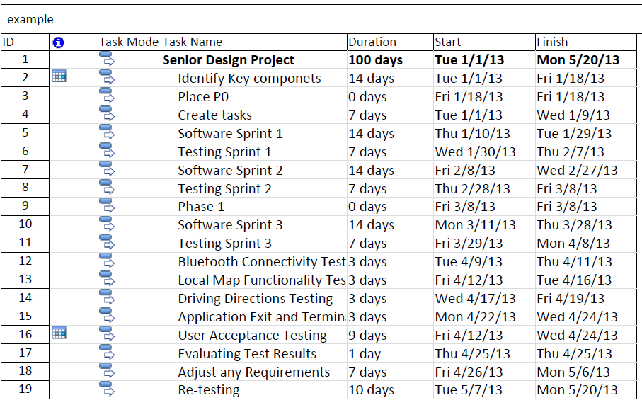
Figure 7-1 Software Milestones

The tentative schedule below outlines the hardware milestones for Senior Design II. Two members of the MirrorMate Team will work with the hardware and the other two members will work with the software.
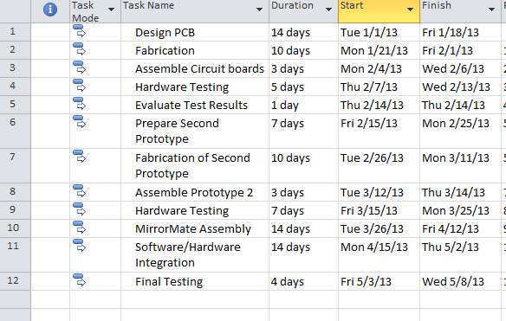
Figure 7-2 Hardware Milestones
7.2 Budget
The MirrorMate Team wasn’t able to obtain guaranteed sponsors. Because of this, the MirrorMate Team will split the costs of the entire project four ways. The below pie chart outlines the estimated costs of the entire project.

Figure 7-3 Budget Chart

7.3 Finance – Sponsorships

7.3.1 Gentex
Gentex is the leading manufacturer of ‘Mirror as a module’ devices. These are typical automotive rearview mirrors with advanced features such as auto-dimming and rear-view camera displays integrated behind the mirror glass. Due to the types of devices that Gentex specializes in designing and producing they would be interested in MirrorMate. The design goals of MirrorMate also coincide well with Gentex’s business model. These are goals of enhanced driver safety and unique features.
Gentex and the MirrorMate Team would realize mutual benefits in a partnership. Gentex would be provided design and intellectual property where as the MirrorMate Team could utilize some mirrors from Gentex’s product line. Gentex has been contact and currently have not committed to any assistance towards the MirrorMate endeavor. The MirrorMate Team will continue to pursue a sponsorship with Gentex.

7.3.2 Department of Transportation

The Department of Transportation was established by Congress and signed into law by President Lyndon B. Johnson on October 15, 1966. The first official day of operation was April 1, 1967. The main goal of the Department of Transportation is to provide, develop and coordinate policies that create efficient and economical transportation across the nation. It has the following mission statement:
“Serve the United States by ensuring a fast, safe, efficient, accessible and convenient transportation system that meets our vital national interests and enhances the quality of life of the American people, today and into the future”
Based on the mission statement, the MirrorMate Team felt this government organization would benefit greatly from the safety enhancements of the MirrorMate interactive rear view mirror. By eliminating taking your phone out to look at the screen, this device has the possibility of lowering traffic accidents. Furthermore, the enhanced notification system of emergency vehicles and special beacons to be placed at slow-down speeds will reduce accidents and deaths caused by accidents. The MirrorMate Team contacted the DOT through their online ticketing system. Unfortunately, no response was returned since the time of writing this. The MirrorMate Team will continue to reach out to the Department of Transportation for future sponsorships during Senior Design II.

7.3.4 Bob’s Barricades

Another potential sponsor was sought in the traffic control system and construction barricade company of Bob’s Barricades. As a leading provider of construction zones equipment Bob’s Barricades was expected to be a leading provider and user of the construction zone beacon being designed by the MirrorMate Team. If the MirrorMate system prototype went into production the company may be a potential buyer.

One of the main goals of Bob’s Barricades is the safety of both drivers and the construction crews working the local roads. The MirrorMate device would be another traffic safety device similar to the barricades, road-signs, and emergency lights that Bob’s Barricades already distributes.

Unfortunately repeated attempts to contact Bob’s Barricades about possible sponsorship were met without reply. Multiple business contacts were attempted through the company’s website and email but no formal conversations were had.

7.3.5 GTT
Global Traffic Technologies established from 3M’s Intelligent Transportation System business in 2007 is the leader in traffic management systems worldwide and has provided safe and dependable traffic solutions to the world of transportation for past 40 years. They are the manufacturers of the Opticom TM Priority Control System as well as the Canoga TM traffic sensing system.
GTT main commitment to innovation is “To proactively deliver advanced transportation solutions to help emergency, transit and traffic personnel increase safety, minimize traffic congestion and reduce greenhouse gas emissions, while maximizing resource efficiency and performance.
In the research the MirrorMate Team came across GTT's Opticom IR emergency vehicle preemption system. The MirrorMate Team observed that the Opticom IR system is used for control over traffic intersections, however the MirrorMate Team believed that it was also possible to implement the receiver into automotive vehicles so when the Opticom transmits that same signal to warn drivers to pullover out of the way in order to reduce the emergency response time for emergency vehicles en route to the scene. It also intended that emitter be mounted at posts and barricades to be used for reduced speed zone warnings in areas such as construction and school zones.
The MirrorMate Team contacted GTT through a grant funding assistance company called firegrantshelp.com and received an email within a few days and a call the day after. They informed the MirrorMate Team to develop a project budget to figure out how much funding was needed. Also to find out if the University of Central Florida is an applicant for any grants the MirrorMate Team applies for, which involves getting permission. The MirrorMate Team will continue to stay in contact with GTT.

7.3.6 Personal Contributions

As of December 5th, 2012, the MirrorMate Team does not have any sponsors for this project. The Team has gone to numerous companies including Gentex, the Department of Transportation, Microchip, Bob’s Barricades and Global Traffic Technologies. Unfortunately, none of these companies have agreed 100 percent to sponsor the MirrorMate project. The MirrorMate Team is currently in talks with Global Traffic Technologies and Microchip for possible sponsorship. Global Traffic Technologies may provide financial support to the Team while Microchip may provide hardware.
Appendix A List of Tables and Figures

Table 2-1 MirrorMate Hardware Requirements Specifications 7
Table 2-2 MirrorMate Hardware Requirements Specifications 8
Table 2-3 IR Beacon Hardware Requirements Specifications 9
Table 2-4 Software Requirements Specification 10
Figure 3-1 Gentex Auto-dimming LCD mirror 11
Figure 3-2 OnStar FMV mirror 12
Figure 3-3 Directus TD43TOUCH mirror 12
Figure 3-4 Bosch Automotive Ultrasonic Sensor 18
Figure 3-5 Maxbotix Ultrasonic Range Finder Sensor 18
Figure 3-6 Mobile Devices Market Share 22
Figure 3-7 Whelen light bar featuring a GTT 795H emitter in the center 24
Figure 3-8 GTT 700 Series Detectors 24
Figure 3-9 XT Racing Ultra Lap and beacon 26
Figure 3-10 LMH6640MF/NOPB Operational Amplifier 30
Figure 3-11 VCOM levels 30
Figure 3-12 VCOM Buffers 31
Figure 3-13 TW8811-LD2-GR TFT controller chip 32
Figure 3-15 TW8811-LD2-GR TFT controller chip schematic 32
Figure 3-16 TFT Controller Chip 33
Figure 4-1 LCD Location 35
Figure 4-2 BMW rearview mirror with IR 36
Figure 4-3 MirrorMate System Overview 37
Figure 4-4 MirrorMate Representation 37
Figure 4-5 PIC32MX340F512H Key Features 38
Table 4-6 MirrorMate Current Requirements 39
Figure 4-7 MirrorMate Power Supply 40
Figure 4-8 TFT Color LCD 41
Figure 4-9 TFT Color LCD schematic 42
Figure 4-10 Pixel Description 43
Figure 4-11 Polarized Light 44
Figure 4-12 Band Pass Filter 45
Figure 4-13 Band Pass Filter Characteristics 46
Figure 4-14 Reduced Speed Zone Data Byte 47
Figure 4-15 IR Beacon Overview 48
Figure 4-16 IR Beacon 3D Model 49
Figure 4-17 RC-5 Protocol 51
Figure 4-18 Manchester Coding 52
Figure 4-19 MirrorMate IR Command 52
Figure 4-20 LED Emitter Amplifier Design 54
Figure 4-21 Core Architecture 56
Figure 4-22 Profile Stack 57
Figure 4-23 Bluetooth Power Classes 58
Figure 4-24 Power Class Ranges 58
Figure 4-25 RN24 Bluetooth Module 60
Table 4-26 Application Hierarchy 68
Figure 4-27 Android Clipboard System 71
Figure 4-28 IME Lifecycle 72
Figure 4-29 Spell Check Lifecycle 74
Figure 4-30 LCD location 76
Figure 4-31 LCD Map 78
Figure 4-32 Mirror Display Description 78
Figure 4-33 LCD Color Chart 80
Figure 4-34 Application Screen Breakdown 82
Figure 4-35 Application Screen Breakdown 83
Figure 4-36 Application Flowchart 84
Figure 4-37 MirrorMate PCB Layout 85
Figure 4-38 IR Beacon PCB Layout 86
Figure 5-1 MirrorMate Schematics Sheet 1 87
Figure 5-2 MirrorMate Schematics Sheet 2 88
Figure 5-3 MirrorMate Schematics Sheet 3 89
Figure 5-4 MirrorMate Schematics Sheet 4 90
Figure 5-5 IR Beacon Schematics Sheet 1 91
Figure 5-6 IR Beacon Schematics Sheet 2 92
Figure 5-7 IR Beacon Schematics Sheet 3 93
Figure 5-8 IR Beacon Schematics Sheet 4 94
Figure 5-9 IR Beacon Schematics Sheet 5 95
Figure 5-10 Application Activity Diagram 96
Figure 5-11 Use Case Diagram 97
Figure 5-12 Architecture Design 98
Figure 5-13 Application Flowchart 99
Figure 5-14 Navigation Flow Chart 100
Figure 5-15 MirrorMate Parts List 101
Figure 5-16 IR Beacon Parts List 102
Figure 6-1 LCD Activation Test 106
Figure 6-2 Mirror Receiver Test 107
Figure 6-3 Beacon/Opticom Transmitter Test 108
Figure 6-4 Application Installation Test 109
Figure 6-5 Bluetooth Connectivity Test 110
Figure 6-6 Local Map Functionality Test 111
Figure 6-7 Driving Directions Test 113
Figure 6-8 Application Exit and Termination Test 115
Figure 6-9 Functionality Test 120
Figure 7-1 Software Milestones 122
Figure 7-2 Hardware Milestones 123
Figure 7-3 Budget Chart 123

Appendix B List of Permissions
MITOCORP
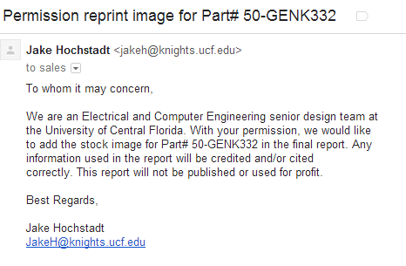
INTRAPHEX
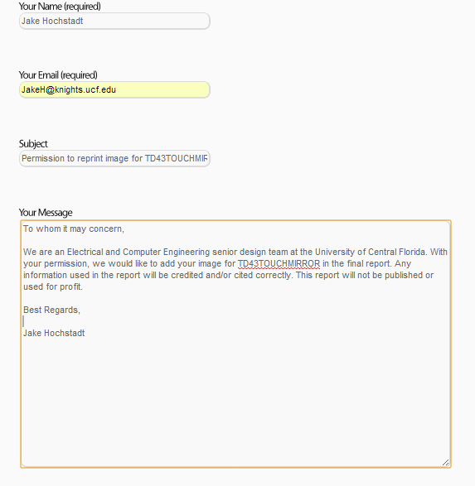

Sparkfun

Whelen.com
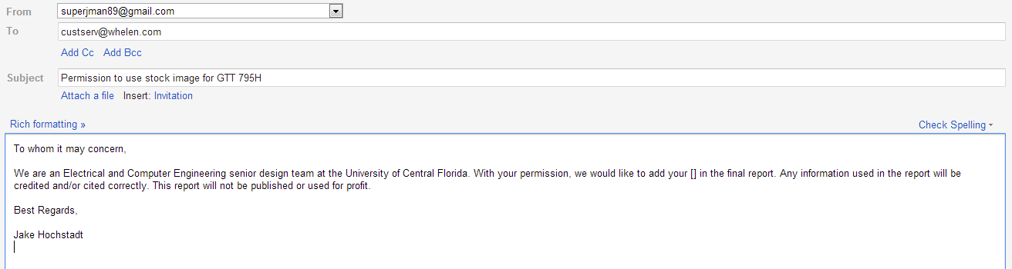
Digikey
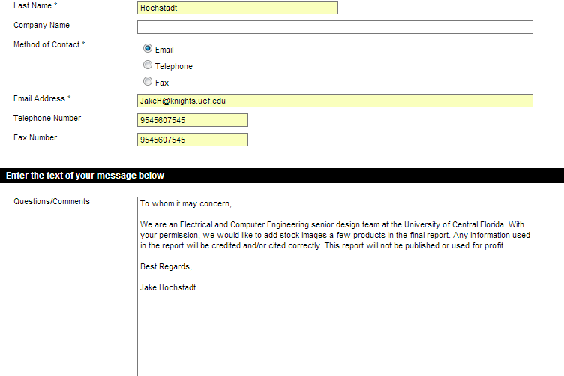

BMW
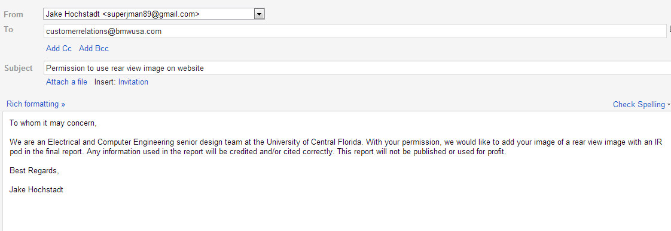
Bluetooth.org
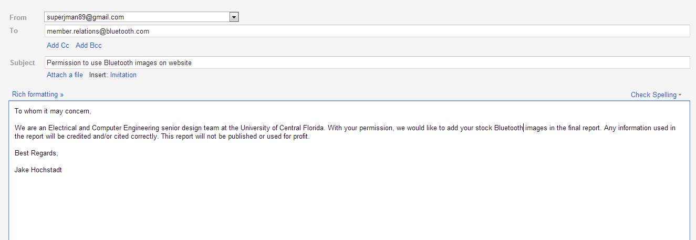
Microchip
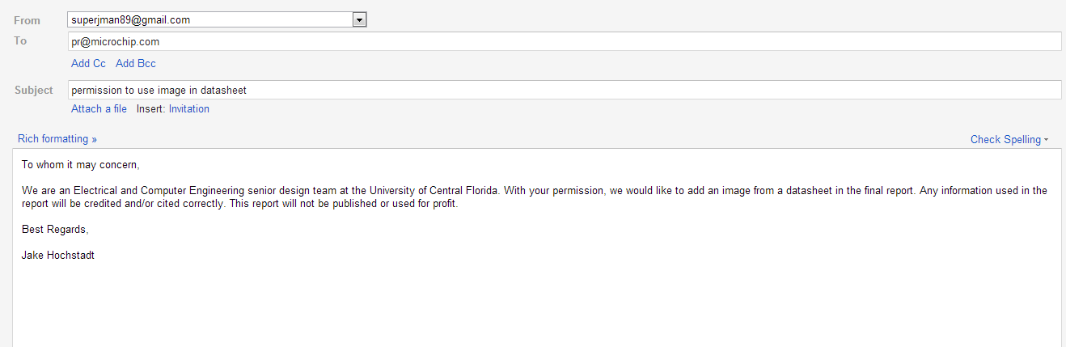
Android
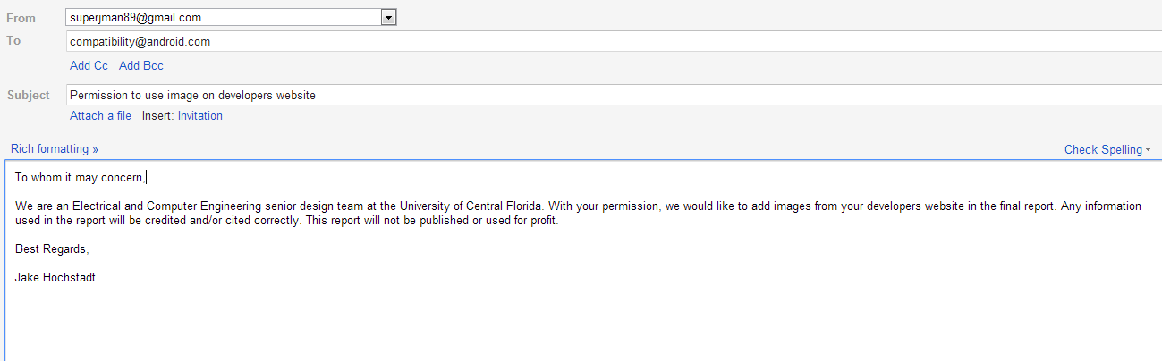
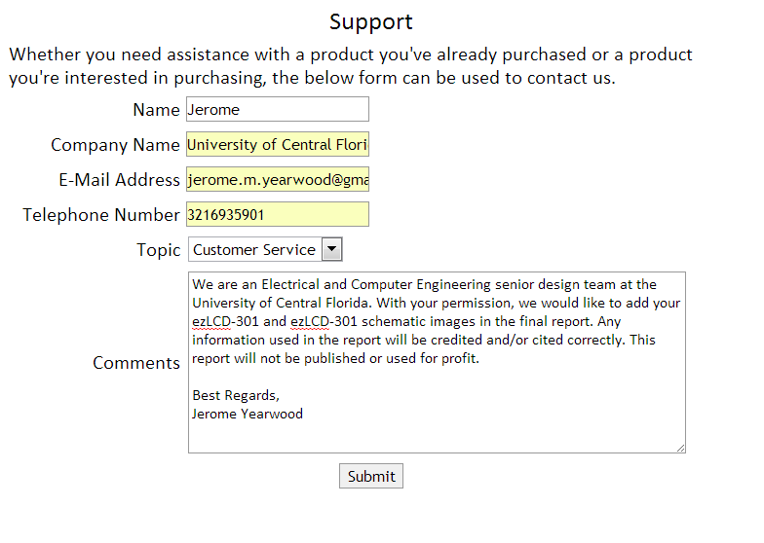
EarthLCD.com

Appendix C List of Sources
[1] "Adobe Products." Adobe. Adobe. Web. 6 Dec 2012. <http://www.adobe.com/products/catalog.html>
[2] "Tuvdotcom." Tuvdotcom. N.p.. Web. 6 Dec 2012. <http://www.tuvdotcom.com/keywords/347?locale=en>.
[3] "Bluetooth ." Bluetooth.org. Bluetooth. Web. 6 Dec 2012. <ttp://www.bluetooth.org/Building/HowTechnologyWorks/ProfilesAndProtocols/Overview.htm>.
[4] "Java Downloads." Java. Java. Web. 6 Dec 2012. <http://www.oracle.com/technetwork/java/javase/downloads/index.html>.
[5] "A-GPS vs GPS." diffen.com. N.p.. Web. 6 Dec 2012. <http://www.diffen.com/difference/A-GPS_vs_GPS>.
[6] "The Google Distance Matrix API." Google Developers. Google. Web. 6 Dec 2012. <https://developers.google.com/maps/documentation/distancematrix/>.
[7] "Usage Limits." Google Developers. Google. Web. 6 Dec 2012. <https://developers.google.com/maps/documentation/javascript/usage
[8] "5 things you didn't know." ibm.com. IBM. Web. 6 Dec 2012. <http://www.ibm.com/developerworks/java/library/j-5things9/index.html>.
[9] "Providing Resources." Google Developers. Google. Web. 6 Dec 2012. <http://developer.android.com/guide/topics/resources/providing-resources.html>.
[10] "Handling Runtime Changes." Google Developers. Google. Web. 6 Dec 2012. <http://developer.android.com/guide/topics/resources/runtime-changes.html>.
[11] "Copy and Paste." Google Developers. Google. Web. 6 Dec 2012. <http://developer.android.com/guide/topics/text/copy-paste.html>.
[12] "Creating an Input Method." Google Developers. Google. Web. 6 Dec 2012. <http://developer.android.com/guide/topics/text/creating-input-method.html>.

